**HO CHI MINH CITY UNIVERSITY OF TECHNOLOGY AND EDUCATION**

**FACULTY FO HIGH-QUALITY TRAINING**

**

**PROJECT**

**BUILDING A PLAGIARISM CHECK WEBSITE FOR IT FACULTY REPORTS**

**Advisor: HUYNH XUAN PHUNG, Ph.D.**

**Student: NGUYEN VAN THANG 17110230**

**NGUYEN VAN HA 17110130**

**Ho Chi Minh City, January 2022**

**HO CHI MINH CITY UNIVERSITY OF TECHNOLOGY AND EDUCATION**

**FACULTY FO HIGH-QUALITY TRAINING**

**

**PROJECT**

**BUILDING A PLAGIARISM CHECK WEBSITE FOR IT FACULTY REPORTS**

**Advisor: HUYNH XUAN PHUNG, Ph.D.**

**Student: NGUYEN VAN THANG 17110230**

**NGUYEN VAN HA 17110130**

**Ho Chi Minh City, January 2022**

|  |  |
| --- | --- |
|  | THE SOCIALIST REPUBLIC OF VIETNAM  **Independence – Freedom– Happiness**  --------  *Ho Chi Minh City, January …, 2022* |

**PROJECT ASSIGNMENT**

|  |  |
| --- | --- |
| Student name: Nguyen Van Thang | Student ID: 17110230 |
| Student name: Nguyen Van Ha | Student ID: 17110130 |
| Major: Information Technology |  |
| Advisor: Huynh Xuan Phung | Phone number: |
| Date of assignment: 06/09/2021 | Date of submission: 03/01/2022 |
| 1. Project title: Building a plagiarism check website for IT faculty reports. | |
| 2. Initial materials provided by the advisor: | |
| 3. Content of the project: Building a plagiarism check website for IT faculty reports. | |
| 4. Final product: A website application document management system and checking duplicate documents. | |
| **CHAIR OF THE PROGRAM**  *(Sign with full name)* | **ADVISOR**  *(Sign with full name)* |

Nguyen Dang Quang Huynh Xuan Phung

|  |  |
| --- | --- |
|  | THE SOCIALIST REPUBLIC OF VIETNAM  **Independence – Freedom– Happiness**  --------  *Ho Chi Minh City, January …, 2022* |

**ADVISOR'S EVALUATION SHEET**

Student name: Nguyen Van Thang Student ID: 17110230

Student name: Nguyen Van Ha Student ID: 17110130

Major: Information Technology

Project title: Building a plagiarism check website for IT faculty reports.

Advisor: Huynh Xuan Phung

EVALUATION

1. Content of the project:

..........................................................................................................................................

..........................................................................................................................................

..........................................................................................................................................

2. Strengths:

..........................................................................................................................................

..........................................................................................................................................

..........................................................................................................................................

3. Weaknesses:

.........................................................................................................................................

..........................................................................................................................................

4. Approval for oral defense? *(Approved or denied)*

..........................................................................................................................................

5. Overall evaluation: (Excellent, Good, Fair, Poor)

..........................................................................................................................................

6. Mark:……………….(*in words*:………………………………………)

*Ho Chi Minh City, 01 …, 2022*

**ADVISOR**

*(Sign with full name)*

|  |  |
| --- | --- |
|  | THE SOCIALIST REPUBLIC OF VIETNAM  **Independence – Freedom– Happiness**  --------  *Ho Chi Minh City, January …, 2022* |

**ADVISOR'S EVALUATION SHEET**

Student name: Nguyen Van Thang Student ID: 17110230

Student name: Nguyen Van Ha Student ID: 17110130

Major: Information Technology

Project title: Building a plagiarism check website for IT faculty reports.

Advisor: Huynh Xuan Phung

EVALUATION

1. Content of the project:

..........................................................................................................................................

..........................................................................................................................................

..........................................................................................................................................

2. Strengths:

..........................................................................................................................................

..........................................................................................................................................

..........................................................................................................................................

3. Weaknesses:

.........................................................................................................................................

.........................................................................................................................................

4. Approval for oral defense? *(Approved or denied)*

..........................................................................................................................................

5. Overall evaluation: (Excellent, Good, Fair, Poor)

.........................................................................................................................................

6. Mark: ……………….(*in words*:………………………………………)

*Ho Chi Minh City, 01 …, 2022*

**ADVISOR**

*(Sign with full name)*

# Disclaimer

In completing the graduation thesis, our group has been supported by my advisor: Huynh Xuan Phung - an HCMC University of Technology and Education lecturer, who gave an enthusiastic guide and provided documents for our group to complete the graduation thesis.

Thanks to lecturer Huynh Xuan Phung for helping our group to have a solid theory and the overview of the technique for making the graduation thesis.

**Table of contents**

**Disclaimer 1**

**Acknowledgments 11**

**CHAPTER 1: INTRODUCTION 12**

**1.1. Purpose 12**

**1.2. Objective 12**

**1.3. Scope 12**

**1.4. Theoretical basic 12**

**1.4.1. Levenshtein distance and the use of a diagonal line 12**

**1.4.2. Next JS framework 15**

**1.4.3. Spring framework 16**

**1.4.4. PostgreSQL 18**

**CHAPTER 2: REQUIREMENT SPECIFICATION 20**

**2.1. Description 20**

**2.2. Functional requirements 20**

**2.2.1. User requirements 20**

**2.2.2. System requirements 20**

**2.3. Non-functional requirements 50**

**2.3.1. Usability 50**

**2.3.2. Reliability 50**

**2.3.3. Performance 51**

**2.3.4. Supportability 51**

**2.3.5. Design Constraints 51**

**2.3.7. Interfaces 51**

**2.4. APIs requirement specification 51**

**2.4.1. Sign up – POST method 51**

**2.4.2. Sign in – POST method 53**

**2.4.3. Forgot password – POST method 53**

**2.4.4. Reset password – PATCH method 54**

**2.4.5. Resend email reset password – GET method 55**

**2.4.6. Refresh token – POST method 55**

**2.4.7. Change password – PATCH method 56**

**2.4.8. Get info of current user – GET method 57**

**2.4.9. Active account – PATCH method 58**

**2.4.10. Update info of current user – PATCH method 59**

**2.4.11. Change avatar – POST method 60**

**2.4.12. Lock user – PATCH method 61**

**2.4.13. Get info of dashboard – GET method 62**

**2.4.14. Log out – GET method 63**

**2.4.15. Get documents of user – GET method 64**

**2.4.16. Upload document – POST method 65**

**2.4.17. Update document – PATCH method 66**

**2.4.18. Delete document – DELETE method 67**

**2.4.19. Manage document – GET method 68**

**CHAPTER 3: SYSTEM DESIGN 70**

**3.1. System Architecture 70**

**3.2. ERD 70**

**3.3. Logical Database Diagram 71**

**3.4. Sequence Diagram 72**

**3.4.1. Upload Document 72**

**3.4.2. Delete Document 73**

**3.4.3. Sign in 74**

**3.5. Activity Diagram 75**

**3.5.1. Sign in 75**

**3.5.2. Upload Document 75**

**3.6. Class Diagram 77**

**3.7. User interfaces design 77**

**3.7.1. Sign in 77**

**3.7.2. Signup 78**

**3.7.3. Forgot password 80**

**3.7.4. Documents page 81**

**3.7.5. Upload document 82**

**3.7.6. Profile 83**

**3.7.7. Change password 85**

**3.8. Design algorithm 86**

**3.8.1. Division sentences 86**

**3.8.2. Get distance of two strings 87**

**3.8.3. Get percent similar 88**

**3.8.4. Fill Levenshtein matrix 90**

**3.8.5. Find the same part of two documents 92**

**3.8.6. Count the number of similar characters 93**

**3.8.7. The function used to check if the character has been covered 93**

**3.8.8. Application flow for function upload document 95**

**3.8.9. Check plagiarism 95**

**CHAPTER 4: SYSTEM IMPLEMENTATION 97**

**4.1. Software development environment 97**

**4.2. Tool and technique 97**

**4.3. Source code management 97**

**CHAPTER 5: TESTING AND EVALUATION 98**

**5.1. Test Case 98**

**5.1.1. Sign in 98**

**5.1.2. Logout 103**

**5.1.3. Upload document 103**

**5.1.4. Delete document 108**

**5.1.5. Download document 109**

**5.1.6. Search document 111**

**5.1.7. Edit document 113**

**5.1.8. Change profile 115**

**5.1.9. Change password 122**

**5.1.10. Change avatar 129**

**5.1.11. Lock account 130**

**5.1.12. Sign up 131**

**5.2. Example 141**

**5.3. Evaluation 145**

**CHAPTER 6: CONCLUSION 146**

**6.1. Conclusion 146**

**6.2. Advantage 146**

**6.3. Disadvantage 146**

**6.4. Future planning 147**

**REFERENCES 148**

**List of tables**

Table 1 Identifier actor 23

Table 2 System characters 23

Table 3 Use case 24

Table 4 Use case sign in 27

Table 5 Use case signup 29

Table 6 Use case forgot password 32

Table 7 Use case upload document 34

Table 8 Use case download documents 36

Table 9 Use case delete documents 37

Table 10 Use case search documents 39

Table 11 Use case edit document 41

Table 12 Use case check detail account 43

Table 13 Use case lock account 45

Table 14 Use case change avatar 47

Table 15 Use case change password 49

Table 16 Use case edit profile 50

Table 17 Use case logout 52

Table 18 Description for API signup 54

Table 19 Description for API sign in 55

Table 20 Description for API forgot password 56

Table 21 Description for API reset password 57

Table 22 Description for API resend the email to reset password 57

Table 23 Description for an API refresh token 58

Table 24 Description for API change password 59

Table 25 Description for API get info of the current user 60

Table 26 Description for API active account 61

Table 27 Description for API update info of the current user 62

Table 28 Description for API change avatar 63

Table 29 Description for API lock user 64

Table 30 Description for API get info of dashboard 65

Table 31 Description for API logout 66

Table 32 Description for API get a document of user 67

Table 33 Description for API upload document 68

Table 34 Description for API update document 69

Table 35 Description for API delete document 70

Table 36 Description for API manage document 71

Table 37 Description for user interface sign in 80

Table 38 Description for interfaces signup 82

Table 39 Description for interfaces reset password 83

Table 40 Description for interfaces documents 84

Table 41 Description for user interfaces upload a document 85

Table 42 Description for interfaces profile 87

Table 43 Description for user interface change password 88

Table 50 Test case sign in-1 99

Table 51 Test case sign in-2 100

Table 52 Test case sign in-3 101

Table 53 Test case sign in-4 102

Table 54 Test case sign in-5 103

Table 55 Test case sign in-6 104

Table 56 Test case logout 104

Table 57 Test case upload document-1 106

Table 58 Test case upload document-2 107

Table 59 Test case upload document-3 108

Table 60 Test case upload document-4 109

Table 61 Test case delete a document 110

Table 62 Test case download document 112

Table 63 Test case search document-1 113

Table 64 Test case search document-2 114

Table 65 Test case edit document-1 115

Table 66 Table 67 Test case edit document-2 116

Table 68 Test case change profile-1 117

Table 69 Test case change profile-2 119

Table 70 Test case change profile-3 120

Table 71 Test case change profile-4 121

Table 72 Test case change profile-5 122

Table 73 Test case change profile-6 123

Table 74 Test case change password-1 125

Table 75 Test case change password-2 126

Table 76 Test case change password-3 127

Table 77 Test case change password-4 128

Table 78 Test case change password-5 130

Table 79 Test case change avatar-1 131

Table 80 Test case lock account-1 132

Table 81 Test case sign up-1 133

Table 82 Test case sign up-2 134

Table 83 Test case sign up-3 136

Table 84 Test case sign up-4 137

Table 85 Test case sign up-5 138

Table 86 Test case sign up-6 140

Table 87 Test case sign up-7 141

Table 88 Test case sign up-8 142

**List of figures**

Figure 1 Using simplified Smith-Waterman algorithm 13

Figure 2 shows the resulting dynamic 15

Figure 3 Divide the table 16

Figure 4 Spring framework runtime 18

Figure 5 Use case diagram 25

Figure 6 Use case sign in 26

Figure 7 Use case signup 28

Figure 8 Use case forgot password 30

Figure 9 Use case upload document 32

Figure 10 Download documents 34

Figure 11 Use case delete documents 36

Figure 12 Use case search document 38

Figure 13 Use case edit document 40

Figure 14 Use case check detail account 42

Figure 15 Use case lock account 43

Figure 16 Use case change avatar 45

Figure 17 Use case change password 47

Figure 18 Use case edit document 49

Figure 19 Use case logout 51

Figure 20 API signup 54

Figure 21 API sign in 55

Figure 22 API forgot password 56

Figure 23 API reset password 57

Figure 24 API resend the email to reset the password 57

Figure 25 API refresh token 58

Figure 26 API change password 59

Figure 27 API get info of the current user 60

Figure 28 API active account 61

Figure 29 API update info of the current user 62

Figure 30 API change avatar 63

Figure 31 API lock user 64

Figure 32 API get info of dashboard 65

Figure 33 API log out 66

Figure 34 API get a document of user 67

Figure 35 API upload document 68

Figure 36 API update document 69

Figure 37 API delete document 70

Figure 38 API manage document 71

Figure 39 System Architecture 72

Figure 40 ERD 73

Figure 41 Logical Database Diagram 74

Figure 42 Sequence Diagram upload documents 75

Figure 43 Sequence Diagram delete a document 76

Figure 44 Sequence Diagram sign in 76

Figure 45 Activity Diagram sign in 77

Figure 46 Activity Diagram upload document 78

Figure 47 Class Diagram 79

Figure 48 User interface sign in 80

Figure 49 User interfaces signup 81

Figure 50 User interfaces forgot password 82

Figure 51 User interfaces reset password 83

Figure 52 User interfaces documents 83

Figure 53 User interfaces upload document-1 84

Figure 54 User interfaces upload document-2 85

Figure 55 User interfaces profile 86

Figure 56 User interface change password 87

Figure 57 Algorithm Flowchart of function devisiontoSentences 89

Figure 58 Algorithm Flowchart of function getLevenshteinDistance 90

Figure 59 Algorithm Flowchart of function getPercentageSimilarity 91

Figure 60 Algorithm Flowchart of function fillLevenshteinMatrix 92

Figure 61 Algorithm Flowchart of function getPartPlagiarism 93

Figure 62 Algorithm Flowchart of function count 94

Figure 63 Algorithm Flowchart of function isCover 95

Figure 64 Application flow for function upload document 96

Figure 65 Algorithm Flowchart of check plagiarism 97

# Acknowledgments

With the topic of this essay, we have been exposed to new fields new technologies. The essential thing that makes this essay is to use the Levenshtein distances to compare the similarities of the two documents. The above knowledge will help us create a data management application for the faculty of a university.

# CHAPTER 1: INTRODUCTION

In today's universities, the problem of plagiarism is a matter of concern, especially in reports or tests in exams. Realizing that this problem is very urgent, my group would like to give opinions on the topic: " Building a plagiarism check website for IT faculty reports."

## **Purpose**

Our aim this time is to be able to create a website that allows users to access and upload their reports. During the process of the user uploading the report, the system will check plagiarism for that report compared to the reports already stored in the faculty's database. The website must have a straightforward interface and be easy to use. If users use it for the first time, they can also use it easily and quickly.

## **Objective**

The goal set for our team is: to be able to apply spring framework and PostgreSQL database technologies to create restful standard APIs to transfer data to the frontend using the next JS. The generated application must have basic functions for users, especially uploading documents using the Levenshtein distance to check the similarity between documents.

## **Scope**

The scope of what we want to do is to create a complete web application for users to use easily. A university faculty can use the application to store documents and check for the plagiarism of uploaded documents.

## **Theoretical basic**

### **Levenshtein distance and the use of a diagonal line**

A commonly-used bottom-up dynamic programming algorithm for computing the Levenshtein distance involves the use of an (n + 1) × (m + 1) matrix, where n and m are the lengths of the two strings. This algorithm is based on the Wagner-Fischer algorithm for edit distance. Here is pseudocode for a function Levenshtein distance that takes two strings, s of length m, and t of length n, and computes the Levenshtein distance between them:

int LevenshteinDistance (char s[1…m], char t[1…n])

// d is a table with m+1 rows and n+1 columns declare int d[0…m, 0…n]

for i from 0 to m

d[i, 0] := i

for j from 0 to n

d[0, j] := j

for i from 1 to m

for j from 1 to n

if s[i] = t[j] then

cost := 0

else cost := 1

d[I, j] := minimum(d[i-1, j] +1, d[i, j-1] +1, d[i-1, j-1] +cost)

return d[m, n]

Now we begin with an example, there are two text files below:

1. X = a b c x d e f g h i

2. Y = a b c d e f g h

Suppose that the dynamic programming array rows represent X and the columns represent Y and suppose that the threshold for a significant match is 3. Figure 2 shows the resulting dynamic programming table

|  |  |  |  |  |  |  |  |  |  |  |
| --- | --- | --- | --- | --- | --- | --- | --- | --- | --- | --- |
|  | a | b | c | x | d | e | f | g | h | i |
| a | 0 | 1 | 2 | 3 | 4 | 5 | 6 | 7 | 8 | 9 |
| b | 1 | 0 | 1 | 2 | 3 | 4 | 5 | 6 | 7 | 8 |
| c | 2 | 1 | 0 | 1 | 2 | 3 | 4 | 5 | 6 | 7 |
| d | 3 | 2 | 1 | 1 | 1 | 2 | 3 | 4 | 5 | 6 |
| e | 4 | 3 | 2 | 2 | 2 | 1 | 2 | 3 | 4 | 5 |
| f | 5 | 4 | 3 | 3 | 3 | 2 | 1 | 2 | 3 | 4 |
| g | 6 | 5 | 4 | 4 | 4 | 3 | 2 | 1 | 2 | 3 |
| h | 7 | 6 | 5 | 5 | 5 | 4 | 3 | 2 | 1 | 2 |

Figure 2 shows the resulting dynamic

Applying the algorithm, we find that the return value 2 is <= 3, but by anglicizing the two text files, we can find the diagonal line portion has the higher similarities, which we flagged in red. Proof: from the theory of the Levenshtein distance, we can get this rule: Suppose the beginning of the comparing node is the same. If the next comparing node is also the same, the cost is 0, so all of these values make of a diagonal line. The rectangle this diagonal line divides represents the similarities. We divide the dynamic programming array into some grids according to the rectangles to decrease the computation. Considering the psychological factors, a plagiarism text is impossible the same with two portions of one text, so we can cut off the table like Figure 3. That means the rows and columns concluding rectangles which are made of the diagonal line will not be computed.

|  |  |  |  |  |  |  |  |  |  |  |  |  |  |  |  |  |  |  |  |  |
| --- | --- | --- | --- | --- | --- | --- | --- | --- | --- | --- | --- | --- | --- | --- | --- | --- | --- | --- | --- | --- |
|  | a | | b | | c | | x | | d | | e | | f | | g | | h | | i | |
| a |  | | 1 | | 2 | |  |  |  |  |  |  |  |  |  |  |  |  |  |  |
| b | 1 | |  | | 1 | |  |  |  |  |  |  |  |  |  |  |  |  |  |  |
| c | 2 | | 1 | |  | |  |  |  |  |  |  |  |  |  |  |  |  |  |  |
| d |  |  |  |  |  |  |  |  |  | | 2 | | 3 | | 4 | | 5 | | 6 | |
| e |  |  |  |  |  |  |  |  | 2 | |  | | 2 | | 3 | | 4 | | 5 | |
| f |  |  |  |  |  |  |  |  | 3 | | 2 | |  | | 2 | | 3 | | 4 | |
| g |  |  |  |  |  |  |  |  | 4 | | 3 | | 2 | |  | | 2 | | 3 | |
| h |  |  |  |  |  |  |  |  | 5 | | 4 | | 3 | | 2 | |  | | 2 | |

Figure 3 Divide the table

All the above means that when we compare some text files, we should first represent the lexical entities by integers and initiate the table by comparing the integers. If they are the same, the node is red. Second, connect the red nodes, which can make up a diagonal line, mark the rectangles the diagonal lines belong to, and compute the number of the nodes to a similar degree. Third, divide the table into grids and make the rows and columns concluding rectangles as portions that need not compute.[1]

### **Next JS framework**

NextJS is a React framework, a platform for developing software applications by using React library. It has many features that make the development of React applications easier.

As a programmer, we don't need to start from scratch when tools are already designed to help us with our projects. Frameworks are software developed and used by developers to build applications, so Next JS is one of them.

This question appeared in my head many times before I wasn't familiar with Next JS. I was sure that React library itself was enough to build an application. But as I was developing my web developer's skills and building highly-scaled large applications, I had to import any additional libraries together with React (for example, for routing).

Next JS makes the development of large React applications easier since it provides many additional features, which we will discuss below in detail. This framework solves many common problems and simply makes the life of a React developer easier. We still write React code and use React features, but also, together with that, we are provided with lots of built-in features to solve common problems and clear instructions on how to use them.[12]

### **Spring framework**

Spring is a framework for developing Java applications used by millions of programmers. It helps to create high-performance, easy-to-test, code-reusable applications…

Spring is lightweight and transparent (lightweight: small in size, the basic version is only about 2MB; transparent: works transparently to programmers).

Spring is an open-source code developed, shared, and extensive user community.

Spring Framework is built on two main design principles: Dependency Injection and Aspect-Oriented Programming.

The core features of Spring can be used to develop Java Desktop, mobile applications, Java Web. Spring's main goal is to make it easier to develop J2EE applications based on the POJO (Plain Old Java Object) usage pattern.

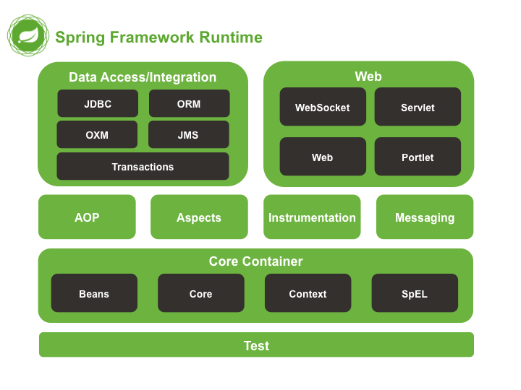

Figure 4 Spring framework runtime

Test: This layer provides support for testing with JUnit and TestNG.

Spring Core Container: Includes spring core, beans, context, and expression language (EL) modules

Spring core, bean provides IOC and Dependency Injection features.

Spring Context supports multi-language (internationalization), Java EE features such as EJB, JMX.

Expression Language is extended from Expression Language in JSP. It provides support for setting/getting values, improved methods for accessing collections, indexes, logical operators, etc.

AOP, Aspects, and Instrumentation: These modules support the implementation of Aspect-Oriented Programming, support integration with AspectJ.

Data Access / Integration: This group includes JDBC, ORM, OXM, JMS, and Transaction modules. These modules provide the ability to communicate with the database

Web: Also known as Spring MVC This group includes Web, Web-Servlet… supporting the creation of web applications... [13]

### **PostgreSQL**

PostgreSQL is an object-relational database management system, developed by the Faculty of Computing, University of California, USA, based on Postgres version 4.2. This program paved the way for many later commercial data management system concepts.

Originally, the operating system was designed to run on Unix-like platforms. Later, PostgreSQL was adapted to be flexible and run on many different platforms such as Windows, Mac OS X, Solaris with many outstanding features and features.

PostgreSQL is free and open-source, built according to the SQL99 standard. Users are free to use, edit and distribute PostgreSQL in various ways.

Compared to many other database management systems, PostgreSQL is not too demanding on maintenance because of its high stability, it can develop many different applications at a relatively low cost.

Features of PostgreSQL:

PostgreSQL provides users with many modern features, high stability, great speed, that's why PostgreSQL became popular, you can easily use many hotel website design services using the platform. This is to create a web, in addition, there are many other applications such as:

Data type: primitives (integers, booleans, numbers, strings); structure (UUID, Range, Array, Date/time); Geometry; Custom; Document.

Data integrity: Word type constraints, Primary Keys, Foreign Keys, UNIQUE, NOT NULL, Recommendation Locks/Advisory Locks, Function Locks/ Explicit Locks, etc.

Performance, convergence: Advanced data signing, scheduling, complex access optimizer, multi-column stats, index-only, transaction-to-transaction scanning test format, multiple instances concurrency control (MVCC), table partitioning, parallel read queries, reliability, disaster recovery, Write-ahead Logging (WAL), replication, restore score – time, table

Security functions: Security, authentication (SCRAM-SHA-256, SSPI, LDAP, GSSAPI, Certificate, and others), strong access control system, column-row level security.

Scalability: stored methods, procedural languages (PL/PGSQL, Python, Perl, and many more), other threading or database connectivity with standard SQL interfaces, and many other extended features.

Text search: Full-text search, system of international character sets (via ICU collations).

More features: Ability to manage the number of users working at the same time, suitable for production environments that manage multiple terabytes and petabytes.

PostgreSQL role?

PostgreSQL is an open data management system for enterprises. This management system is compatible with many different platforms, using a variety of languages and popular middleware today. Therefore, PostgreSQL is widely applied in government GIS data industries, banking and finance, production - business, web technology, and scientific data collection jobs.

PostgreSQL is free and open source. Therefore, you do not need to pay anything when using this service. However, the PostgreSQL database management system is not owned by any organization which is also a drawback. It's difficult for users to get their name out there despite having enough features like other DBMS systems.

# CHAPTER 2: REQUIREMENT SPECIFICATION

* 1. **Description**

This is a website to manage reports of the faculty of information technology such as specialized essay reports, graduation thesis reports, etc. Users can register themselves for an account on the system to be able to use the functions of the system.

Each account logged into the system can view the documents they have uploaded. In addition, users can upload their reports here, the system will check for plagiarism for each uploaded report, when plagiarism detect the system will display the same paragraphs for users to check. Admin will be the person who manages the existing accounts in the system, to system works at its best.

* 1. **Functional requirements**
     1. **User requirements**
        1. **Users must authenticate to the system and use it according to their authority.**

To be able to use the website, users need to log in to the website with a registered account. If you don't have an account, you need to register and confirm your email.

Users can view their uploaded documents and can edit, delete, download, and upload new documents. During the upload process, the system will check the document for plagiarism before it is added to the database. In addition, users can also edit their profile, avatar and can use email to reset the password by the "forgot password" function.

* + 1. **System requirements**
       1. **Identifier actor**

|  |  |  |
| --- | --- | --- |
| STT | Actor | Description |
| 1 | Admin | The user has logged into the system with an account with "Admin" privileges. |
| 2 | User | The user has logged into the system with an account with "User" privileges. |
| 3 | User Unauthenticated | Guest is not authenticated by the system |

Table 1 Identifier actor

* + - 1. **System characters**

|  |  |  |  |  |  |
| --- | --- | --- | --- | --- | --- |
| No | Main function | User | User Authenticated | User Unauthenticated | Admin |
| 1 | Sign in |  |  | x |  |
| 2 | Logout |  | x |  |  |
| 3 | Upload Document | x |  |  |  |
| 4 | Manager personal document | x |  |  |  |
| 5 | Manager All document |  |  |  | x |
| 5 | Manage User |  |  |  | x |
| 6 | Manage Profile |  | x |  |  |
| 7 | Signup |  |  | x |  |
| 8 | Forgot password |  |  | x |  |

Table 2 System characters

* + - 1. **Use case**

|  |  |  |
| --- | --- | --- |
| System Functions | Main use case | Use Case # |
| User unauthenticated can sign up and sign in as some roles | | |
|  | Sign in | UC_1.1 |
|  | Sign up | UC_1.2 |
|  | Forgot password | UC_1.3 |
| User has the right to manage documents | | |
|  | Upload documents | UC_1.4 |
|  | Edit documents | UC_1.5 |
|  | Download documents | UC_1.6 |
|  | Delete documents | UC_1.7 |
|  | Search documents | UC_1.8 |
| Admin has the right to manage user accounts | | |
|  | Lock account | UC_1.9 |
|  | Check detail account | UC_2.0 |
| User Authenticated can manage profile and logout | | |
|  | Change avatar | UC_2.1 |
|  | Change password | UC_2.2 |
|  | Edit profile | UC_2.3 |
|  | Logout | UC_2.4 |

Table 3 Use case

* + - 1. **Use case diagram**

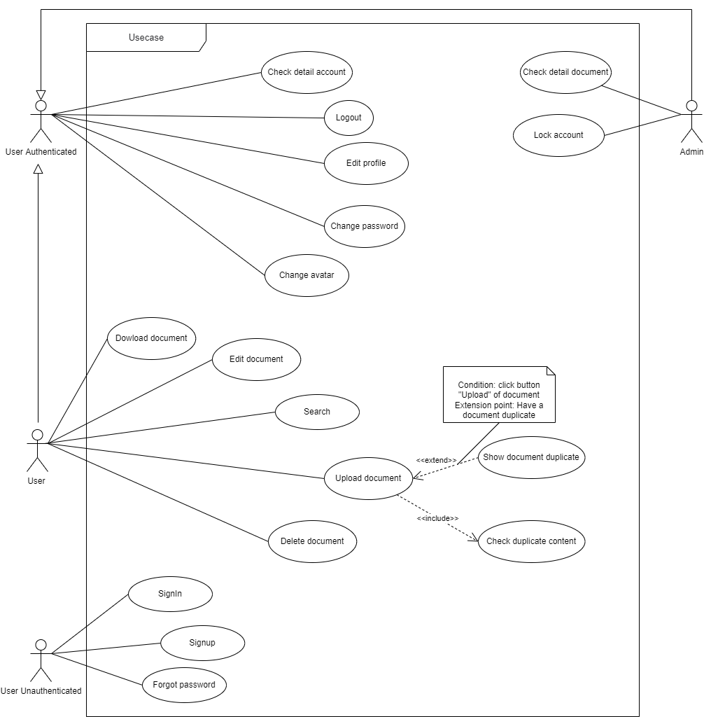

Figure 5 Use case diagram

* + - 1. **Use case description**
         1. **User Unauthenticated can sign in as some role**

**Use case sign in**

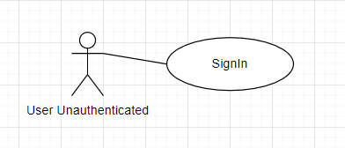

Figure 6 Use case sign in

|  |  |  |  |
| --- | --- | --- | --- |
| USE CASE – 1.1 | | | |
| Use Case No. | UC_1.1 | Use Case Version | 1.0 |
| Use Case Name | Sign in | | |
| Author | Nguyen Van Thang | | |
| Date | 01/01/2022 | Priority | Low |
| Actor:   * User Unauthenticated   Summary:   * Allow users to sign in to the website   Goal:   * Users can sign in to the system in one defined role   Triggers:   * Users submit a request to access the website   Preconditions:   * Users must fill in the email and password.   Postconditions:   * Success: Users will be redirected to their work screen. * Fail: User can't sign in to the website.   Main Success Scenario:   |  |  |  | | --- | --- | --- | | Step | Actor Action | System Response | | 1 | User type username and password to the text field | The website set a password to private char. | | 2 | User tap on the sign-in button | The website creates a user token and will redirect the user to the main working screen, depending on the user role. |   Alternative Scenario:  Exceptions:   |  |  |  | | --- | --- | --- | | No | Actor Action | System Response | | 1 | User entered missing email or password. | The website displays a message asking the user to enter the full email or password. | | 2 | The user entered an incorrect username or password. | The website will display a message that the user has entered the wrong email or password. |   Relationship:  Business Rules:   * The user is not logged in to the website. | | | |
|  | | | |

Table 4 Use case sign in

**Use case sign up**

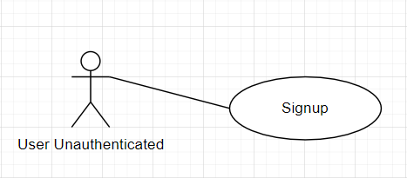

Figure 7 Use case signup

|  |  |  |  |
| --- | --- | --- | --- |
| USE CASE – 1.2 | | | |
| Use Case No. | UC_1.2 | Use Case Version | 1.0 |
| Use Case Name | Sign up | | |
| Author | Nguyen Van Thang | | |
| Date | 01/01/2022 | Priority | Low |
| Actor:   * User Unauthenticated   Summary:   * Allows users who do not have an account to log in to the website to register for a new account.   Goal:   * Users can register an account to use the functions on the website   Triggers:   * The user sends a request to register a new account to the website   Preconditions:   * Users must fill in the information.   Postconditions:   * Success: Users will be redirected to their confirmation email screen and the system sent to email. * Fail: Users can't sign up to the system.   Main Success Scenario:   |  |  |  | | --- | --- | --- | | Step | Actor Action | System Response | | 1 | User type all the text field |  | | 2 | User tap on sign up button | The system sends to email and will redirect the user to confirm the email screen. |   Alternative Scenario:  Exceptions:   |  |  |  | | --- | --- | --- | | No | Actor Action | System Response | | 1 | The user does not enter the full field. | The system will send a notice asking the user to fill in all fields. | | 2 | User entered already exists email. | The system will send a notification to the email that already exists. |   Relationship:  Business Rules:   * The user does not have an account in the system. | | | |
|  | | | |

Table 5 Use case signup

**Forgot password**

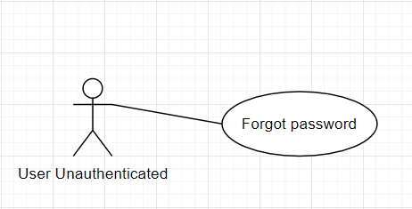

Figure 8 Use case forgot password

|  |  |  |  |
| --- | --- | --- | --- |
| USE CASE – 1.3 | | | |
| Use Case No. | UC_1.3 | Use Case Version | 1.0 |
| Use Case Name | Forgot password | | |
| Author | Nguyen Van Thang | | |
| Date | 01/01/2022 | Priority | Low |
| Actor:   * User Unauthenticated   Summary:   * Allow users to forget a password to the system   Goal:   * Users change new accounts from email reset password   Triggers:   * The user sends a request to forget a password to the system   Preconditions:   * Users must fill in the email.   Postconditions:   * Success: Reset password success. * Fail: User can't reset password to the system.   Main Success Scenario:   |  |  |  | | --- | --- | --- | | Step | Actor Action | System Response | | 1 | User click forgot password | Display send email forgot password page | | 2 | Enter email register | The system is sent to email reset password. | | 3 | Enter the link in the email | The system is redirected to the reset password page. | | 4 | Enter a new password and confirm password and press save | The system change password and shows message change success. |   Alternative Scenario:  Exceptions:   |  |  |  | | --- | --- | --- | | No | Actor Action | System Response | | 1 | Not enter all fields. | The system will send a notice asking the user to fill in all fields. | | 2 | New password and confirm password are not the same. | The system will send a notification to a new password and confirm passwords are not the same. |   Relationship:  Business Rules:   * The user does not remember the password | | | |
|  | | | |

Table 6 Use case forgot password

* + - * 1. **User has the right to manage documents**

**Upload document**

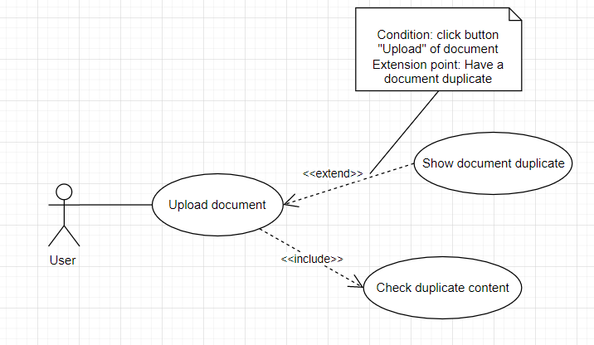

Figure 9 Use case upload document

|  |  |  |  |
| --- | --- | --- | --- |
| USE CASE – 1.4 | | | |
| Use Case No. | UC_1.4 | Use Case Version | 1.0 |
| Use Case Name | Upload document | | |
| Author | Nguyen Van Thang | | |
| Date | 01/01/2022 | Priority | Low |
| Actor:   * User   Summary:   * Allows users to upload da documents to the website   Goal:   * Upload documents to the website.   Triggers:   * Submit a request to upload a document to the website   Preconditions:   * The user has a new document to upload   Postconditions:   * Success: shows the successful addition message and the document is displayed in the documents list. * Fail: error message display   Main Success Scenario:   |  |  |  | | --- | --- | --- | | Step | Actor Action | System Response | | 1 | Users click to add a new document | The system will redirect the user to upload document page | | 2 | The user completes the information and presses the upload button | The system will check if the uploaded document matches or not, if not, the upload is successful, and if it matches, it displays the degree of similarity and a detailed table of similar sentences as well as % alike. |   Exceptions:   |  |  |  | | --- | --- | --- | | No | Actor Action | System Response | | 1 | The user does not enter the full fields | The system will send a notice asking the user to fill in all fields |   Business Rules:   * User must sign in with permissions User * After adding the document is displayed on the document list | | | |
|  | | | |

Table 7 Use case upload document

**Download documents**

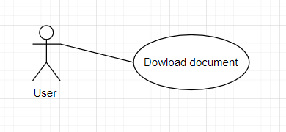

Figure 10 Download documents

|  |  |  |  |
| --- | --- | --- | --- |
| USE CASE – 1.5 | | | |
| Use Case No. | UC_1.5 | Use Case Version | 1.0 |
| Use Case Name | Download document | | |
| Author | Nguyen Van Thang | | |
| Date | 01/01/2022 | Priority | Low |
| Actor:   * User   Summary:   * Allows users to download the documents to the website   Goal:   * Download the document from the website.   Triggers:   * Submit a request to download the document to the website   Preconditions:   * The user has a document to download   Postconditions:   * Success: Shows the successful addition message and downloaded document * Fail: Error message display   Main Success Scenario:   |  |  |  | | --- | --- | --- | | Step | Actor Action | System Response | | 1 | Users click on documents | The system will redirect the user to the document page | | 2 | Users click to download the document user want to download | The system will download the document and notify the successful download |   Business Rules:   * User must sign in with permissions User * Authenticated can be downloaded | | | |
|  | | | |

Table 8 Use case download documents

**Delete documents**

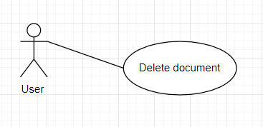

Figure 11 Use case delete documents

|  |  |  |  |
| --- | --- | --- | --- |
| USE CASE – 1.6 | | | |
| Use Case No. | UC_1.6 | Use Case Version | 1.0 |
| Use Case Name | Delete documents | | |
| Author | Nguyen Van Thang | | |
| Date | 01/01/2022 | Priority | Low |
| Actor:   * User   Summary:   * Allows users to delete documents to the website   Goal:   * Delete the document from the website.   Triggers:   * Submit a request to delete documents to the website   Preconditions:   * The user whose document you want to delete   Postconditions:   * Success: Shows the successful addition message and deleted documents * Fail: Error message display   Main Success Scenario:   |  |  |  | | --- | --- | --- | | Step | Actor Action | System Response | | 1 | Users click on documents | The system will redirect the user to the document page | | 2 | Users click to delete the document user want to download | The system will delete the document and notify the successful delete |   Business Rules:   * User must sign in with permissions User * Authenticated can be deleted | | | |
|  | | | |

Table 9 Use case delete documents

**Search documents**

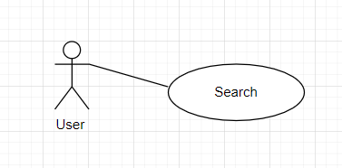

Figure 12 Use case search document

|  |  |  |  |
| --- | --- | --- | --- |
| USE CASE – 1.7 | | | |
| Use Case No. | UC_1.7 | Use Case Version | 1.0 |
| Use Case Name | Search documents | | |
| Author | Nguyen Van Thang | | |
| Date | 01/01/2022 | Priority | Low |
| Actor:   * User   Summary:   * Allows users to search documents on the website   Goal:   * The document you want to search for, or the document with a similar search term   Triggers:   * Submit a request to search documents to the website   Preconditions:   * The user whose document you want to search   Postconditions:   * Success: Shows documents or list document or null * Fail: Error message display   Main Success Scenario:   |  |  |  | | --- | --- | --- | | Step | Actor Action | System Response | | 1 | Users click on documents | The system will redirect the user to the document page | | 2 | Users click to search the document user want to search | The system will return the document that the user wants to find |   Exceptions:   |  |  |  | | --- | --- | --- | | No | Actor Action | System Response | | 1 | User does not enter the title you want to search | The system will send a notice asking the user to fill in all fields |   Business Rules:   * User must sign in with permissions User * Authenticated can be search document | | | |
|  | | | |

Table 10 Use case search documents

**Edit documents**

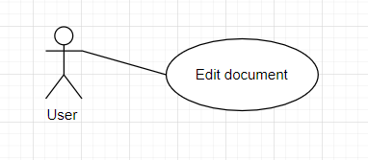

Figure 13 Use case edit document

|  |  |  |  |
| --- | --- | --- | --- |
| USE CASE – 1.8 | | | |
| Use Case No. | UC_1.8 | Use Case Version | 1.0 |
| Use Case Name | Edit documents | | |
| Author | Nguyen Van Thang | | |
| Date | 01/01/2022 | Priority | Low |
| Actor:   * User   Summary:   * Allows users to edit documents to the website   Goal:   * The document you want to edit.   Triggers:   * Submit a request to edit documents to the website   Preconditions:   * The user whose document you want to edit   Postconditions:   * Success: Shows notification edit success * Fail: Error message display   Main Success Scenario:   |  |  |  | | --- | --- | --- | | Step | Actor Action | System Response | | 1 | Users click on documents. | The system will redirect the user to the document page. | | 2 | Users who click the document want to edit. | The system will show a popup with the information of the document. | | 3 | Users fill in the fields they want to change and press save | The system will save new information and close the popup |   Exceptions:   |  |  |  | | --- | --- | --- | | No | Actor Action | System Response | | 1 | The user does not enter all fields required | The system will send a notice asking the user to fill in all fields |   Business Rules:   * User must sign in with permissions User * Authenticated can be edited document | | | |
|  | | | |

Table 11 Use case edit document

* + - * 1. **Admin has the right to manage user accounts**

**Check detailed account**

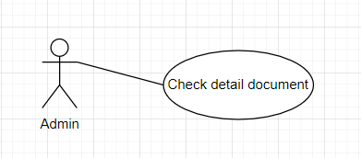

Figure 14 Use case check detail account

|  |  |  |  |
| --- | --- | --- | --- |
| USE CASE – 1.9 | | | |
| Use Case No. | UC_1.9 | Use Case Version | 1.0 |
| Use Case Name | Check detail account | | |
| Author | Nguyen Van Thang | | |
| Date | 01/01/2022 | Priority | Low |
| Actor:   * Admin   Summary:   * Allows admin to check information account to the website   Goal:   * Information account to the website   Triggers:   * Submit a request to check detailed account to the website   Preconditions:   * The admin whose account you want to check   Postconditions:   * Success: Shows a successful addition message and the new account added to the   account list   * Fail: Error message display   Main Success Scenario:   |  |  |  | | --- | --- | --- | | Step | Actor Action | System Response | | 1 | Users click to manage user | The system will redirect the users to manage user page | | 2 | The admin is to click on the account user you want to check. | The system show popup with all the info of the user |   Business Rules:   * User must sign in with permissions admin * Admin can check detailed account user | | | |
|  | | | |

Table 12 Use case check detail account

**Lock account**

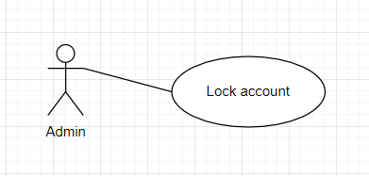

Figure 15 Use case lock account

|  |  |  |  |
| --- | --- | --- | --- |
| USE CASE – 2.0 | | | |
| Use Case No. | UC_2.0 | Use Case Version | 1.0 |
| Use Case Name | Lock account | | |
| Author | Nguyen Van Thang | | |
| Date | 01/01/2022 | Priority | Low |
| Actor:   * Admin   Summary:   * Allows admin to lock the account to the website   Goal:   * The account is locked   Triggers:   * Submit a request to lock the account to the website   Preconditions:   * The user whose account you want to lock   Postconditions:   * Success: Display successful locked message * Fail: Error message display   Main Success Scenario:   |  |  |  | | --- | --- | --- | | Step | Actor Action | System Response | | 1 | Users click to account manage. | The system will redirect the user to the account management page. | | 2 | The admin clicks on the account user you want to lock. | The system shows a popup with all the info of the user. | | 3 | Enter button lock | The system lock account and the user can't sign in |   Business Rules:   * User must sign in with permissions admin * Admin can lock the account | | | |
|  | | | |

Table 13 Use case lock account

* + - * 1. **User Authenticated can manage profile and logout**

**Change avatar**

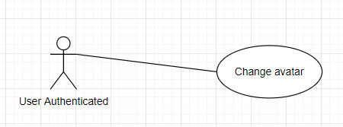

Figure 16 Use case change avatar

|  |  |  |  |
| --- | --- | --- | --- |
| USE CASE – 2.1 | | | |
| Use Case No. | UC_2.1 | Use Case Version | 1.0 |
| Use Case Name | Change avatar | | |
| Author | Nguyen Van Thang | | |
| Date | 01/01/2022 | Priority | Low |
| Actor:   * Admin, User   Summary:   * Allow users to change avatar   Goal:   * The avatar changed   Triggers:   * Submit a request to change the avatar to the website   Preconditions:   * Users want to change their avatars.   Postconditions:   * Success: Display successful change avatar message * Fail: Error message display   Main Success Scenario:   |  |  |  | | --- | --- | --- | | Step | Actor Action | System Response | | 1 | Users click to profile manage. | The system will redirect the user to the profile management page. | | 2 | User hover to the avatar | The system shows an icon change avatar. | | 3 | User selects the image he wants to change | The system shows a popup confirm change avatar | | 4 | User press button yes | The system shows a success message. |   Business Rules:   * User must sign in with permissions admin or user * Can change avatar | | | |
|  | | | |

Table 14 Use case change avatar

**Change password**

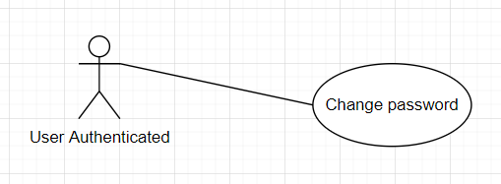

Figure 17 Use case change password

|  |  |  |  |
| --- | --- | --- | --- |
| USE CASE – 2.2 | | | |
| Use Case No. | UC_2.2 | Use Case Version | 1.0 |
| Use Case Name | Change password | | |
| Author | Nguyen Van Thang | | |
| Date | 01/01/2022 | Priority | Low |
| Actor:   * Admin, User   Summary:   * Allow users to change password   Goal:   * The password changed   Triggers:   * Submit a request to change the password to the website   Preconditions:   * The user wants to change the password   Postconditions:   * Success: Display successful change password message * Fail: Error message display   Main Success Scenario:   |  |  |  | | --- | --- | --- | | Step | Actor Action | System Response | | 1 | Users click to profile manage. | The system will redirect the user to the profile management page. | | 2 | User clicks to tab change password. | The system displays the fields to enter to change the password. | | 3 | The user fills all the fields and presses the button Save. | The system shows a success message. |   Exceptions:   |  |  |  | | --- | --- | --- | | Step | Actor Action | System Response | | 1 | User leaves required fields blank | The system displays a message asking for information. |   Business Rules:   * Users must sign in with permissions admin or user. * Can change password. | | | |
|  | | | |

Table 15 Use case change password

**Edit profile**

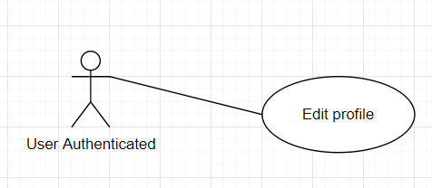

Figure 18 Use case edit document

|  |  |  |  |
| --- | --- | --- | --- |
| USE CASE – 2.3 | | | |
| Use Case No. | UC_2.3 | Use Case Version | 1.0 |
| Use Case Name | Edit profile | | |
| Author | Nguyen Van Thang | | |
| Date | 01/01/2022 | Priority | Low |
| Actor:   * Admin, User   Summary:   * Allow users to change personal information   Goal:   * The information changed   Triggers:   * Submit a request to change profile to the website   Preconditions:   * The user wants to change personal information   Postconditions:   * Success: Display successful change info message * Fail: Error message display   Main Success Scenario:   |  |  |  | | --- | --- | --- | | Step | Actor Action | System Response | | 1 | Users click to profile manage. | The system will redirect the user to the profile management page. | | 2 | User fills all the fields they want to change and press save. | The system shows a change success message. |   Exceptions:   |  |  |  | | --- | --- | --- | | Step | Actor Action | System Response | | 1 | User leaves required fields blank | The system displays a message asking for information. |   Business Rules:   * Users must sign in with permissions admin or user * Can change profile | | | |
|  | | | |

Table 16 Use case edit profile

**Logout**

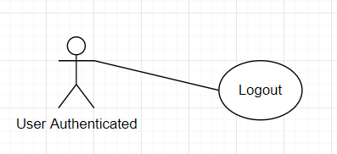

Figure 19 Use case logout

|  |  |  |  |
| --- | --- | --- | --- |
| USE CASE – 2.4 | | | |
| Use Case No. | UC_2.4 | Use Case Version | 1.0 |
| Use Case Name | Logout | | |
| Author | Nguyen Van Thang | | |
| Date | 01/01/2022 | Priority | Low |
| Actor:   * User   Summary:   * Allow users to log out of the system   Goal:   * Users can log out after they have finished their work.   Triggers:   * Redirect to the main sign-in screen.   Preconditions:   * Users must sign in to the system.   Postconditions:   * Success: The user will be redirected to the sign-in screen.   Main Success Scenario:   |  |  |  | | --- | --- | --- | | Step | Actor Action | System Response | | 1 | User tap on avatar user choose Log out | The system will redirect the user to the sign-in page and delete the token |   Business Rules:   * The user who is not signed in to the app. | | | |

Table 17 Use case logout

* 1. **Non-functional requirements**

### **Usability**

Users of the system can use the functions easily.

The system is organized in such a way that there is minimal user error.

Non-Functional Requirements is testable:

Training can use all system functions competently after being trained after 1 hour. After training time, the average number of errors generated by experienced users should not exceed 2 errors per hour of using the system.

### **Reliability**

Security: Each user will have an account to authenticate into the system with different permissions.

For example, A manager can create new accounts and assign permissions to them.

Average time to repair the system when there is an error: Non-Functional Requirements allow the system to stop working within 12 hours of the failure.

System error: The system must be checked regularly. If there is an error, it must be a minor error that does not affect the system and must be fixed within the day

### **Performance**

The maximum response time for action is 15 seconds

The number of transactions at the same time is enough for a moderate company to use

### **Supportability**

Easy to fix errors: Average system failure detection 30 minutes.

Ease of maintenance: Add new functions quickly without affecting existing functions.

### **Design Constraints**

The system is written in spring boot

A database designed on PostgreSQL

* + 1. **Purchased Components**

Frontend: NextJS - Visual Studio Code

Backend: Spring boot – IntelliJ IDEA

### **Interfaces**

The interface must be clear, clear, easy to see, easy to use so that users can clearly understand its operation, minimizing unnecessary errors that affect the user experience.

The user cannot modify the structure of the system such as database, code, or interface. Below is the interface of the software

* 1. **APIs requirement specification**
     1. **Sign up – POST method**

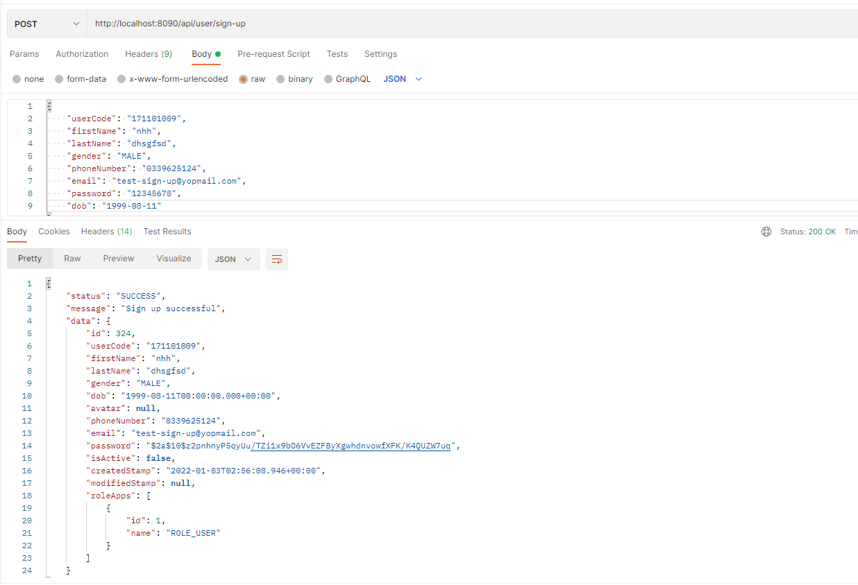

Figure 20 API signup

|  |  |  |  |  |
| --- | --- | --- | --- | --- |
| Route | Method | Request JSON | Response JSON | Usage |
| /api/user/sign-up | POST | - userCode: String  - firstName: String  - lastName: String  - gender: String  - dob: String  - phoneNumber: String  - email: String  - password: String | Return response data | Create a new user in the system |

Table 18 Description for API signup

* + 1. **Sign in – POST method**

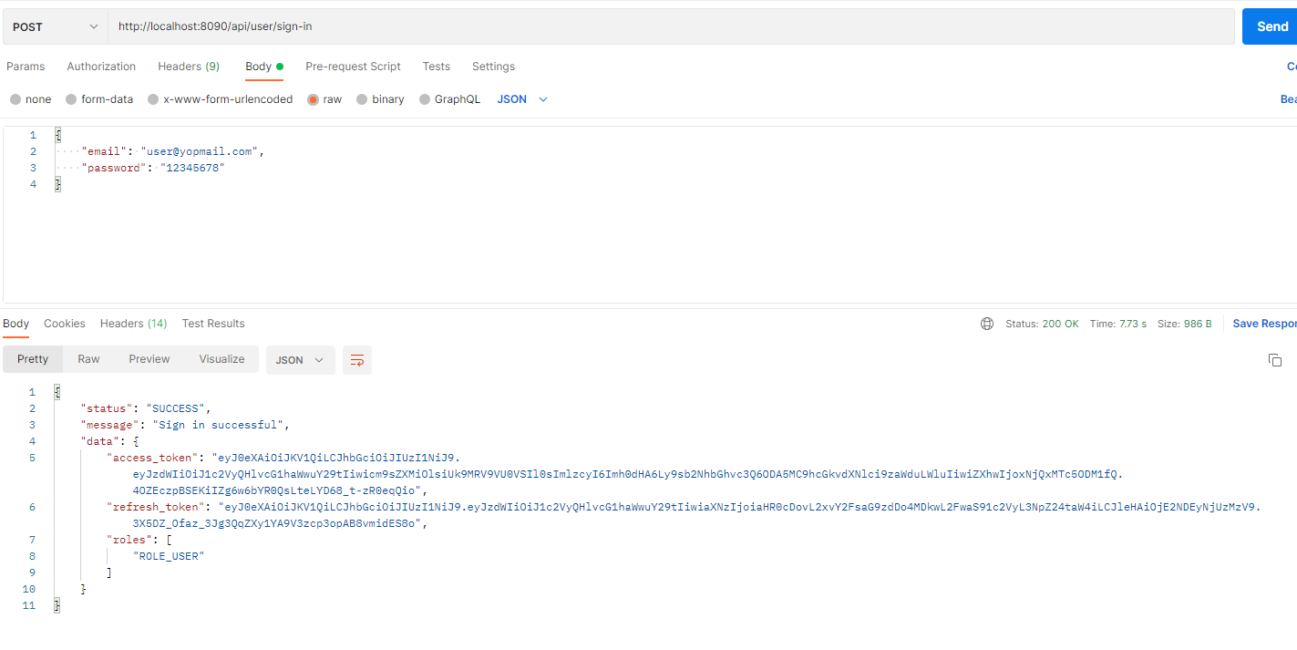

Figure 21 API sign in

|  |  |  |  |  |
| --- | --- | --- | --- | --- |
| Route | Method | Request JSON | Response JSON | Usage |
| /api/user/sign-in | POST | - email: String  - password: String | Return response data | Authenticated in the system |

Table 19 Description for API sign in

* + 1. **Forgot password – POST method**

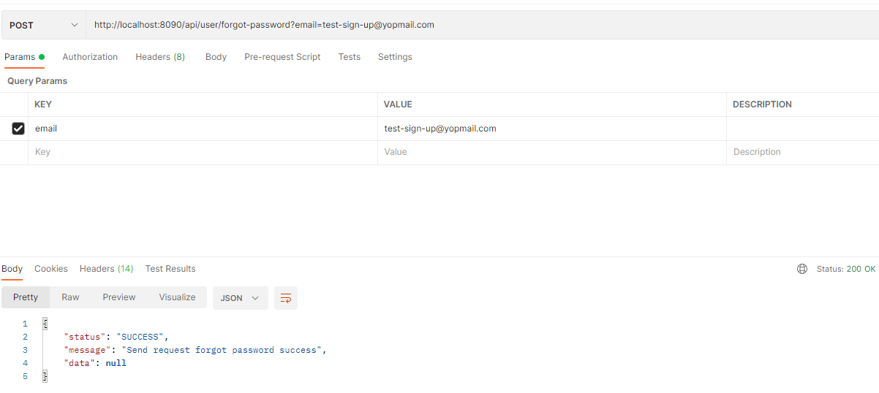

Figure 22 API forgot password

|  |  |  |  |  |
| --- | --- | --- | --- | --- |
| Route | Method | Request JSON | Response JSON | Usage |
| /api/user/forgot-password?email={email} | POST | - email: String | Return response data | Send email to reset password |

Table 20 Description for API forgot password

* + 1. **Reset password – PATCH method**

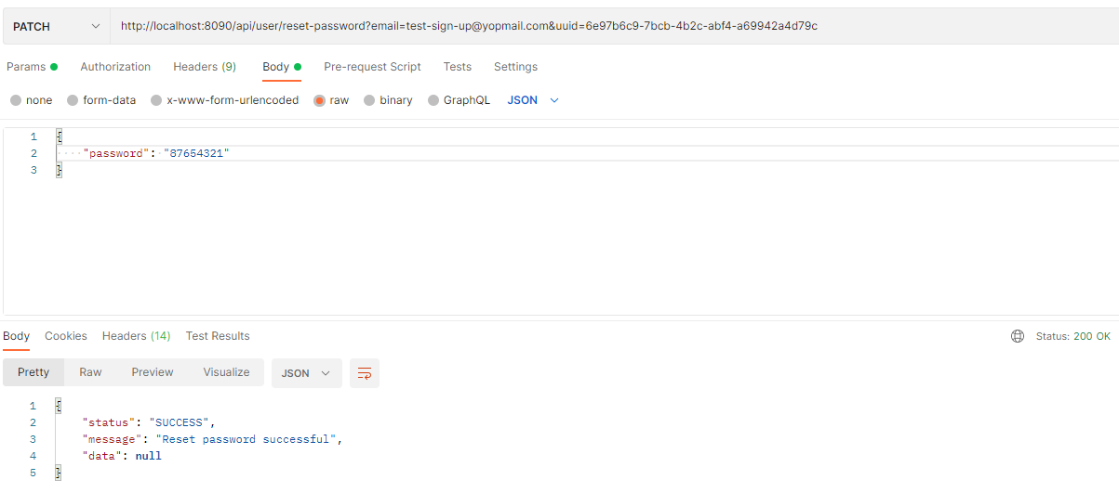

Figure 23 API reset password

|  |  |  |  |  |
| --- | --- | --- | --- | --- |
| Route | Method | Request JSON | Response JSON | Usage |
| /api/user/reset-password?email={email}&uuid={uuid} | PATCH | - email: String  - uuid: String | Return response data | Reset password for user |

Table 21 Description for API reset password

* + 1. **Resend email reset password – GET method**

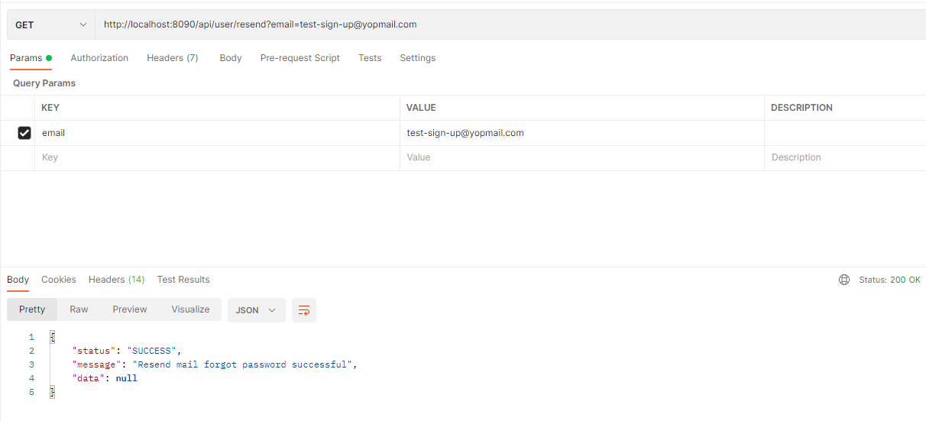

Figure 24 API resend the email to reset the password

|  |  |  |  |  |
| --- | --- | --- | --- | --- |
| Route | Method | Request JSON | Response JSON | Usage |
| /api/user/resend?email={email } | GET | - email: String | Return response data | Resend email to reset password |

Table 22 Description for API resend the email to reset password

* + 1. **Refresh token – POST method**

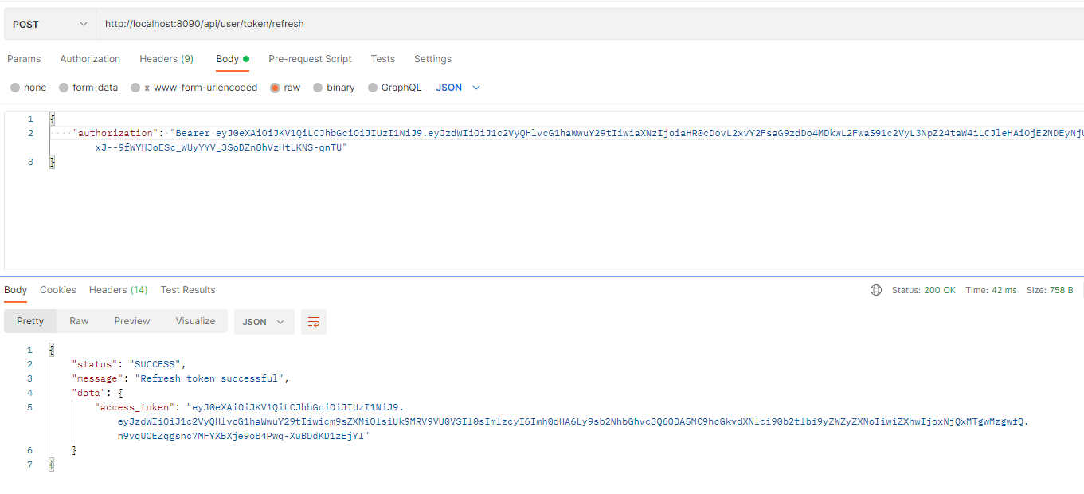

Figure 25 API refresh token

|  |  |  |  |  |
| --- | --- | --- | --- | --- |
| Route | Method | Request JSON | Response JSON | Usage |
| /api/user/token/refresh | POST | - authorization: String | Return response data | Generate a new access token |

Table 23 Description for an API refresh token

* + 1. **Change password – PATCH method**

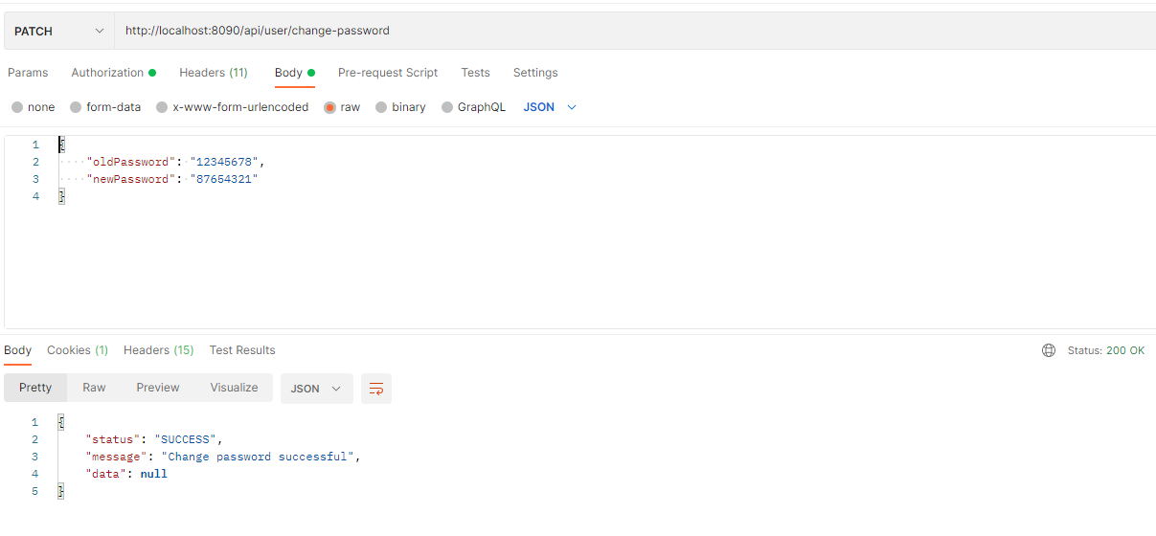

Figure 26 API change password

|  |  |  |  |  |
| --- | --- | --- | --- | --- |
| Route | Method | Request JSON | Response JSON | Usage |
| /api/user/token/change-password | PATCH | - oldPassword: String  - newPassword: String | Return response data | Change the password of the user |

Table 24 Description for API change password

* + 1. **Get info of current user – GET method**

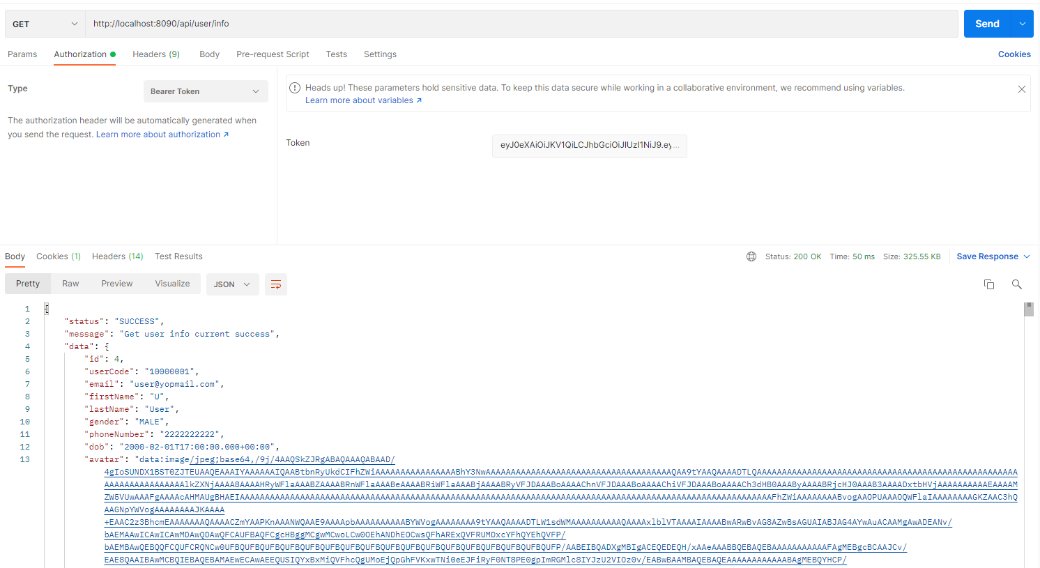

Figure 27 API get info of the current user

|  |  |  |  |  |
| --- | --- | --- | --- | --- |
| Route | Method | Request JSON | Response JSON | Usage |
| /api/user/info | GET |  | Return response data | Get information of the current user |

Table 25 Description for API get info of the current user

* + 1. **Active account – PATCH method**

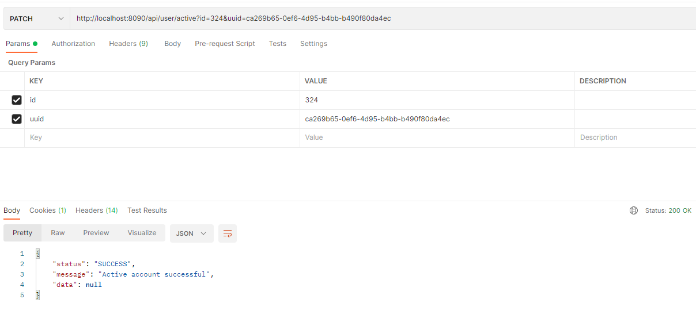

Figure 28 API active account

|  |  |  |  |  |
| --- | --- | --- | --- | --- |
| Route | Method | Request JSON | Response JSON | Usage |
| /api/user/active | PATCH | * Id: String * Uuid: String | Return response data | Get information of the current user |

Table 26 Description for API active account

* + 1. **Update info of current user – PATCH method**

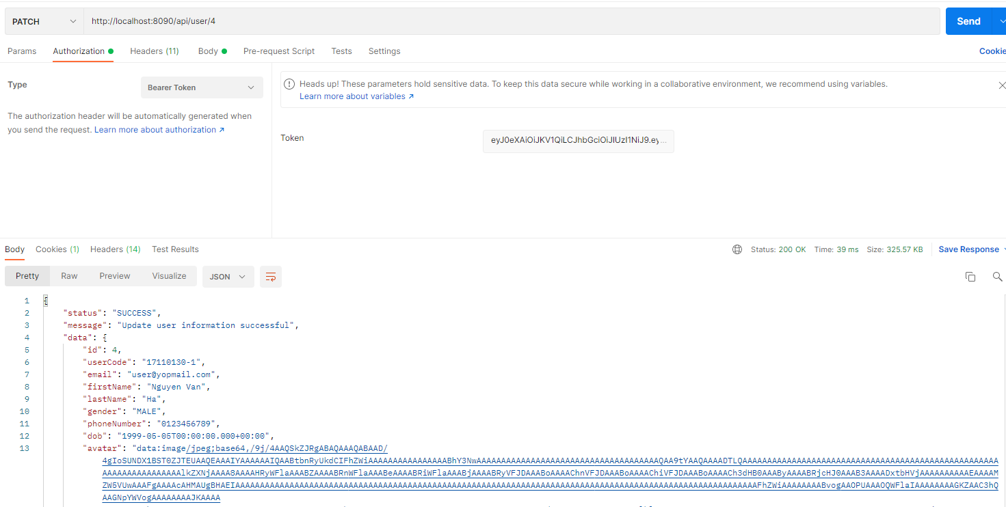

Figure 29 API update info of the current user

|  |  |  |  |  |
| --- | --- | --- | --- | --- |
| Route | Method | Request JSON | Response JSON | Usage |
| /api/user/{id} | PATCH | * Id: String * firstName: String * lastName: String * userCode: String * gender: String * dob: String * phoneNumber: String | Return response data | Update information of the current user |

Table 27 Description for API update info of the current user

* + 1. **Change avatar – POST method**

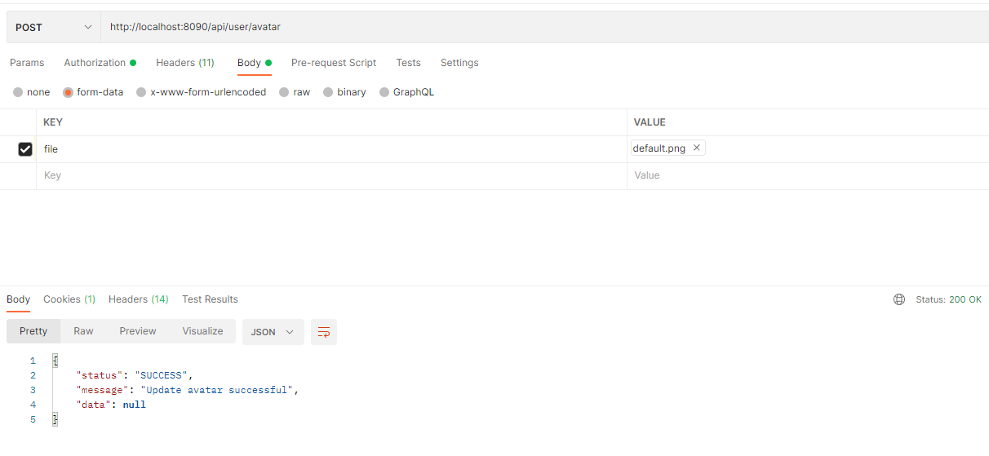

Figure 30 API change avatar

|  |  |  |  |  |
| --- | --- | --- | --- | --- |
| Route | Method | Request JSON | Response JSON | Usage |
| /api/user/avatar | POST | * File: MultipartFile | Return response data | Change avatar of the user |

Table 28 Description for API change avatar

* + 1. **Lock user – PATCH method**

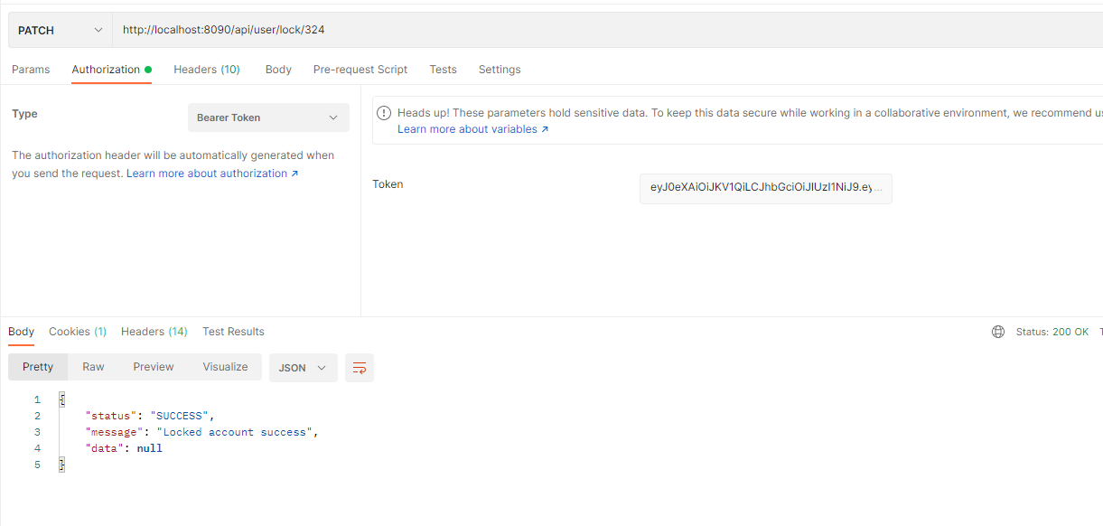

Figure 31 API lock user

|  |  |  |  |  |
| --- | --- | --- | --- | --- |
| Route | Method | Request JSON | Response JSON | Usage |
| /api/user/lock/{id} | PATCH | * Id: String | Return response data | Admin wants to lock the user in the system |

Table 29 Description for API lock user

* + 1. **Get info of dashboard – GET method**

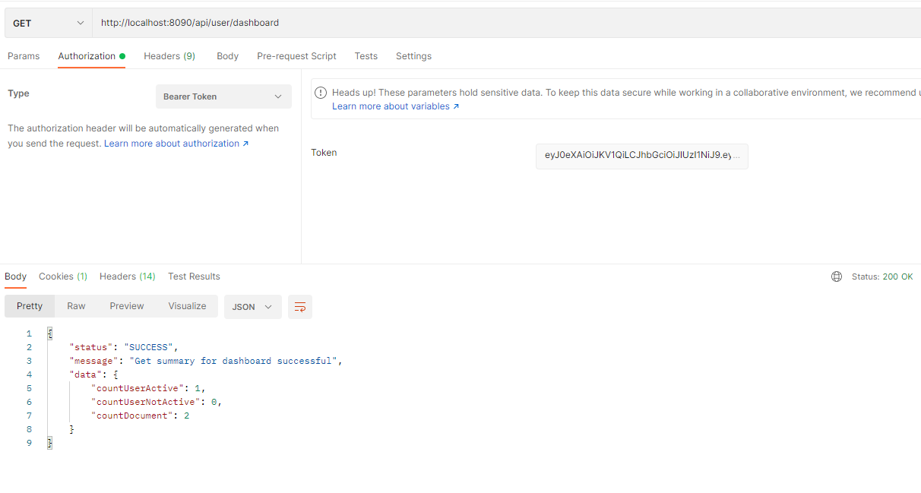

Figure 32 API get info of dashboard

|  |  |  |  |  |
| --- | --- | --- | --- | --- |
| Route | Method | Request JSON | Response JSON | Usage |
| /api/user/dashboard | GET |  | Return response data | Admin wants to get information to show on dashboard |

Table 30 Description for API get info of dashboard

* + 1. **Log out – GET method**

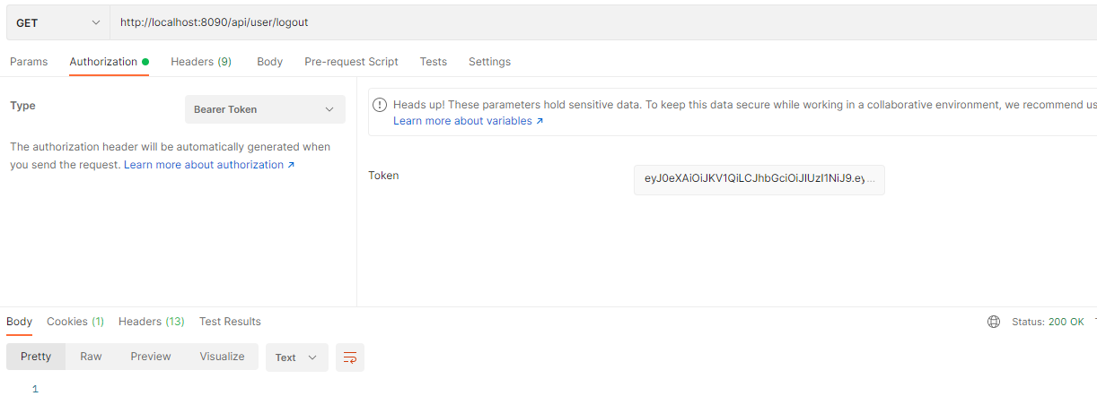

Figure 33 API log out

|  |  |  |  |  |
| --- | --- | --- | --- | --- |
| Route | Method | Request JSON | Response JSON | Usage |
| /api/user/logout | GET |  | Return response data | Users want to log out of the system |

Table 31 Description for API logout

* + 1. **Get documents of user – GET method**

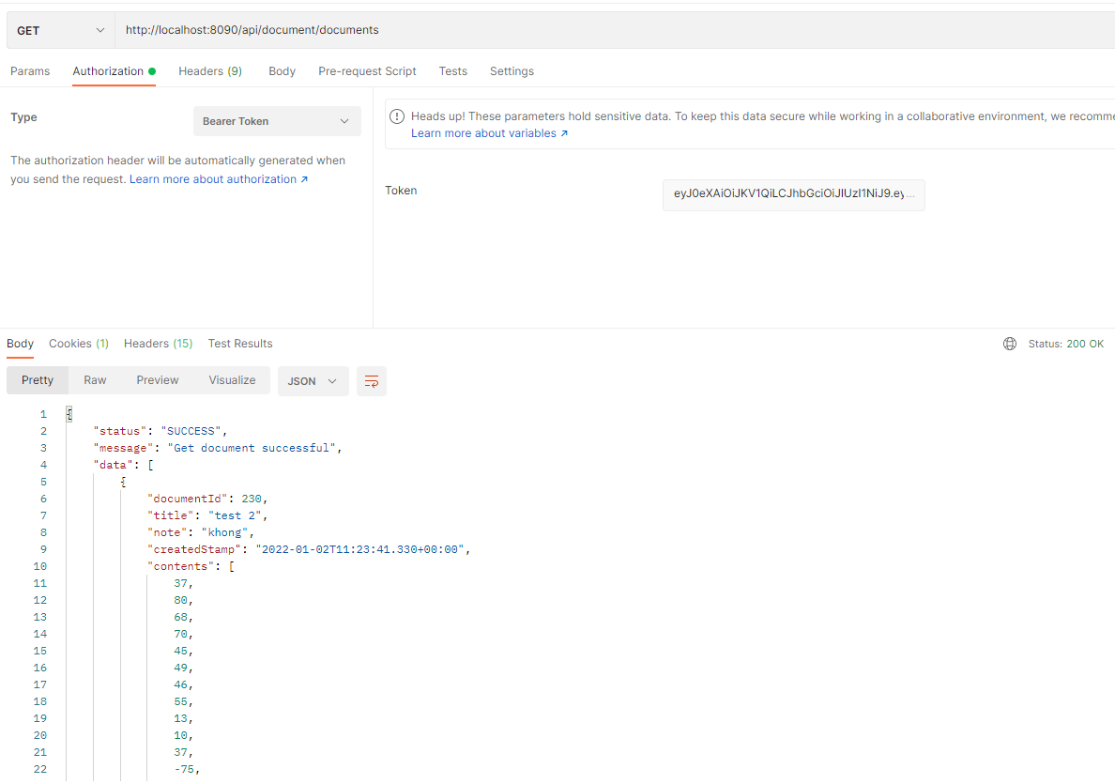

Figure 34 API get a document of user

|  |  |  |  |  |
| --- | --- | --- | --- | --- |
| Route | Method | Request JSON | Response JSON | Usage |
| /api/document/documents | GET |  | Return response data | Users want to get all document |

Table 32 Description for API get a document of user

* + 1. **Upload document – POST method**

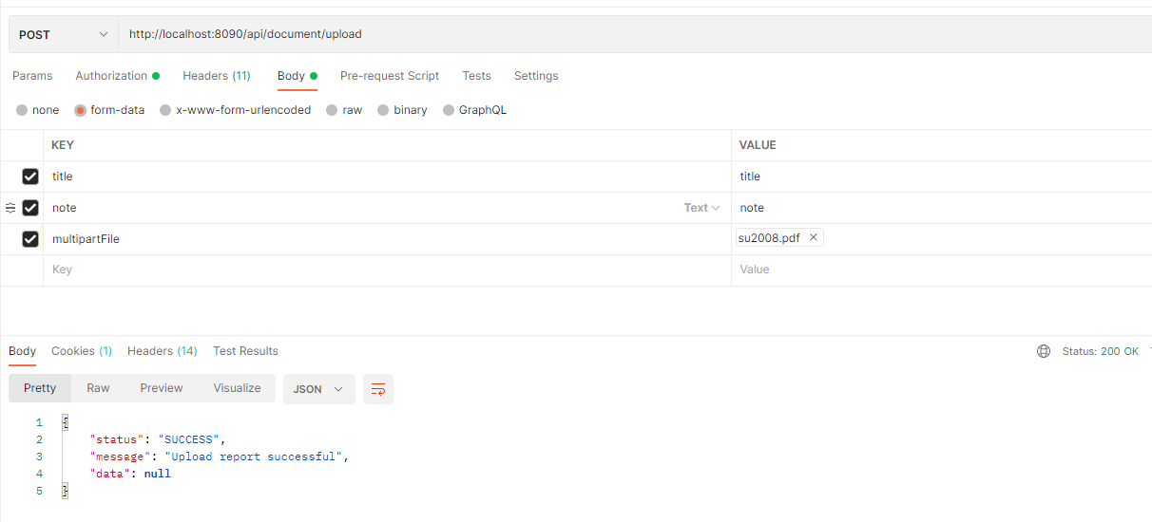

Figure 35 API upload document

|  |  |  |  |  |
| --- | --- | --- | --- | --- |
| Route | Method | Request JSON | Response JSON | Usage |
| /api/document/upload | POST | * title: String * note: String * multipartFile: MultipartFile | Return response data | Users want to upload a document |

Table 33 Description for API upload document

* + 1. **Update document – PATCH method**

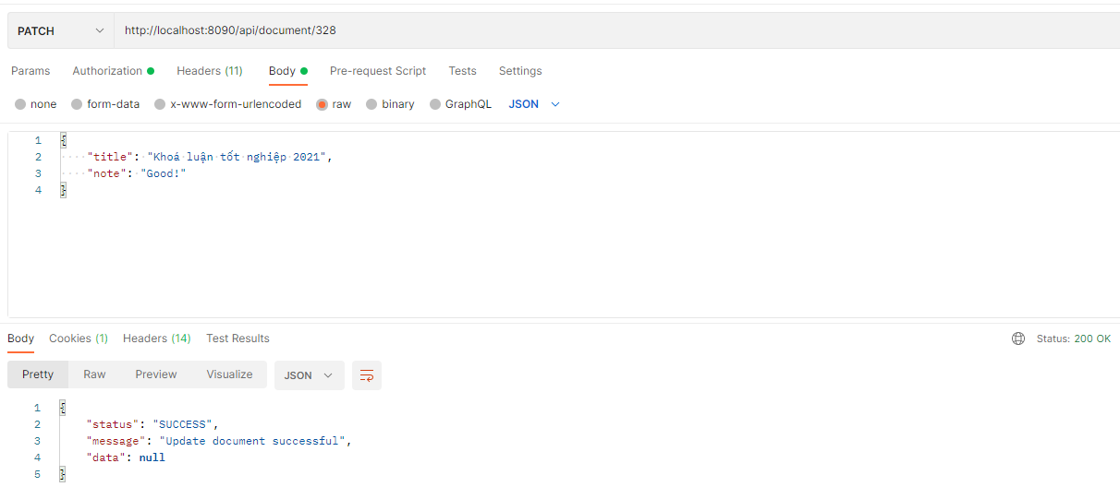

Figure 36 API update document

|  |  |  |  |  |
| --- | --- | --- | --- | --- |
| Route | Method | Request JSON | Response JSON | Usage |
| /api/document/{id} | PATCH | * Id: String | Return response data | Users want to update the document |

Table 34 Description for API update document

* + 1. **Delete document – DELETE method**

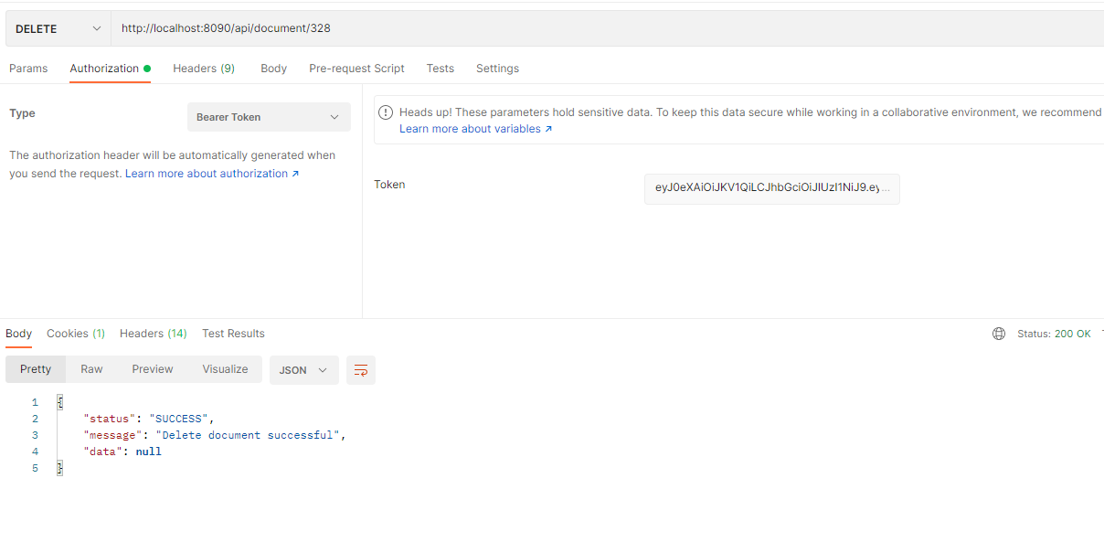

Figure 37 API delete document

|  |  |  |  |  |
| --- | --- | --- | --- | --- |
| Route | Method | Request JSON | Response JSON | Usage |
| /api/document/{id} | DELETE | * Id: String | Return response data | The user wants to delete a document |

Table 35 Description for API delete document

* + 1. **Manage document – GET method**

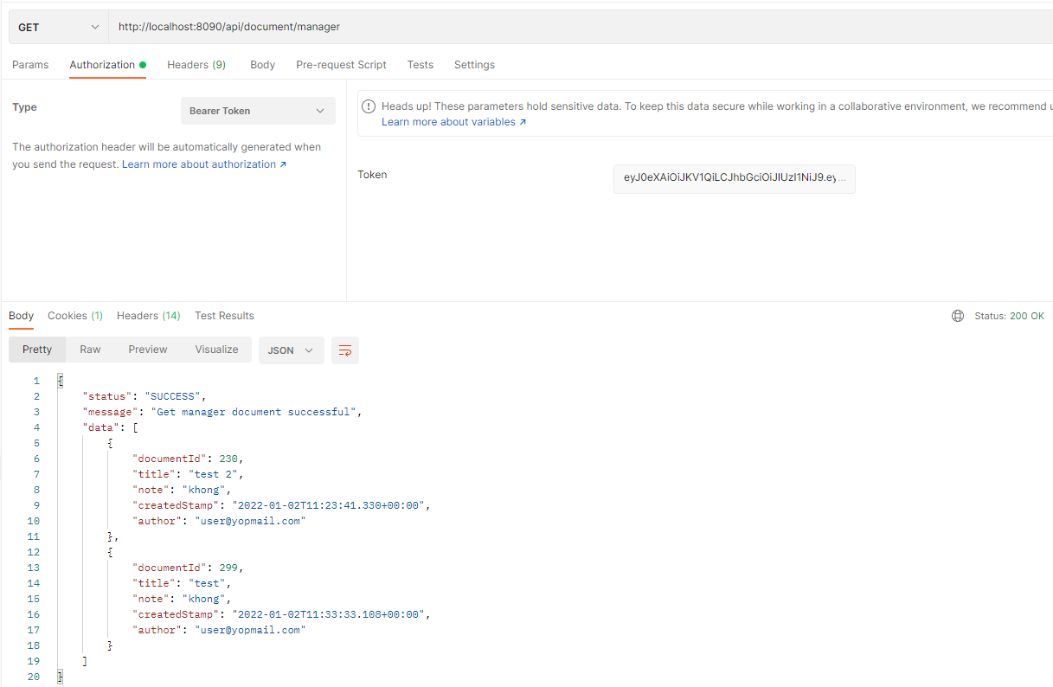

Figure 38 API manage document

|  |  |  |  |  |
| --- | --- | --- | --- | --- |
| Route | Method | Request JSON | Response JSON | Usage |
| /api/document/manager | GET |  | Return response data | Admin wants to get all documents in the system |

Table 36 Description for API manage document

# CHAPTER 3: SYSTEM DESIGN

* 1. **System Architecture**

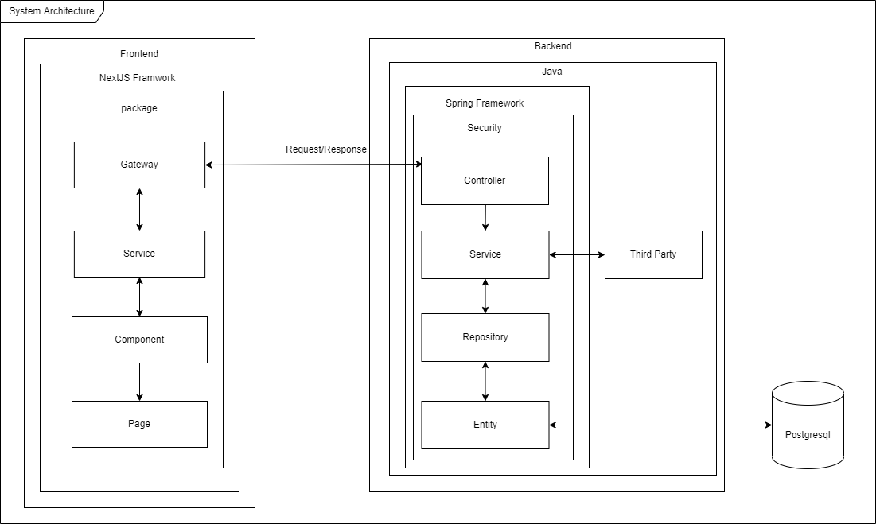

Figure 39 System Architecture

* 1. **ERD**

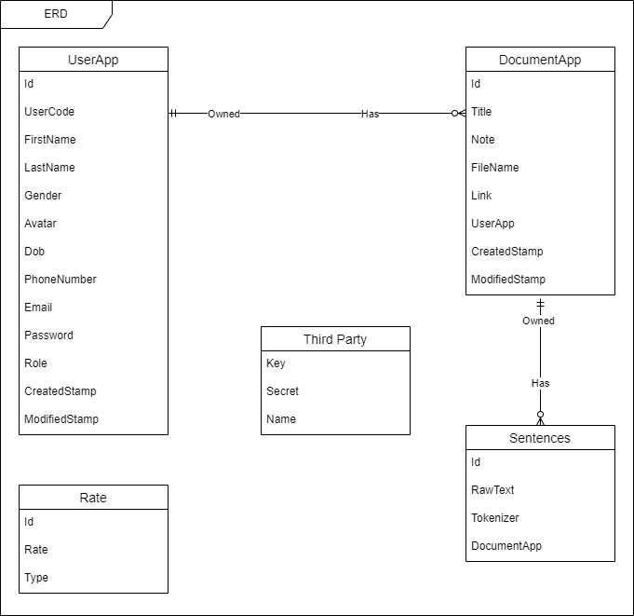

Figure 40 ERD

* 1. **Logical Database Diagram**

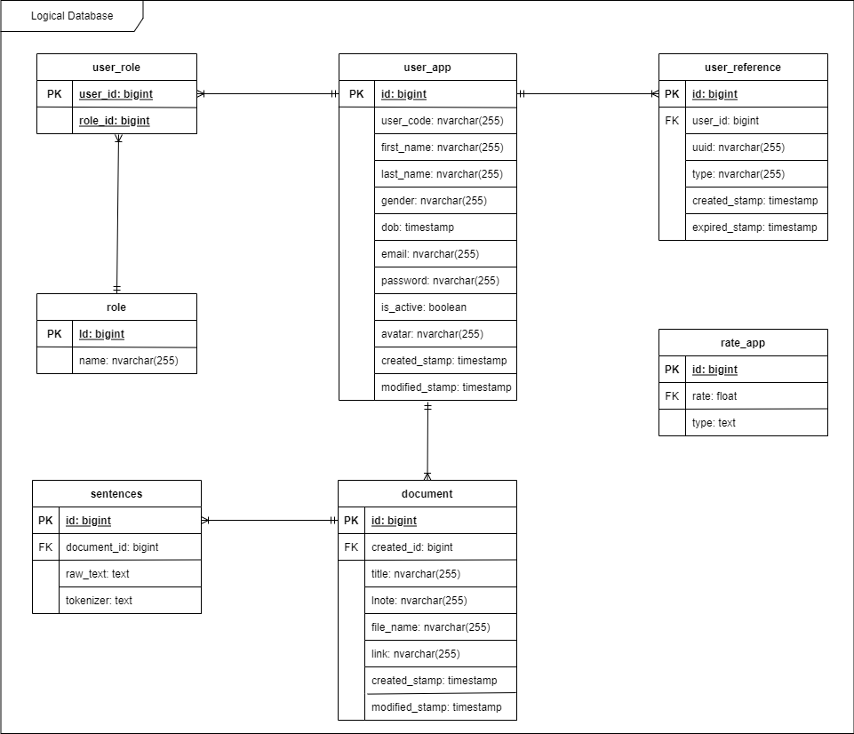

Figure 41 Logical Database Diagram

* 1. **Sequence Diagram**
     1. **Upload Document**

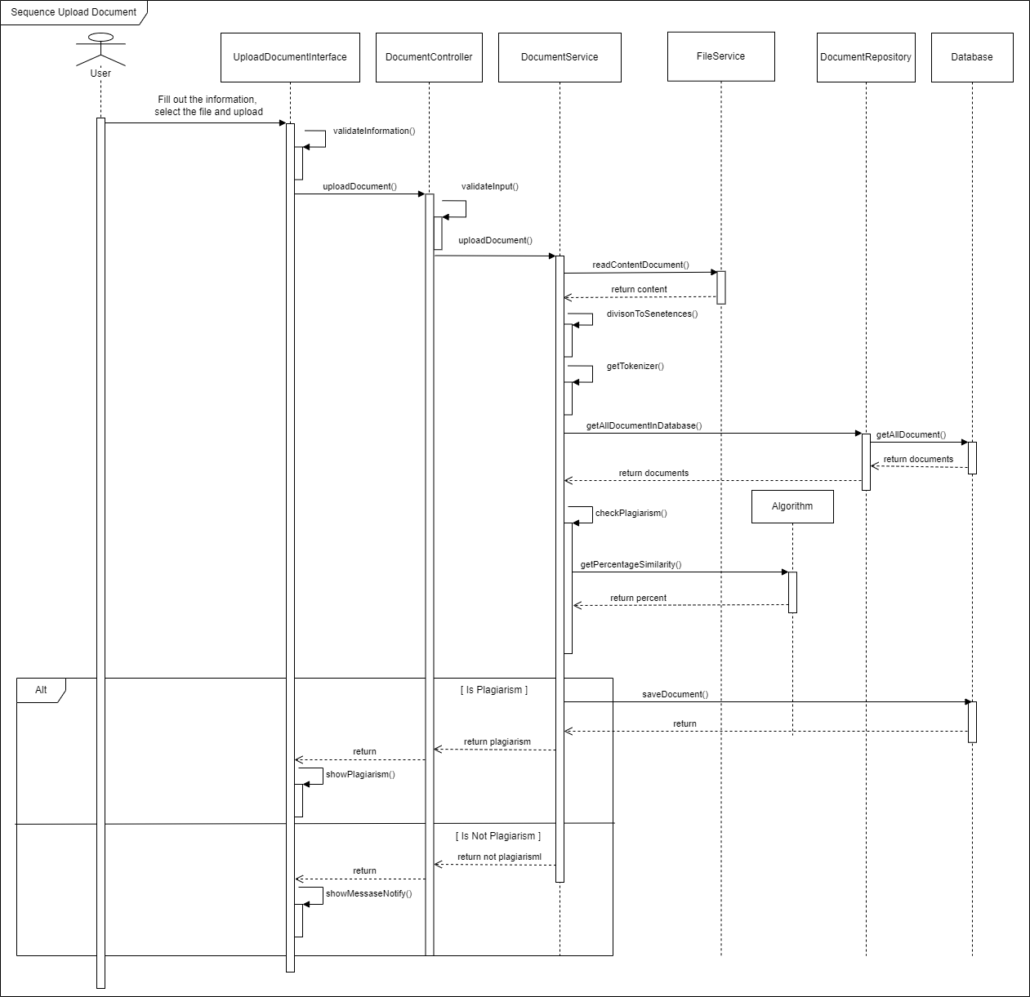

Figure 42 Sequence Diagram upload documents

* + 1. **Delete Document**

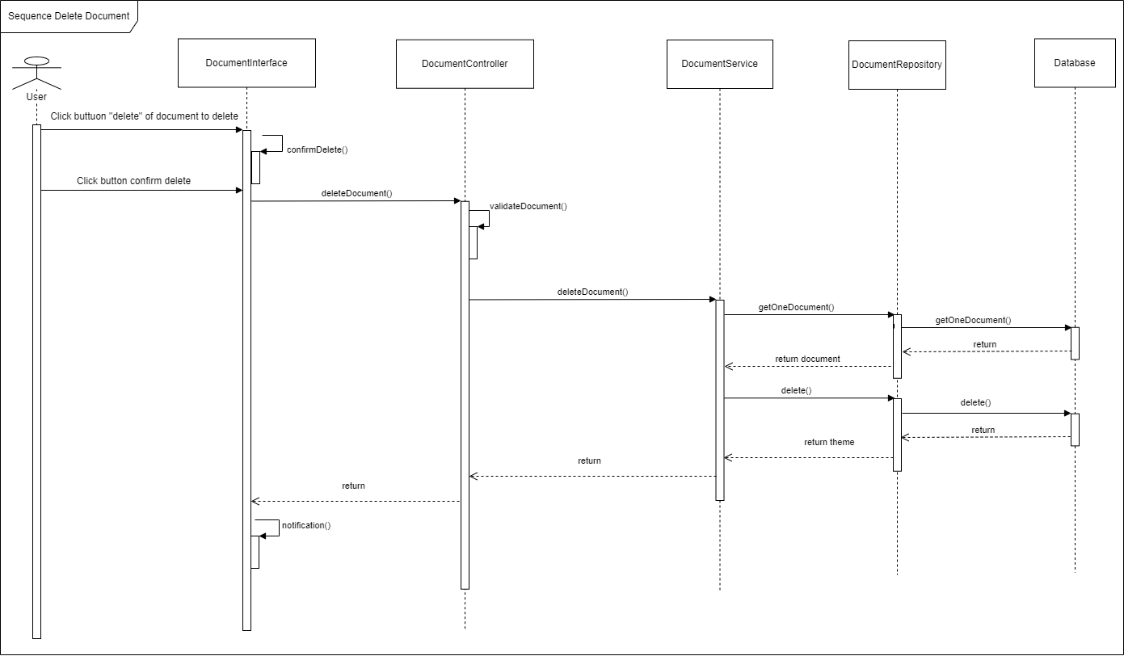

Figure 43 Sequence Diagram delete a document

* + 1. **Sign in**

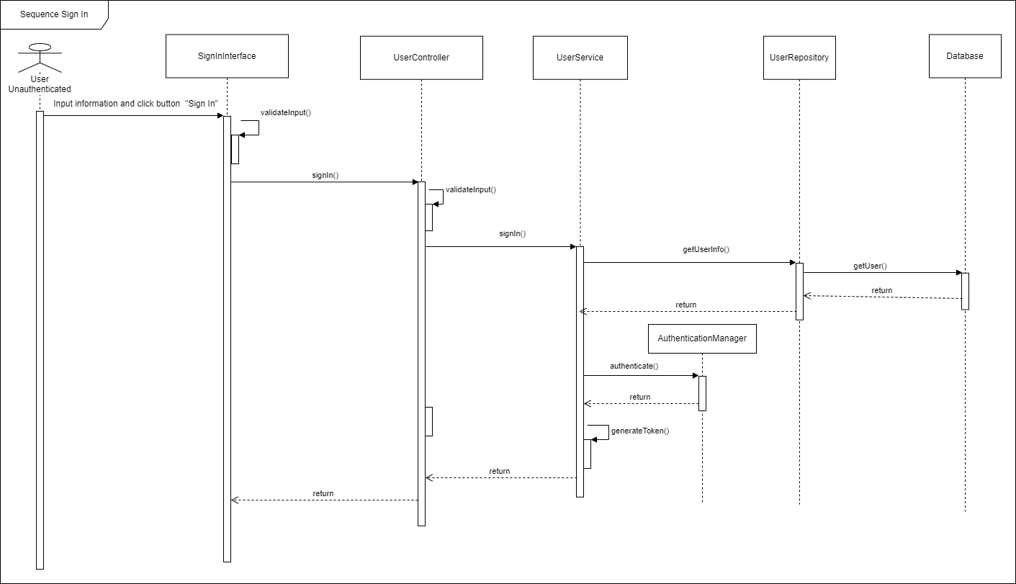

Figure 44 Sequence Diagram sign in

* 1. **Activity Diagram**
     1. **Sign in**

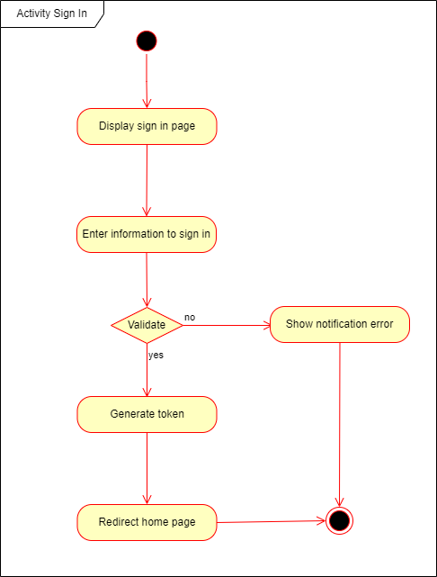

Figure 45 Activity Diagram sign in

* + 1. **Upload Document**

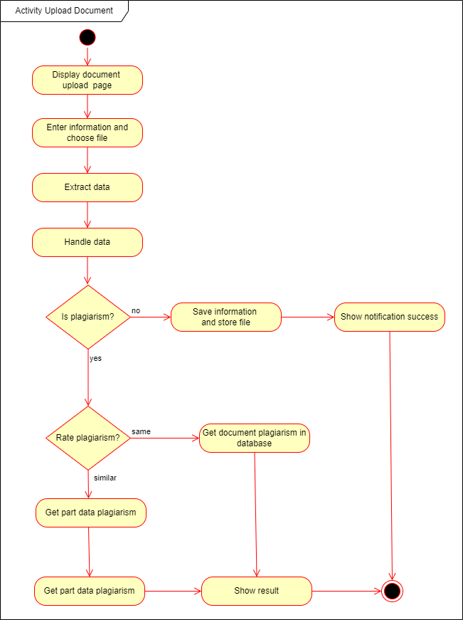

Figure 46 Activity Diagram upload document

* 1. **Class Diagram**

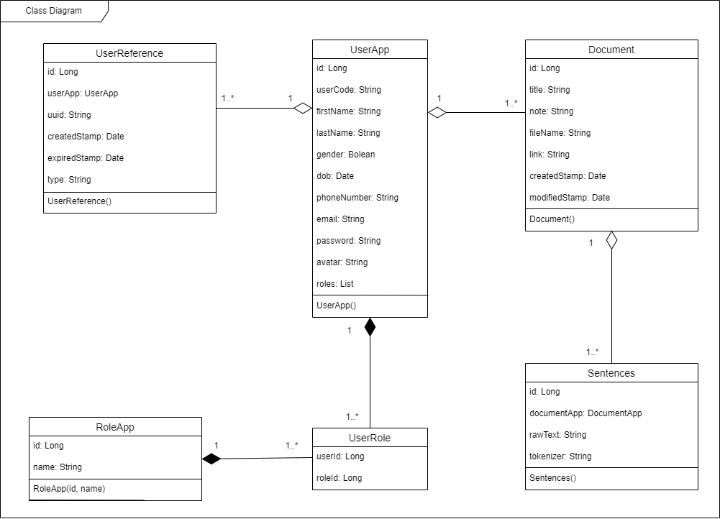

Figure 47 Class Diagram

* 1. **User interfaces design**
     1. **Sign in**

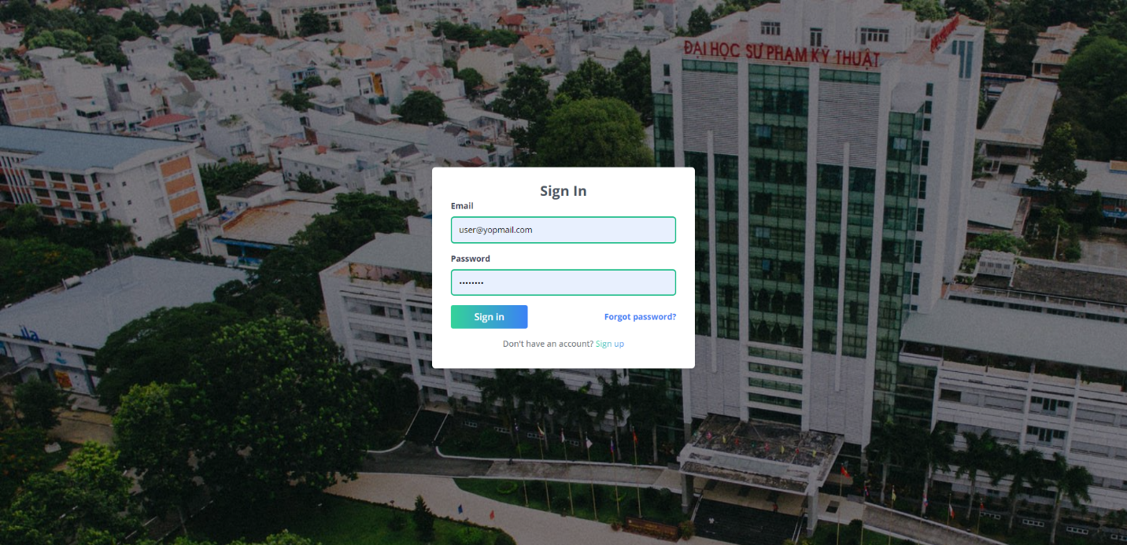

5

3

4

2

1

Figure 48 User interface sign in

|  |  |  |  |  |
| --- | --- | --- | --- | --- |
| No | Object name | Format | Action | Note |
| 1 | Text field's email | Text field |  | A place to input email |
| 2 | Text field's password | Text field |  | A place to input a password |
| 3 | Button Sign in | Button | Authenticate  to access the  website |  |
| 4 | Link forgot password | Link | Redirect to forgot password page |  |
| 5 | Link sign up | Link | Redirect to sign up page |  |

Table 37 Description for user interface sign in

* + 1. **Signup**

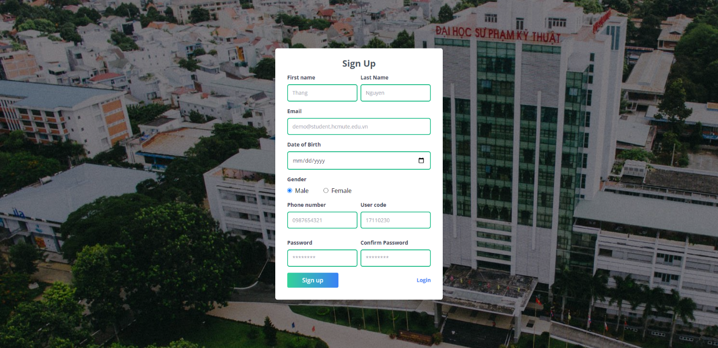

11

10

5

4

3

1

9

8

7

6

2

Figure 49 User interfaces signup

|  |  |  |  |  |
| --- | --- | --- | --- | --- |
| No | Object name | Format | Action | Note |
| 1 | Text field’s First Name | Text field |  | A place to input first name |
| 2 | Text field's Last name | Text field |  | A place to input last Name |
| 3 | Text field's email | Text field |  | A place to input email |
| 4 | Date fields dob | Date field |  | A place to input dob |
| 5 | Radio field's gender | Radio field |  | A place to input gender |
| 6 | Text field's phone Number | Text field |  | A place to input phone Number |
| 7 | Text field's user code | Text field |  | A place to input user Code |
| 8 | Text field's password | Text field |  | A place to input a password |
| 9 | Text fields confirm password | Text field |  | A place to input confirm password |
| 10 | Button signup | Button | Sign up account  to the  website |  |
| 11 | Link sign in | Link | Redirect to sign-in page |  |

Table 38 Description for interfaces signup

* + 1. **Forgot password**

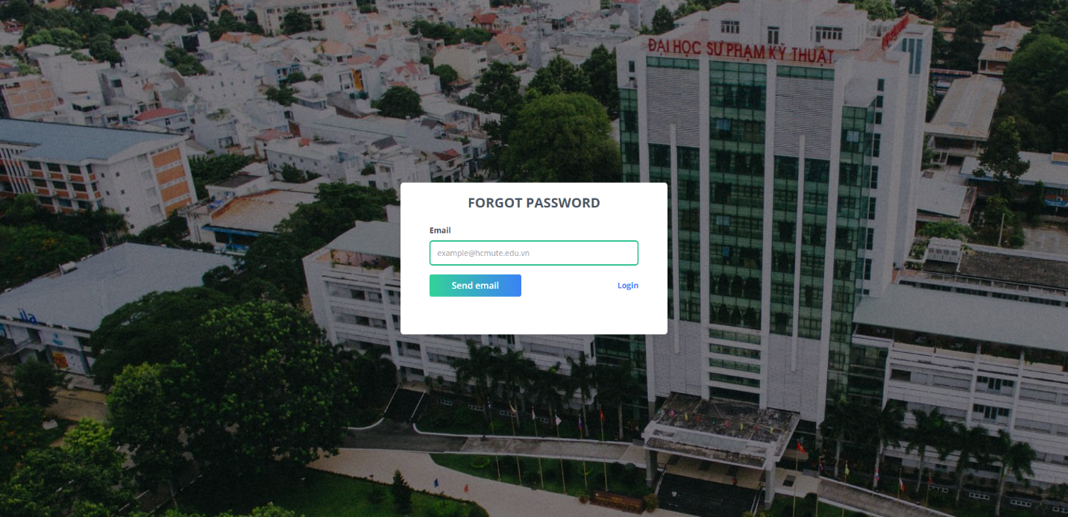

2

3

1

Figure 50 User interfaces forgot password

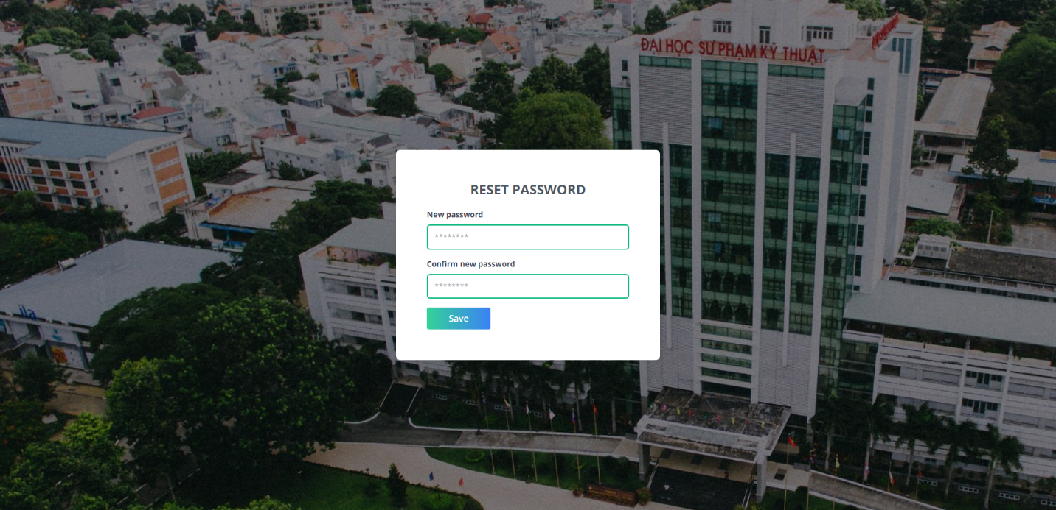

6

5

4

Figure 51 User interfaces reset password

|  |  |  |  |  |
| --- | --- | --- | --- | --- |
| No | Object name | Format | Action | Note |
| 1 | Text field email | Text field |  | A place to input email |
| 2 | Button send mail | Button | Send email reset |  |
| 3 | Link sign in | Link | Redirect to sign-in page |  |
| 4 | Text field new password | Text field |  | A place to input a new password |
| 5 | Text field confirm password | Text field |  | A place to input confirm password |
| 6 | Button save | Button | Reset password |  |

Table 39 Description for interfaces reset password

* + 1. **Documents page**

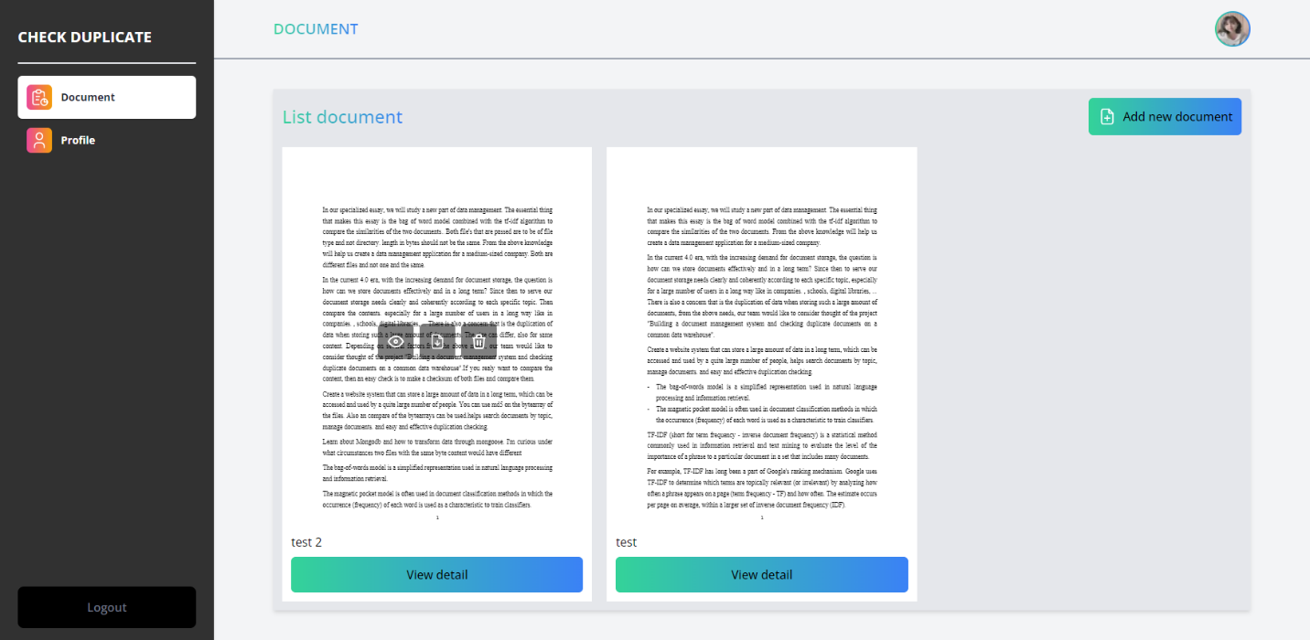

8

7

6

5

2

4

3

1

Figure 52 User interfaces documents

|  |  |  |  |  |
| --- | --- | --- | --- | --- |
| No | Object name | Format | Action | Note |
| 1 | Button add a new document | Button | Show popup add a new document |  |
| 2 | Button view document | Button | Redirect to preview file |  |
| 3 | Button download document | Button | Download file |  |
| 4 | Button delete document | Button | Show confirmation delete a document |  |
| 5 | Label title | Label |  | Title document |
| 6 | Button view detail | Button | View detail document |  |
| 7 | Tab profile | Tab | Page profile |  |
| 8 | Button logout | Button | Logout account |  |

Table 40 Description for interfaces documents

* + 1. **Upload document**

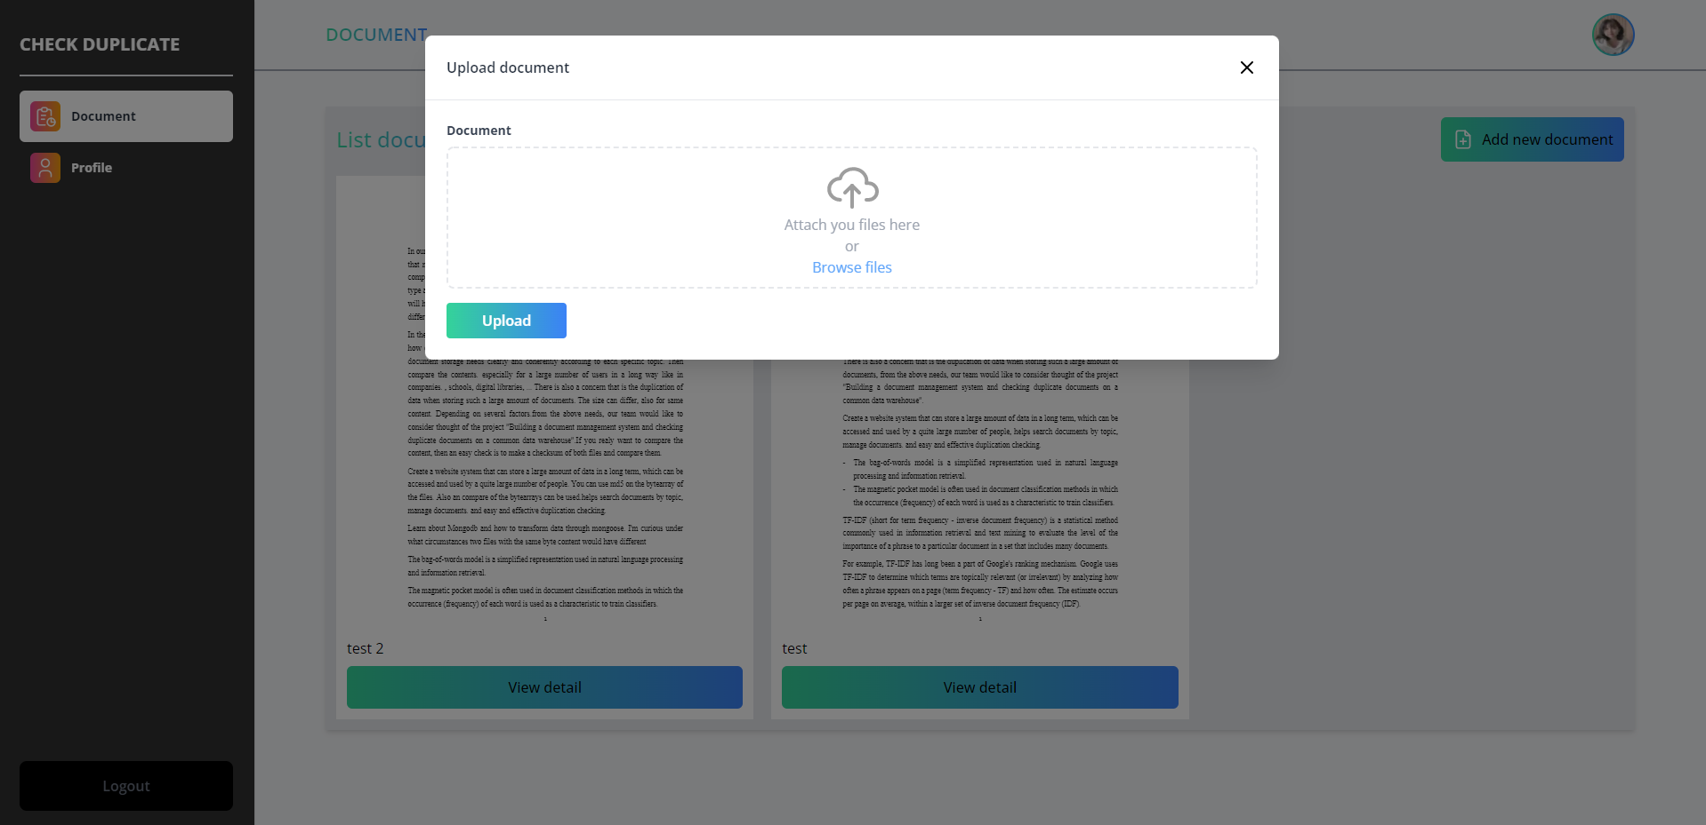

2

1

Figure 53 User interfaces upload document-1

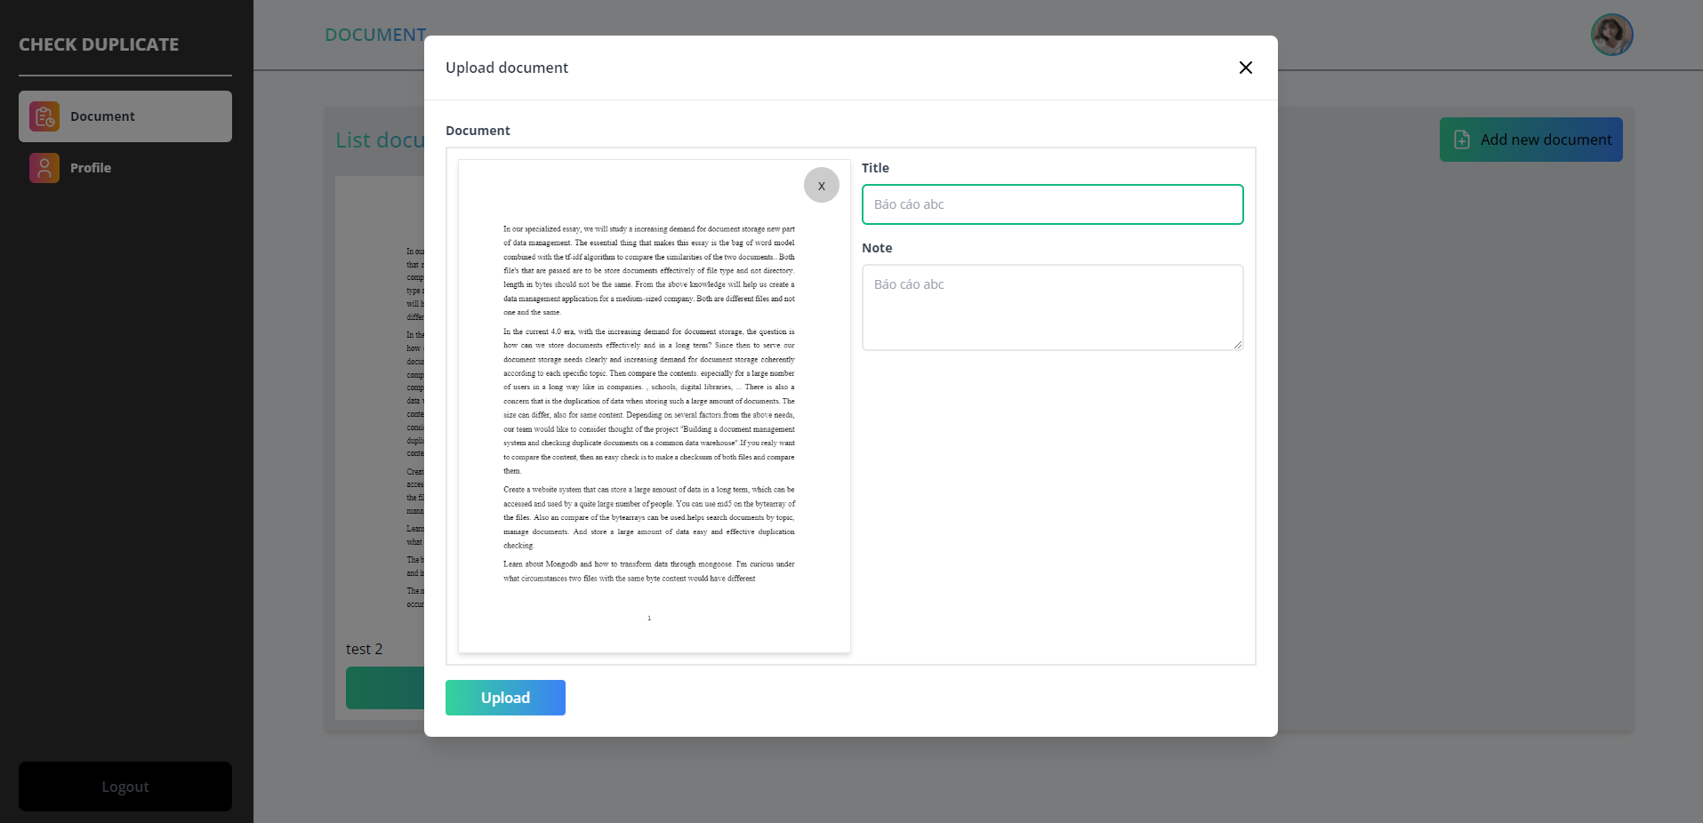

6

5

4

3

Figure 54 User interfaces upload document-2

|  |  |  |  |  |
| --- | --- | --- | --- | --- |
| No | Object name | Format | Action | Note |
| 1 | Input file | Input field |  | A place to input file document |
| 2 | Button close | Button | Close popup |  |
| 3 | Button delete | Button | Delete selected file |  |
| 4 | Text field title document | Text field |  | A place to input title document |
| 5 | Text field note document | Text field |  | A place to input note document |
| 6 | Button upload | Button | Upload document |  |

Table 41 Description for user interfaces upload a document

* + 1. **Profile**

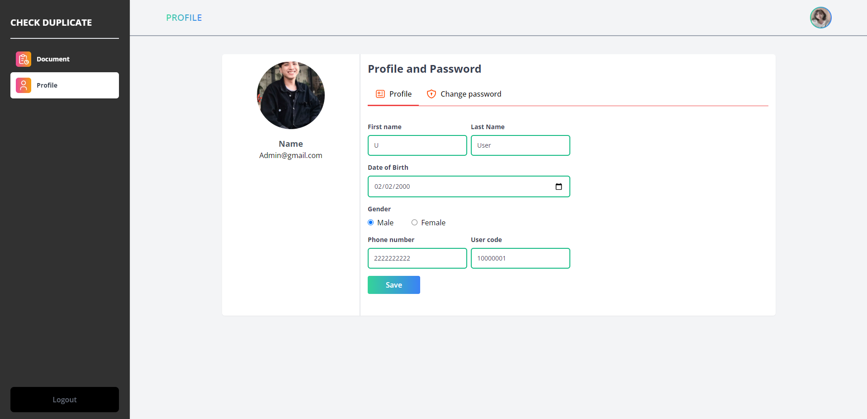

11

10

9

8

7

6

5

4

2

3

1

Figure 55 User interfaces profile

|  |  |  |  |  |
| --- | --- | --- | --- | --- |
| No | Object name | Format | Action | Note |
| 1 | Image avatar | Image |  | Display the avatar user |
| 2 | Label name | Label |  | Display name user |
| 3 | Label email | Label |  | Display email user |
| 4 | Tab change password | Tab | Display tab change password |  |
| 5 | Text field first Name | Text field |  | A place to input first name |
| 6 | Text field Last name | Text field |  | A place to input the last name |
| 5 | Date field dob | Text field |  | A place to input dob |
| 6 | Radio field gender | Text field |  | A place to input gender |
| 9 | Text field phone Number | Text field |  | A place to the input phone number |
| 10 | Text field user code | Text field |  | A place to input user code |
| 11 | Button save | Button | Update profile |  |

Table 42 Description for interfaces profile

* + 1. **Change password**

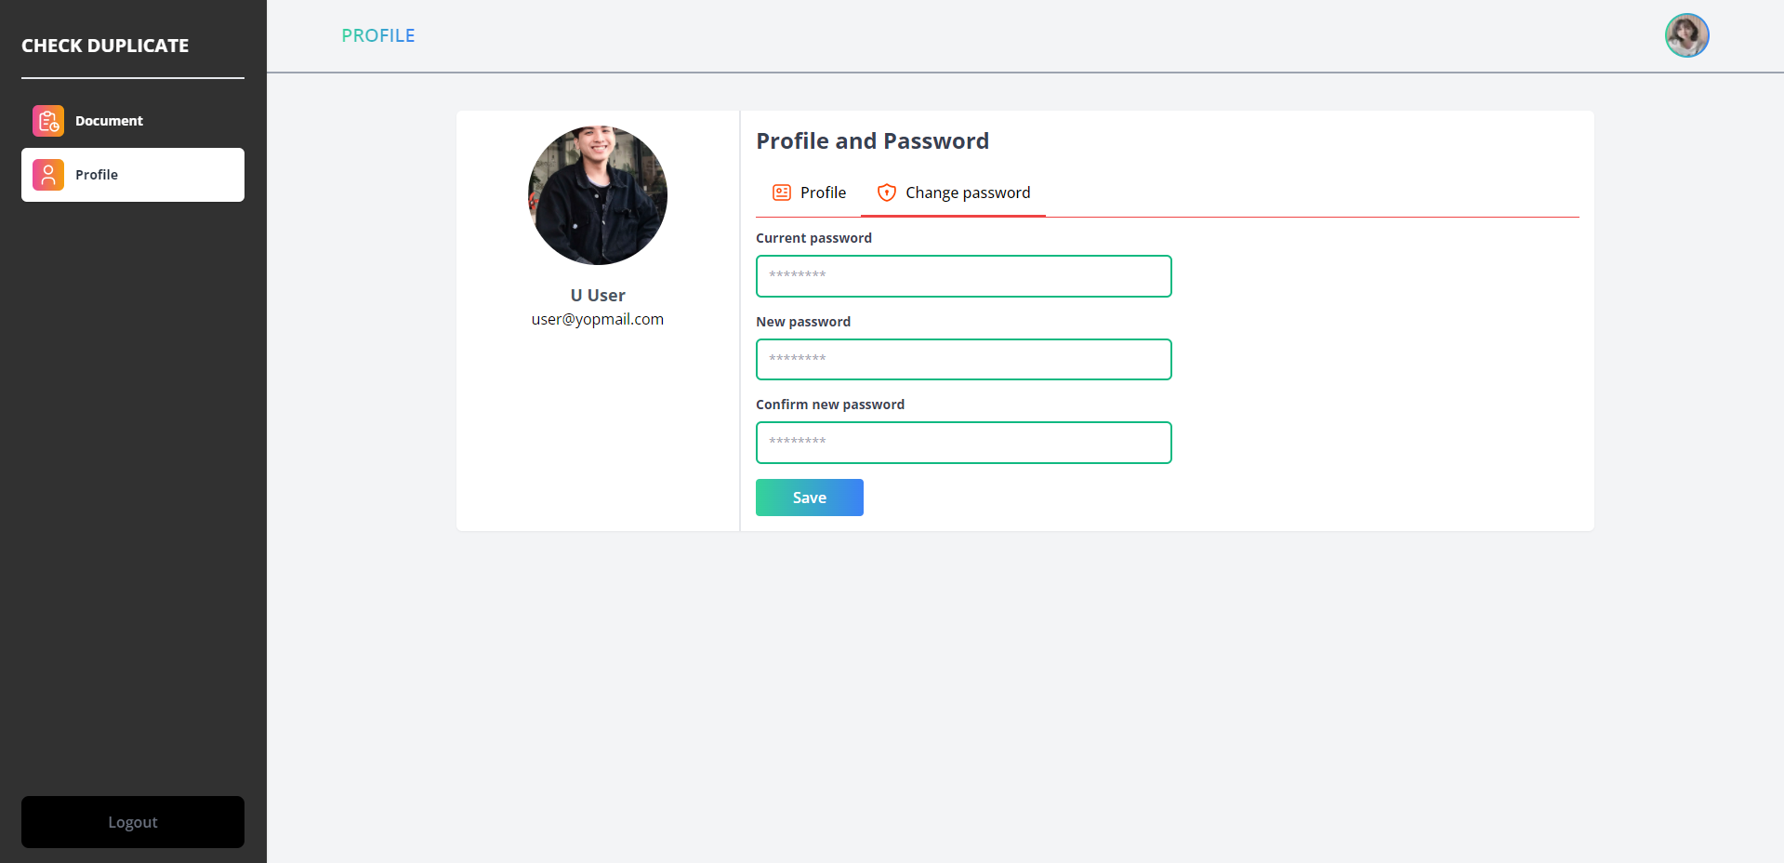

4

3

2

1

Figure 56 User interface change password

|  |  |  |  |  |
| --- | --- | --- | --- | --- |
| No | Object name | Format | Action | Note |
| 1 | Text field current Password | Text field |  | A place to input the current password |
| 2 | Text field new Password | Text field |  | A place to input a new password |
| 3 | Text field confirm password | Text field |  | A place to input confirm password |
| 4 | Button save | Button | Change password |  |

Table 43 Description for user interface change password

* 1. **Design algorithm**
     1. **Division sentences**

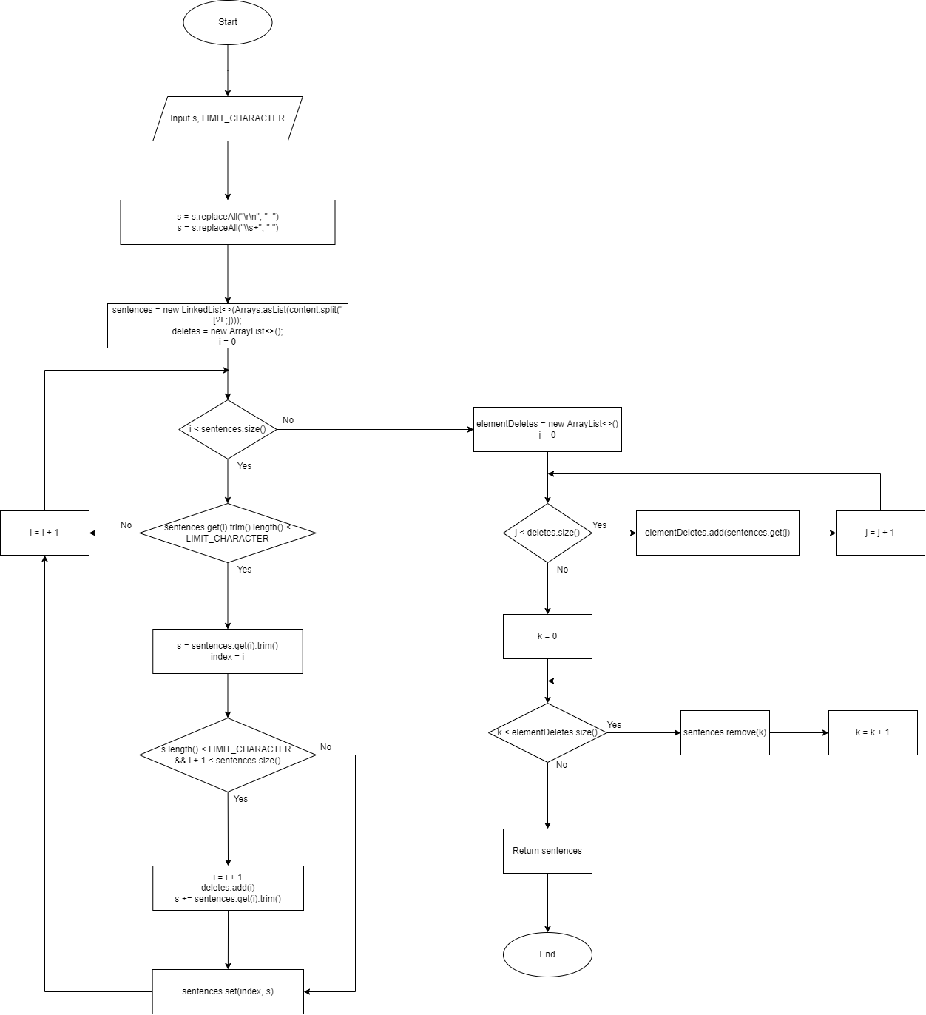

Figure 57 Algorithm Flowchart of function devisiontoSentences

* + 1. **Get distance of two strings**

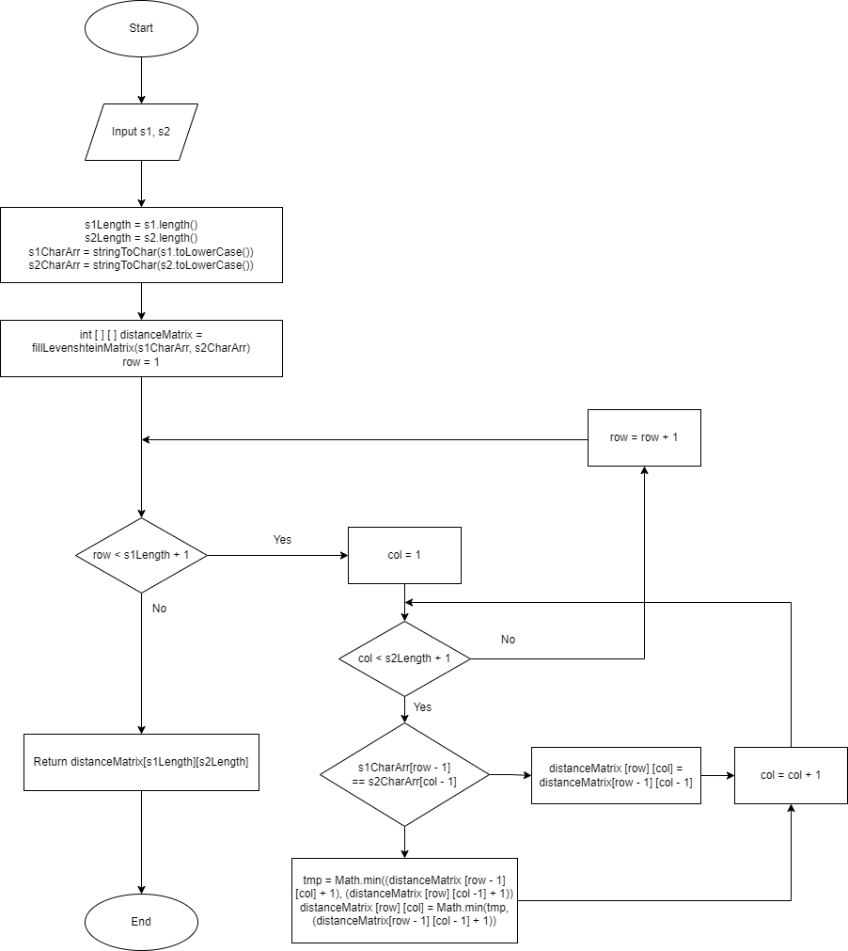

Figure 58 Algorithm Flowchart of function getLevenshteinDistance

* + 1. **Get percent similar**

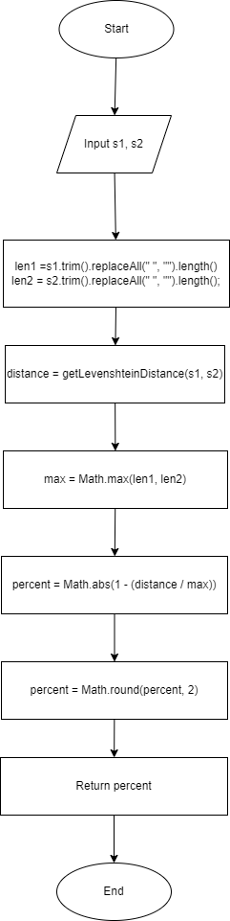

Figure 59 Algorithm Flowchart of function getPercentageSimilarity

* + 1. **Fill Levenshtein matrix**

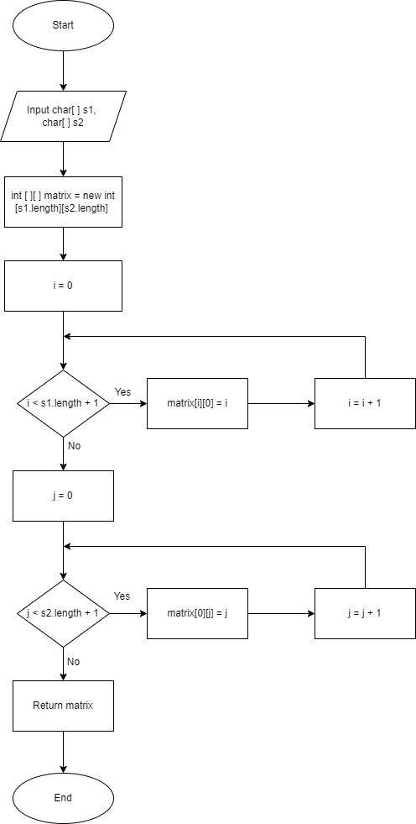

Figure 60 Algorithm Flowchart of function fillLevenshteinMatrix

* + 1. **Find the same part of two documents**

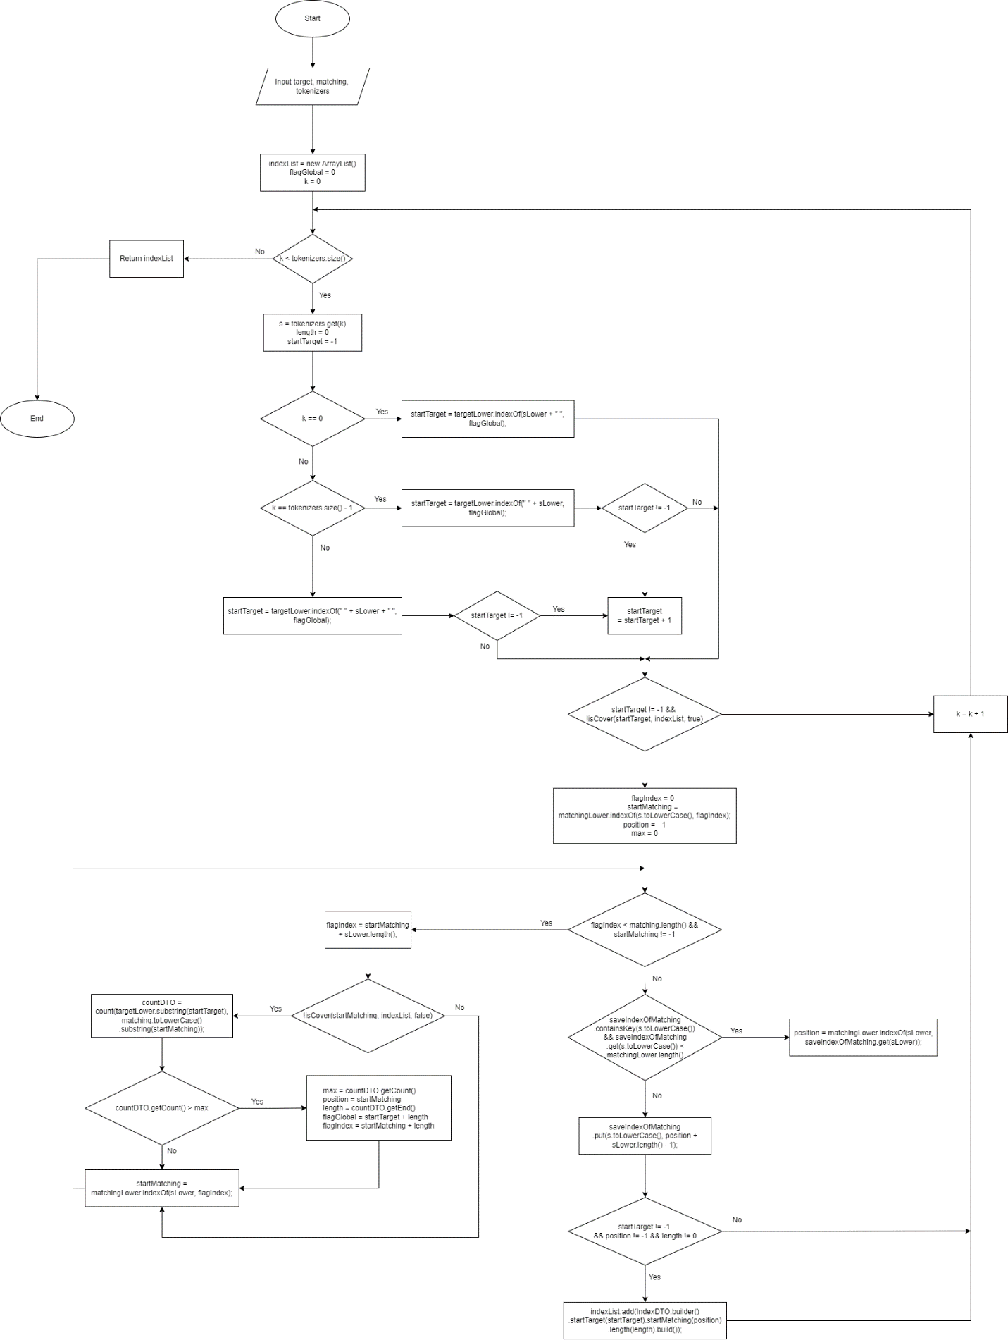

Figure 61 Algorithm Flowchart of function getPartPlagiarism

* + 1. **Count the number of similar characters**

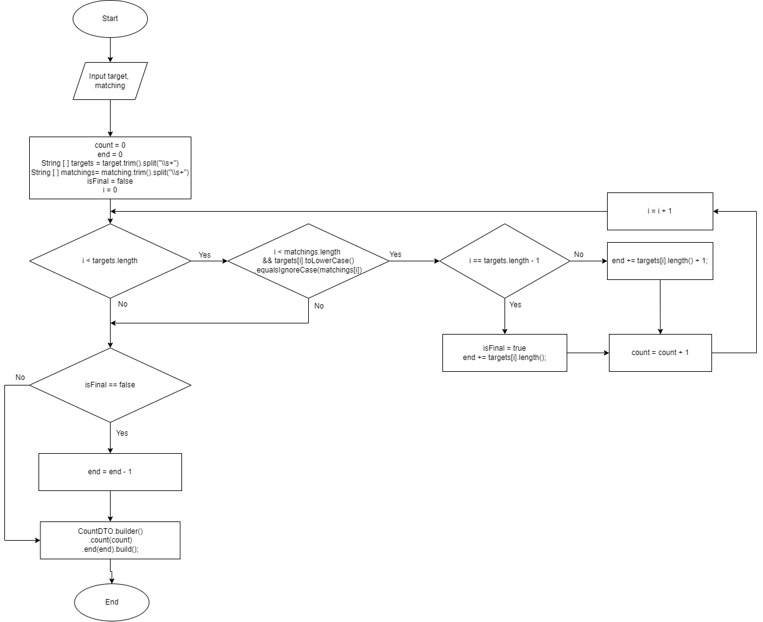

Figure 62 Algorithm Flowchart of function count

* + 1. **The function used to check if the character has been covered**

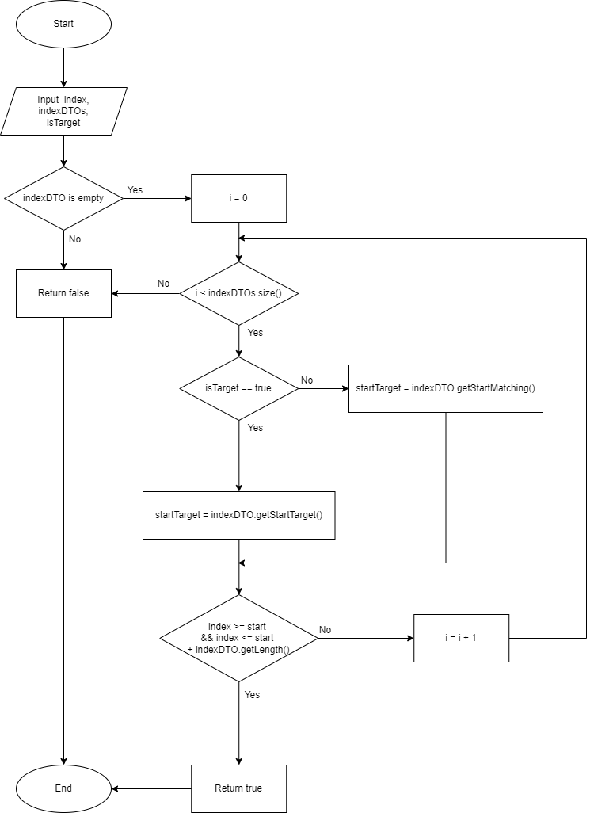

Figure 63 Algorithm Flowchart of function isCover

* + 1. **Application flow for function upload document**

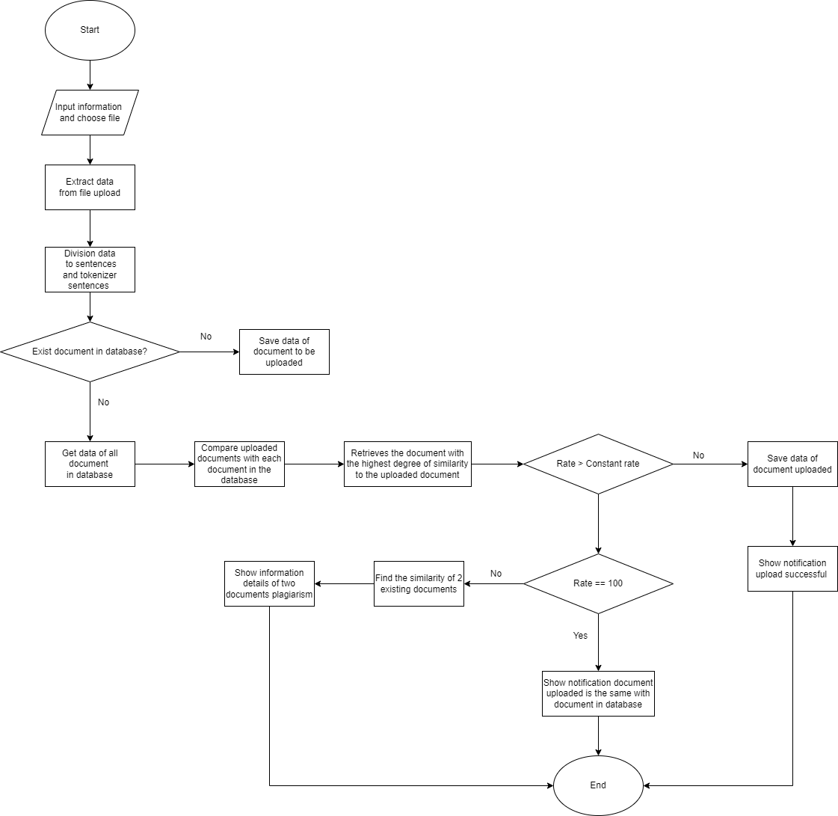

Figure 64 Application flow for function upload document

* + 1. **Check plagiarism**

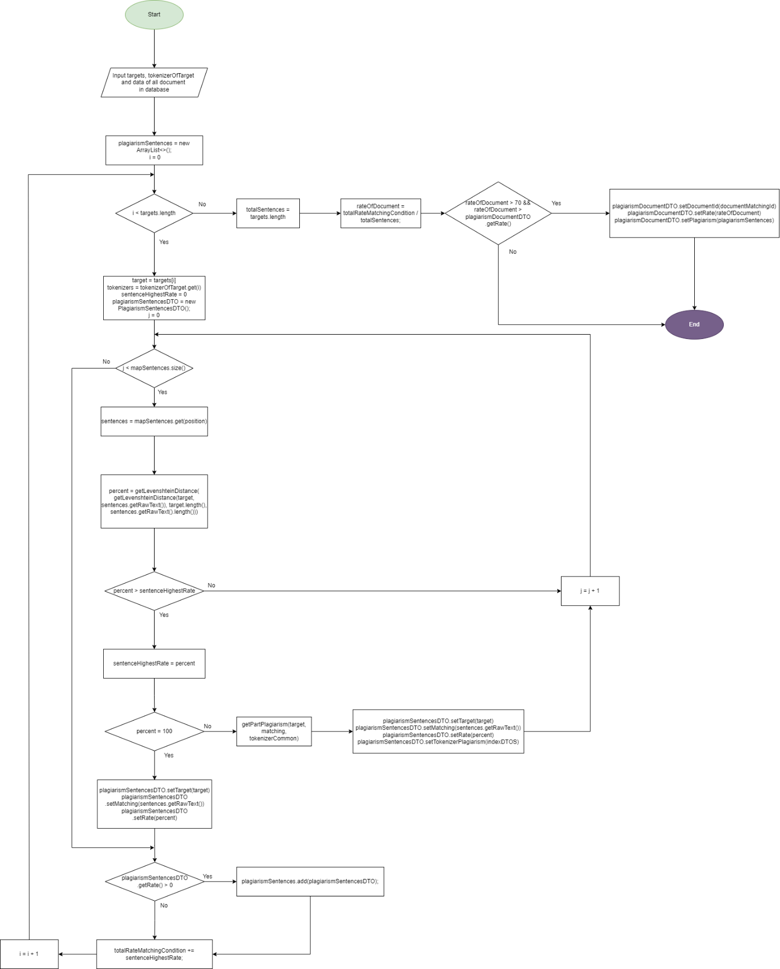

Figure 65 Algorithm Flowchart of check plagiarism

# CHAPTER 4: SYSTEM IMPLEMENTATION

* 1. **Software development environment**
* Frontend:
* Next JS Framework
* Backend:
* Spring boot Framework
  1. **Tool and technique**
* Programming language: JavaScript, java
* The software is designed and developed on Visual Studio Code, IntelliJ IDEA
* The database is built on PostgreSQL
  1. **Source code management**
* GitHub management tool is git bash and GitHub desktop
* Link GitHub: https://github.com/NguyenVanThang17110230/KLTN_KTDV

# CHAPTER 5: TESTING AND EVALUATION

* 1. **Test Case**
     1. **Sign in**

|  |  |  |  |  |  |  |  |  |  |
| --- | --- | --- | --- | --- | --- | --- | --- | --- | --- |
| **Test Scenario ID** | | Sign in | | | **Test Case ID** | | Sign in-1 | | |
| **Test Case Description** | | Sign in-Positive test case | | | **Test Priority** | | High | | |
| **Prerequisite** | | Enter the correct email and password | | | **Post-Requisite** | | NA | | |
| Test Execution Steps: | | | | | | | | | | |
| **No** | **Action** | | **Inputs** | **Expected Output** | **Actual Output** | **Test Environment** | | **Test Result** | **Test Comments** | |
| 1 | Access the website | | Website check plagiarism | Page sign in | Page sign in | localhost | | Passed | Successful access | |
| 2 | Enter a username and password | | Username: user@yopmail.com  Password: 12345678 | Sign in successfully and switch to the admin page | Sign in successfully and switch to the admin page | localhost | | Passed | Successful sign in | |

Table 50 Test case sign in-1

|  |  |  |  |  |  |  |  |  |  |
| --- | --- | --- | --- | --- | --- | --- | --- | --- | --- |
| **Test Scenario ID** | | Sign in | | | **Test Case ID** | | Sign in-2 | | |
| **Test Case Description** | | Sign in-Negative test case | | | **Test Priority** | | High | | |
| **Prerequisite** | | Incorrect password or email | | | **Post-Requisite** | | NA | | |
| Test Execution Steps: | | | | | | | | | | |
| **No** | **Action** | | **Inputs** | **Expected Output** | **Actual Output** | **Test Environment** | | **Test Result** | **Test Comments** | |
| 1 | Access the website | | Website check plagiarism | Page sign in | Page sign in | localhost | | Passed | Successful access | |
| 2 | Enter the correct username and wrong password | | Username: user@yopmail.com  Password: 123 | Username or password incorrect | Username or password incorrect | localhost | | Passed | Sign in fail | |
| 3 | Enter the wrong username and correct password | | Username: dem@gmail.com  Password: 1234 | Username or password incorrect | Username or password incorrect | localhost | | Passed | Sign in fail | |

Table 51 Test case sign in-2

|  |  |  |  |  |  |  |  |  |  |
| --- | --- | --- | --- | --- | --- | --- | --- | --- | --- |
| **Test Scenario ID** | | Sign in | | | **Test Case ID** | | Sign in-3 | | |
| **Test Case Description** | | Sign in - Negative test case | | | **Test Priority** | | High | | |
| **Prerequisite** | | Do not enter a username | | | **Post-Requisite** | | NA | | |
| Test Execution Steps: | | | | | | | | | | |
| **No** | **Action** | | **Inputs** | **Expected Output** | **Actual Output** | **Test Environment** | | **Test Result** | **Test Comments** | |
| 1 | Access the website | | Website check plagiarism | Page sign in | Page sign in | localhost | | Passed | Successful access | |
| 2 | Do not enter username and enter the correct password | | Username:  Password: 1234 | Please enter your full username and password | Please enter your full username and password | localhost | | Passed | Sign in fail | |

Table 52 Test case sign in-3

|  |  |  |  |  |  |  |  |  |  |
| --- | --- | --- | --- | --- | --- | --- | --- | --- | --- |
| **Test Scenario ID** | | Sign in | | | **Test Case ID** | | Sign in-4 | | |
| **Test Case Description** | | Sign in-Negative test case | | | **Test Priority** | | High | | |
| **Prerequisite** | | Do not enter a password | | | **Post-Requisite** | | NA | | |
| Test Execution Steps: | | | | | | | | | | |
| **No** | **Action** | | **Inputs** | **Expected Output** | **Actual Output** | **Test Environment** | | **Test Result** | **Test Comments** | |
| 1 | Access the website | | Website check plagiarism | Page sign in | Page sign in | localhost | | Passed | Successful access | |
| 2 | Do not enter the password and enter the correct username | | Username:  User@yopmail.com  Password: | Please enter your full username and password | Please enter your full username and password | localhost | | Passed | Sign in fail | |

Table 53 Test case sign in-4

|  |  |  |  |  |  |  |  |  |  |
| --- | --- | --- | --- | --- | --- | --- | --- | --- | --- |
| **Test Scenario ID** | | Sign in | | | **Test Case ID** | | Sign in-5 | | |
| **Test Case Description** | | Sign in-Negative test case | | | **Test Priority** | | High | | |
| **Prerequisite** | | The account is not active | | | **Post-Requisite** | | NA | | |
| Test Execution Steps: | | | | | | | | | | |
| **No** | **Action** | | **Inputs** | **Expected Output** | **Actual Output** | **Test Environment** | | **Test Result** | **Test Comments** | |
| 1 | Access the website | | Website check plagiarism | Page sign in | Page sign in | localhost | | Passed | Successful access | |
| 2 | Do not enter username and enter the correct password | | Username: user@yopmail.com  Password: 12345678 | Please check email and active account | Please check email and active account | localhost | | Passed | Sign in fail | |

Table 54 Test case sign in-5

|  |  |  |  |  |  |  |  |  |  |
| --- | --- | --- | --- | --- | --- | --- | --- | --- | --- |
| **Test Scenario ID** | | Sign in | | | **Test Case ID** | | Sign in-6 | | |
| **Test Case Description** | | Sign in-Negative test case | | | **Test Priority** | | High | | |
| **Prerequisite** | | Account is lock | | | **Post-Requisite** | | NA | | |
| Test Execution Steps: | | | | | | | | | | |
| **No** | **Action** | | **Inputs** | **Expected Output** | **Actual Output** | **Test Environment** | | **Test Result** | **Test Comments** | |
| 1 | Access the website | | Website check plagiarism | Page sign in | Page sign in | localhost | | Passed | Successful access | |
| 2 | Do not enter username and enter the correct password | | Username: user@yopmail.com  Password: 12345678 | Your account has been locked | Your account has been locked | localhost | | Passed | Sign in fail | |

Table 55 Test case sign in-6

* + 1. **Logout**

|  |  |  |  |  |  |  |  |  |  |
| --- | --- | --- | --- | --- | --- | --- | --- | --- | --- |
| **Test Scenario ID** | | logout | | | **Test Case ID** | | Logout-1 | | |
| **Test Case Description** | | Logout-Positive test case | | | **Test Priority** | | High | | |
| **Prerequisite** | | Multiply logout and confirm the logout | | | **Post-Requisite** | | NA | | |
| Test Execution Steps: | | | | | | | | | | |
| **No** | **Action** | | **Inputs** | **Expected Output** | **Actual Output** | **Test Environment** | | **Test Result** | **Test Comments** | |
| 2 | Click on logout | | N/A | Return to the sign-in page | Return to the sign-in page | localhost | | Passed | successful logout | |

Table 56 Test case logout

* + 1. **Upload document**

|  |  |  |  |  |  |  |  |  |  |
| --- | --- | --- | --- | --- | --- | --- | --- | --- | --- |
| **Test Scenario ID** | | Upload document | | | **Test Case ID** | | Upload-1 | | |
| **Test Case Description** | | Sign in - positive test case | | | **Test Priority** | | High | | |
| **Prerequisite** | | Enter all the information, select the file to upload and documents uploaded are not duplicated | | | **Post-Requisite** | | NA | | |
| Test Execution Steps: | | | | | | | | | | |
| **No** | **Action** | | **Inputs** | **Expected Output** | **Actual Output** | **Test Environment** | | **Test Result** | **Test Comments** | |
| 1 | Access the website | | Website check plagiarism | Page sign in | Page sign in | localhost | | Passed | Successful access | |
| 2 | Sign in as a normal user | | Username:  [User@yopmail.com](mailto:Demo1@gmail.com)  Password:  12345678 | Page document | Page document | localhost | | Passed | Successful sign in | |
| 3 | Select the document upload function | | N/A | Page document upload | Page document upload | localhost | | Passed | N/A | |
| 4 | Enter all the information and click to select a file  And click button upload | | file: file.pdf  title: Example  note: No | Upload success | Upload success | Localhost | | passed | Upload success | |

Table 57 Test case upload document-1

|  |  |  |  |  |  |  |  |  |  |
| --- | --- | --- | --- | --- | --- | --- | --- | --- | --- |
| **Test Scenario ID** | | Upload document | | | **Test Case ID** | | Upload-2 | | |
| **Test Case Description** | | Sign in-Negative test case | | | **Test Priority** | | High | | |
| **Prerequisite** | | Enter all the information, no selected the file to upload | | | **Post-Requisite** | | NA | | |
| Test Execution Steps: | | | | | | | | | | |
| **No** | **Action** | | **Inputs** | **Expected Output** | **Actual Output** | **Test Environment** | | **Test Result** | **Test Comments** | |
| 1 | Access the website | | Website check plagiarism | Page sign in | Page sign in | localhost | | Passed | Successful access | |
| 2 | Sign in as a normal user | | Username:  [User@yopmail.com](mailto:Demo1@gmail.com)  Password:  12345678 | Page document | Page document | localhost | | Passed | Successful sign in | |
| 3 | Select the document upload function | | N/A | Page document upload | Page document upload | localhost | | Passed | N/A | |
| 4 | Enter all the information and click to select a file  And click button upload | | file: N/A  title: Example  note: No | Please select files before uploading | Please select files before uploading | Localhost | | passed | Upload fail | |

Table 58 Test case upload document-2

|  |  |  |  |  |  |  |  |  |  |
| --- | --- | --- | --- | --- | --- | --- | --- | --- | --- |
| **Test Scenario ID** | | Upload document | | | **Test Case ID** | | Upload-3 | | |
| **Test Case Description** | | Sign in-Negative test case | | | **Test Priority** | | High | | |
| **Prerequisite** | | Enter missing field, select the file to upload | | | **Post-Requisite** | | NA | | |
| Test Execution Steps: | | | | | | | | | | |
| **No** | **Action** | | **Inputs** | **Expected Output** | **Actual Output** | **Test Environment** | | **Test Result** | **Test Comments** | |
| 1 | Access the website | | Website check plagiarism | Page sign in | Page sign in | localhost | | Passed | Successful access | |
| 2 | Sign in as a normal user | | Username:  [User@yopmail.com](mailto:Demo1@gmail.com)  Password:  12345678 | Page document | Page document | localhost | | Passed | Successful sign in | |
| 3 | Select the document upload function | | N/A | Page document upload | Page document upload | localhost | | Passed | N/A | |
| 4 | Do not enter all fields and click to select a file  And click button upload | | file: file.pdf  title: N/A  note: No | Title is required | Title is required | Localhost | | passed | Upload fail | |

Table 59 Test case upload document-3

|  |  |  |  |  |  |  |  |  |  |
| --- | --- | --- | --- | --- | --- | --- | --- | --- | --- |
| **Test Scenario ID** | | Upload document | | | **Test Case ID** | | Upload-4 | | |
| **Test Case Description** | | Sign in - positive test case | | | **Test Priority** | | High | | |
| **Prerequisite** | | Upload duplicate files and press the save button | | | **Post-Requisite** | | NA | | |
| Test Execution Steps: | | | | | | | | | | |
| **No** | **Action** | | **Inputs** | **Expected Output** | **Actual Output** | **Test Environment** | | **Test Result** | **Test Comments** | |
| 1 | Access the website | | Website check plagiarism | Page sign in | Page sign in | localhost | | Passed | Successful access | |
| 2 | Sign in as a normal user | | Username:  [User@yopmail.com](mailto:Demo1@gmail.com)  Password:  12345678 | Page document | Page document | localhost | | Passed | Successful sign in | |
| 3 | Select the document upload function | | N/A | Page document upload | Page document upload | localhost | | Passed | N/A | |
| 4 | Enter all the information and click to select file duplicate  And click button upload | | file: file1.pdf  title: Example  note: No | List content plagiarism. | List content plagiarism. | Localhost | | passed | N/A | |

Table 60 Test case upload document-4

* + 1. **Delete document**

|  |  |  |  |  |  |  |  |  |  |
| --- | --- | --- | --- | --- | --- | --- | --- | --- | --- |
| **Test Scenario ID** | | Delete document | | | **Test Case ID** | | Delete-1 | | |
| **Test Case Description** | | Delete document-positive test case | | | **Test Priority** | | High | | |
| **Prerequisite** | | Select the document and delete | | | **Post-Requisite** | | NA | | |
| Test Execution Steps: | | | | | | | | | | |
| **No** | **Action** | | **Inputs** | **Expected Output** | **Actual Output** | **Test Environment** | | **Test Result** | **Test Comments** | |
| 1 | Access the website | | Website check plagiarism | Page sign in | Page sign in | localhost | | Passed | Successful access | |
| 2 | Sign in as a normal user | | Username:  [User@yopmail.com](mailto:Demo1@gmail.com)  Password:  12345678 | Page document | Page  document | localhost | | Passed | Successful sign in | |
| 3 | Select the document function | | N/A | Page document | Page document | localhost | | Passed | N/A | |
| 4 | select the document you want to delete and click delete | | N/A | The document is removed from the list | The document is removed from the list | Localhost | | passed | Successful delete | |

Table 61 Test case delete a document

* + 1. **Download document**

|  |  |  |  |  |  |  |  |  |  |
| --- | --- | --- | --- | --- | --- | --- | --- | --- | --- |
| **Test Scenario ID** | | Download document | | | **Test Case ID** | | Download-1 | | |
| **Test Case Description** | | Download document-positive test case | | | **Test Priority** | | High | | |
| **Prerequisite** | | Select document and download | | | **Post-Requisite** | | NA | | |
| Test Execution Steps: | | | | | | | | | | |
| **No** | **Action** | | **Inputs** | **Expected Output** | **Actual Output** | **Test Environment** | | **Test Result** | **Test Comments** | |
| 1 | Access the website | | Website check plagiarism | Page sign in | Page sign in | localhost | | Passed | Successful access | |
| 2 | Sign in as a normal user | | Username:  [User@yopmail.com](mailto:Demo1@gmail.com)  Password:  12345678 | Page document | Page document | localhost | | Passed | Successful sign in | |
| 3 | Select the document function | | N/A | Page document | Page document | localhost | | Passed | N/A | |
| 4 | select the document you want to download and click download | | N/A | downloaded documents | downloaded documents | Localhost | | passed | Successful download | |

Table 62 Test case download document

* + 1. **Search document**

|  |  |  |  |  |  |  |  |  |  |
| --- | --- | --- | --- | --- | --- | --- | --- | --- | --- |
| **Test Scenario ID** | | Search document | | | **Test Case ID** | | Search-1 | | |
| **Test Case Description** | | Search document-positive test case | | | **Test Priority** | | High | | |
| **Prerequisite** | | Enter the keyword you want to search | | | **Post-Requisite** | | NA | | |
| Test Execution Steps: | | | | | | | | | | |
| **No** | **Action** | | **Inputs** | **Expected Output** | **Actual Output** | **Test Environment** | | **Test Result** | **Test Comments** | |
| 1 | Access the website | | Website check plagiarism | Page sign in | Page sign in | localhost | | Passed | Successful access | |
| 2 | Sign in as a normal user | | Username:  [User@yopmail.com](mailto:Demo1@gmail.com)  Password:  12345678 | Page document | Page document | localhost | | Passed | Successful sign in | |
| 3 | Select the document function | | N/A | Page document | Page document | localhost | | Passed | N/A | |
| 4 | Enter the document you want to search and click the button search | | Key: Example | the document list contains the word zero | the document list contains the word zero | Localhost | | passed | Successful search | |

Table 63 Test case search document-1

|  |  |  |  |  |  |  |  |  |  |
| --- | --- | --- | --- | --- | --- | --- | --- | --- | --- |
| **Test Scenario ID** | | Search document | | | **Test Case ID** | | Search-2 | | |
| **Test Case Description** | | Search document-Negative test case | | | **Test Priority** | | High | | |
| **Prerequisite** | | Do not enter keywords and press the search button | | | **Post-Requisite** | | NA | | |
| Test Execution Steps: | | | | | | | | | | |
| **No** | **Action** | | **Inputs** | **Expected Output** | **Actual Output** | **Test Environment** | | **Test Result** | **Test Comments** | |
| 1 | Access the website | | Website check plagiarism | Page sign in | Page sign in | localhost | | Passed | Successful access | |
| 2 | Sign in as a normal user | | Username:  [User@yopmail.com](mailto:Demo1@gmail.com)  Password:  12345678 | Page document | Page document | localhost | | Passed | Successful sign in | |
| 3 | Select the document function | | N/A | Page document | Page document | localhost | | Passed | N/A | |
| 4 | Enter the document you want to search and click the button search | | Key: N/A | N/A | N/A | Localhost | | passed | N/A | |

Table 64 Test case search document-2

* + 1. **Edit document**

|  |  |  |  |  |  |  |  |  |  |
| --- | --- | --- | --- | --- | --- | --- | --- | --- | --- |
| **Test Scenario ID** | | Edit document | | | **Test Case ID** | | Edit-1 | | |
| **Test Case Description** | | Edit document-Positive test case | | | **Test Priority** | | High | | |
| **Prerequisite** | | Enter all fields and press the save button | | | **Post-Requisite** | | NA | | |
| Test Execution Steps: | | | | | | | | | | |
| **No** | **Action** | | **Inputs** | **Expected Output** | **Actual Output** | **Test Environment** | | **Test Result** | **Test Comments** | |
| 1 | Access the website | | Website check plagiarism | Page sign in | Page sign in | localhost | | Passed | Successful access | |
| 2 | Sign in as a normal user | | Username:  [User@yopmail.com](mailto:Demo1@gmail.com)  Password:  12345678 | Page document | Page document | localhost | | Passed | Successful sign in | |
| 3 | Select the document | | N/A | Popup detail document | Popup detail document | localhost | | Passed | N/A | |
| 4 | Enter all fields required and press save | | Title: Example  Note: No | N/A | N/A | Localhost | | passed | N/A | |

Table 65 Test case edit document-1

|  |  |  |  |  |  |  |  |  |  |
| --- | --- | --- | --- | --- | --- | --- | --- | --- | --- |
| **Test Scenario ID** | | Edit document | | | **Test Case ID** | | Edit-2 | | |
| **Test Case Description** | | Edit document-Negative test case | | | **Test Priority** | | High | | |
| **Prerequisite** | | Field require blank | | | **Post-Requisite** | | NA | | |
| Test Execution Steps: | | | | | | | | | | |
| **No** | **Action** | | **Inputs** | **Expected Output** | **Actual Output** | **Test Environment** | | **Test Result** | **Test Comments** | |
| 1 | Access the website | | Website check plagiarism | Page sign in | Page sign in | localhost | | Passed | Successful access | |
| 2 | Sign in as a normal user | | Username:  [User@yopmail.com](mailto:Demo1@gmail.com)  Password:  12345678 | Page document | Page document | localhost | | Passed | Successful sign in | |
| 3 | Select the document | | N/A | Popup detail document | Popup detail document | localhost | | Passed | N/A | |
| 4 | Do not enter a required field | | Title: N/A  Note: No | Title is required | Title is required | Localhost | | passed | N/A | |

Table 66 Table 67 Test case edit document-2

* + 1. **Change profile**

|  |  |  |  |  |  |  |  |  |  |
| --- | --- | --- | --- | --- | --- | --- | --- | --- | --- |
| **Test Scenario ID** | | Change profile | | | **Test Case ID** | | Change-profile-1 | | |
| **Test Case Description** | | Create theme-positive test case | | | **Test Priority** | | High | | |
| **Prerequisite** | | Enter all fields and press the save button | | | **Post-Requisite** | | NA | | |
| Test Execution Steps: | | | | | | | | | | |
| **No** | **Action** | | **Inputs** | **Expected Output** | **Actual Output** | **Test Environment** | | **Test Result** | **Test Comments** | |
| 1 | Access the website | | Website check plagiarism | Page sign in | Page sign in | localhost | | Passed | Successful access | |
| 2 | Sign in as a normal user | | Username:  [User@yopmail.com](mailto:Demo1@gmail.com)  Password:  12345678 | Page document | Page document | localhost | | Passed | Successful sign in | |
| 3 | Select the tab profile | | N/A | Page profile | Page profile | localhost | | Passed | N/A | |
| 4 | Enter all fields and press the save button | | first Name: test  Last name: test  dob: 1/1/1999  gender: Male  phone Number: 098686868  user code: 17110230 | Successful additional notification | Successful additional notification | Localhost | | passed | Successful create | |

Table 68 Test case change profile-1

|  |  |  |  |  |  |  |  |  |  |
| --- | --- | --- | --- | --- | --- | --- | --- | --- | --- |
| **Test Scenario ID** | | Change profile | | | **Test Case ID** | | Change-profile-2 | | |
| **Test Case Description** | | Change profile-Negative test case. | | | **Test Priority** | | High | | |
| **Prerequisite** | | Do not enter fields first Name and press the save button. | | | **Post-Requisite** | | N/A | | |
| Test Execution Steps: | | | | | | | | | | |
| **No** | **Action** | | **Inputs** | **Expected Output** | **Actual Output** | **Test Environment** | | **Test Result** | **Test Comments** | |
| 1 | Access the website | | Website check plagiarism | Page sign in | Page sign in | localhost | | Passed | Successful access | |
| 2 | Sign in as a normal user | | Username:  [User@yopmail.com](mailto:Demo1@gmail.com)  Password:  12345678 | Page document | Page document | localhost | | Passed | Successful sign in | |
| 3 | Select the tab profile | | N/A | Page profile | Page profile | localhost | | Passed | N/A | |
| 4 | do not enter fields and press add button | | first Name: N/A  Last name: test  dob: 1/1/1999  gender: Male  phone Number: 098686868  user code: 17110230 | First name is required | First name is required | Localhost | | passed | Change profile fail | |

Table 69 Test case change profile-2

|  |  |  |  |  |  |  |  |  |  |
| --- | --- | --- | --- | --- | --- | --- | --- | --- | --- |
| **Test Scenario ID** | | Change profile | | | **Test Case ID** | | Change-profile-3 | | |
| **Test Case Description** | | Change profile-Negative test case. | | | **Test Priority** | | High | | |
| **Prerequisite** | | Do not enter fields' last Name and press the save button. | | | **Post-Requisite** | | N/A | | |
| Test Execution Steps: | | | | | | | | | | |
| **No** | **Action** | | **Inputs** | **Expected Output** | **Actual Output** | **Test Environment** | | **Test Result** | **Test Comments** | |
| 1 | Access the website | | Website check plagiarism | Page sign in | Page sign in | localhost | | Passed | Successful access | |
| 2 | Sign in as a normal user | | Username:  [User@yopmail.com](mailto:Demo1@gmail.com)  Password:  12345678 | Page document | Page document | localhost | | Passed | Successful sign in | |
| 3 | Select the tab profile | | N/A | Page profile | Page profile | localhost | | Passed | N/A | |
| 4 | do not enter fields and press add button | | first Name: test  Last name: N/A  dob: 1/1/1999  gender: Male  phone Number: 098686868  user code: 17110230 | Last name is required | Last name is required | Localhost | | passed | Change profile fail | |

Table 70 Test case change profile-3

|  |  |  |  |  |  |  |  |  |  |
| --- | --- | --- | --- | --- | --- | --- | --- | --- | --- |
| **Test Scenario ID** | | Change profile | | | **Test Case ID** | | Change-profile-4 | | |
| **Test Case Description** | | Change profile-Negative test case. | | | **Test Priority** | | High | | |
| **Prerequisite** | | Do not enter fields dob and press the save button. | | | **Post-Requisite** | | N/A | | |
| Test Execution Steps: | | | | | | | | | | |
| **No** | **Action** | | **Inputs** | **Expected Output** | **Actual Output** | **Test Environment** | | **Test Result** | **Test Comments** | |
| 1 | Access the website | | Website check plagiarism | Page sign in | Page sign in | localhost | | Passed | Successful access | |
| 2 | Sign in as a normal user | | Username:  [User@yopmail.com](mailto:Demo1@gmail.com)  Password:  12345678 | Page document | Page document | localhost | | Passed | Successful sign in | |
| 3 | Select the tab profile | | N/A | Page profile | Page profile | localhost | | Passed | N/A | |
| 4 | do not enter fields and press add button | | first Name: test  Last name: test  dob: N/A  gender: Male  phone Number: 098686868  user code: 17110230 | Date of birth is required | Date of birth is required | Localhost | | passed | Change profile fail | |

Table 71 Test case change profile-4

|  |  |  |  |  |  |  |  |  |  |
| --- | --- | --- | --- | --- | --- | --- | --- | --- | --- |
| **Test Scenario ID** | | Change profile | | | **Test Case ID** | | Change-profile-5 | | |
| **Test Case Description** | | Change profile-Negative test case. | | | **Test Priority** | | High | | |
| **Prerequisite** | | Do not enter fields user code and press the save button. | | | **Post-Requisite** | | N/A | | |
| Test Execution Steps: | | | | | | | | | | |
| **No** | **Action** | | **Inputs** | **Expected Output** | **Actual Output** | **Test Environment** | | **Test Result** | **Test Comments** | |
| 1 | Access the website | | Website check plagiarism | Page sign in | Page sign in | localhost | | Passed | Successful access | |
| 2 | Sign in as a normal user | | Username:  [User@yopmail.com](mailto:Demo1@gmail.com)  Password:  12345678 | Page document | Page document | localhost | | Passed | Successful sign in | |
| 3 | Select the tab profile | | N/A | Page profile | Page profile | localhost | | Passed | N/A | |
| 4 | do not enter fields and press add button | | first Name: test  Last name: test  dob: 1/1/1999  gender: Male  phone Number: 098686868  user code: N/A | User code is required | User code is required | Localhost | | passed | Change profile fail | |

Table 72 Test case change profile-5

|  |  |  |  |  |  |  |  |  |  |
| --- | --- | --- | --- | --- | --- | --- | --- | --- | --- |
| **Test Scenario ID** | | Change profile | | | **Test Case ID** | | Change-profile-6 | | |
| **Test Case Description** | | Change profile-Negative test case. | | | **Test Priority** | | High | | |
| **Prerequisite** | | Do not enter fields phone Numbers and press the save button. | | | **Post-Requisite** | | N/A | | |
| Test Execution Steps: | | | | | | | | | | |
| **No** | **Action** | | **Inputs** | **Expected Output** | **Actual Output** | **Test Environment** | | **Test Result** | **Test Comments** | |
| 1 | Access the website | | Website check plagiarism | Page sign in | Page sign in | localhost | | Passed | Successful access | |
| 2 | Sign in as a normal user | | Username:  [User@yopmail.com](mailto:Demo1@gmail.com)  Password:  12345678 | Page document | Page document | localhost | | Passed | Successful sign in | |
| 3 | Select the tab profile | | N/A | Page profile | Page profile | localhost | | Passed | N/A | |
| 4 | do not enter fields and press add button | | first Name: test  Last name: test  dob: 1/1/1999  gender: Male  phone Number: N/A  user code: 17110230 | Phone number is required | Phone number is required | Localhost | | passed | Change profile fail | |

Table 73 Test case change profile-6

* + 1. **Change password**

|  |  |  |  |  |  |  |  |  |  |
| --- | --- | --- | --- | --- | --- | --- | --- | --- | --- |
| **Test Scenario ID** | | Change password | | | **Test Case ID** | | Change-password-1 | | |
| **Test Case Description** | | Change profile-positive test case. | | | **Test Priority** | | High | | |
| **Prerequisite** | | Enter all fields and press save. | | | **Post-Requisite** | | N/A | | |
| Test Execution Steps: | | | | | | | | | | |
| **No** | **Action** | | **Inputs** | **Expected Output** | **Actual Output** | **Test Environment** | | **Test Result** | **Test Comments** | |
| 1 | Access the website | | Website check plagiarism | Page sign in | Page sign in | localhost | | Passed | Successful access | |
| 2 | Sign in as a normal user | | Username:  [User@yopmail.com](mailto:Demo1@gmail.com)  Password:  12345678 | Page document | Page document | localhost | | Passed | Successful sign in | |
| 3 | Select the tab profile | | N/A | Page profile | Page profile | localhost | | Passed | N/A | |
| 4 | Select the tab change password | | N/A | Tab change password | Tab change password | localhost | | Passed | N/A | |
| 5 | Enter all fields and press save | | Current password: 12345678  new Password:  123456789  Confirm password: 123456789 | Message change success | Message change success | Localhost | | passed | Change password success | |

Table 74 Test case change password-1

|  |  |  |  |  |  |  |  |  |  |
| --- | --- | --- | --- | --- | --- | --- | --- | --- | --- |
| **Test Scenario ID** | | Change password | | | **Test Case ID** | | Change-password-2 | | |
| **Test Case Description** | | Change profile-negative test case. | | | **Test Priority** | | High | | |
| **Prerequisite** | | Not enter field current password and press save. | | | **Post-Requisite** | | N/A | | |
| Test Execution Steps: | | | | | | | | | | |
| **No** | **Action** | | **Inputs** | **Expected Output** | **Actual Output** | **Test Environment** | | **Test Result** | **Test Comments** | |
| 1 | Access the website | | Website check plagiarism | Page sign in | Page sign in | localhost | | Passed | Successful access | |
| 2 | Sign in as a normal user | | Username:  [User@yopmail.com](mailto:Demo1@gmail.com)  Password:  12345678 | Page document | Page document | localhost | | Passed | Successful sign in | |
| 3 | Select the tab profile | | N/A | Page profile | Page profile | localhost | | Passed | N/A | |
| 4 | Select the tab change password | | N/A | Tab change password | Tab change password | localhost | | Passed | N/A | |
| 5 | Enter all fields and press save | | Current password: N/A  new Password:  123456789  Confirm password: 123456789 | A current password is required | A current password is required | Localhost | | passed | Change password fail | |

Table 75 Test case change password-2

|  |  |  |  |  |  |  |  |  |  |
| --- | --- | --- | --- | --- | --- | --- | --- | --- | --- |
| **Test Scenario ID** | | Change password | | | **Test Case ID** | | Change-password-3 | | |
| **Test Case Description** | | Change profile-negative test case. | | | **Test Priority** | | High | | |
| **Prerequisite** | | Not enter field new Password and press save. | | | **Post-Requisite** | | N/A | | |
| Test Execution Steps: | | | | | | | | | | |
| **No** | **Action** | | **Inputs** | **Expected Output** | **Actual Output** | **Test Environment** | | **Test Result** | **Test Comments** | |
| 1 | Access the website | | Website check plagiarism | Page sign in | Page sign in | localhost | | Passed | Successful access | |
| 2 | Sign in as a normal user | | Username:  [User@yopmail.com](mailto:Demo1@gmail.com)  Password:  12345678 | Page document | Page document | localhost | | Passed | Successful sign in | |
| 3 | Select the tab profile | | N/A | Page profile | Page profile | localhost | | Passed | N/A | |
| 4 | Select the tab change password | | N/A | Tab change password | Tab change password | localhost | | Passed | N/A | |
| 5 | Enter all fields and press save | | Current password: 12345678  new Password:  N/A  Confirm password: 123456789 | A new password is required | A new password is required | Localhost | | passed | Change password fail | |

Table 76 Test case change password-3

|  |  |  |  |  |  |  |  |  |  |
| --- | --- | --- | --- | --- | --- | --- | --- | --- | --- |
| **Test Scenario ID** | | Change password | | | **Test Case ID** | | Change-password-4 | | |
| **Test Case Description** | | Change profile-negative test case. | | | **Test Priority** | | High | | |
| **Prerequisite** | | Not enter field confirm password and press save. | | | **Post-Requisite** | | N/A | | |
| Test Execution Steps: | | | | | | | | | | |
| **No** | **Action** | | **Inputs** | **Expected Output** | **Actual Output** | **Test Environment** | | **Test Result** | **Test Comments** | |
| 1 | Access the website | | Website check plagiarism | Page sign in | Page sign in | localhost | | Passed | Successful access | |
| 2 | Sign in as a normal user | | Username:  [User@yopmail.com](mailto:Demo1@gmail.com)  Password:  12345678 | Page document | Page document | localhost | | Passed | Successful sign in | |
| 3 | Select the tab profile | | N/A | Page profile | Page profile | localhost | | Passed | N/A | |
| 4 | Select the tab change password | | N/A | Tab change password | Tab change password | localhost | | Passed | N/A | |
| 5 | Enter all fields and press save | | Current password: 12345678  new Password:  123456789  Confirm password: N/A | Confirm password is required | Confirm password is required | Localhost | | passed | Change password fail | |

Table 77 Test case change password-4

|  |  |  |  |  |  |  |  |  |  |
| --- | --- | --- | --- | --- | --- | --- | --- | --- | --- |
| **Test Scenario ID** | | Change password | | | **Test Case ID** | | Change-password-5 | | |
| **Test Case Description** | | Change profile-negative test case. | | | **Test Priority** | | High | | |
| **Prerequisite** | | The new password and confirm password are not the same. | | | **Post-Requisite** | | N/A | | |
| Test Execution Steps: | | | | | | | | | | |
| **No** | **Action** | | **Inputs** | **Expected Output** | **Actual Output** | **Test Environment** | | **Test Result** | **Test Comments** | |
| 1 | Access the website | | Website check plagiarism | Page sign in | Page sign in | localhost | | Passed | Successful access | |
| 2 | Sign in as a normal user | | Username:  [User@yopmail.com](mailto:Demo1@gmail.com)  Password:  12345678 | Page document | Page document | localhost | | Passed | Successful sign in | |
| 3 | Select the tab profile | | N/A | Page profile | Page profile | localhost | | Passed | N/A | |
| 4 | Select the tab change password | | N/A | Tab change password | Tab change password | localhost | | Passed | N/A | |
| 5 | Enter all fields and press save | | Current password: 12345678  new Password:  123456789  Confirm password: 1234567891 | New password and confirm password are not the same | New password and confirm password are not the same | Localhost | | passed | Change password fail | |

Table 78 Test case change password-5

* + 1. **Change avatar**

|  |  |  |  |  |  |  |  |  |  |
| --- | --- | --- | --- | --- | --- | --- | --- | --- | --- |
| **Test Scenario ID** | | Change avatar | | | **Test Case ID** | | Change-avatar-1 | | |
| **Test Case Description** | | Delete theme-positive test case | | | **Test Priority** | | High | | |
| **Prerequisite** | | Choose file and confirm save | | | **Post-Requisite** | | NA | | |
| Test Execution Steps: | | | | | | | | | | |
| **No** | **Action** | | **Inputs** | **Expected Output** | **Actual Output** | **Test Environment** | | **Test Result** | **Test Comments** | |
| 1 | Access the website | | Website check plagiarism | Page sign in | Page sign in | localhost | | Passed | Successful access | |
| 2 | Sign in as a normal user | | Username:  [User@yopmail.com](mailto:Demo1@gmail.com)  Password:  12345678 | Page document | Page document | localhost | | Passed | Successful sign in | |
| 3 | Select the tab profile | | N/A | Page profile | Page profile | localhost | | Passed | N/A | |
| 4 | Select the file and confirm save | | File: abc.png | Change avatar success | Change avatar success | localhost | | Passed | N/A | |

Table 79 Test case change avatar-1

* + 1. **Lock account**

|  |  |  |  |  |  |  |  |  |  |
| --- | --- | --- | --- | --- | --- | --- | --- | --- | --- |
| **Test Scenario ID** | | Lock account | | | **Test Case ID** | | Lock-1 | | |
| **Test Case Description** | | Lock account-positive test case | | | **Test Priority** | | High | | |
| **Prerequisite** | | Choose account and lock | | | **Post-Requisite** | | NA | | |
| Test Execution Steps: | | | | | | | | | | |
| **No** | **Action** | | **Inputs** | **Expected Output** | **Actual Output** | **Test Environment** | | **Test Result** | **Test Comments** | |
| 1 | Access the website | | Website check plagiarism | Page sign in | Page sign in | localhost | | Passed | Successful access | |
| 2 | Sign in as admin | | Username:  [admin@yopmail.com](mailto:admin@yopmail.com)  Password:  12345678 | Page admin | Page  admin | localhost | | Passed | Successful sign in | |
| 3 | Select tab manage account | | N/A | Page account | Page account | localhost | | Passed | N/A | |
| 4 | Choose the account you want to lock | | N/A | Popup account detail | Popup account detail | Localhost | | passed | N/A | |
| 5 | Press lock | | IdAcount:1 | Lock success | Lock success | Localhost | | passed | Successful lock | |

Table 80 Test case lock account-1

* + 1. **Sign up**

|  |  |  |  |  |  |  |  |  |  |
| --- | --- | --- | --- | --- | --- | --- | --- | --- | --- |
| **Test Scenario ID** | | Sign up | | | **Test Case ID** | | Signup-1 | | |
| **Test Case Description** | | Sign up-positive test case. | | | **Test Priority** | | High | | |
| **Prerequisite** | | Enter all fields and press sign up | | | **Post-Requisite** | | N/A | | |
| Test Execution Steps: | | | | | | | | | | |
| **No** | **Action** | | **Inputs** | **Expected Output** | **Actual Output** | **Test Environment** | | **Test Result** | **Test Comments** | |
| 1 | Access the website | | Website check plagiarism | Page sign in | Page sign in | localhost | | Passed | Successful access | |
| 2 | Click to sign up | | N/A | Page signup | Page signup | localhost | | Passed | N/A | |
| 4 | Enter all fields and press the signup button | | first Name: test  Last name: test  email: test@gmail.com  dob: 1/1/1999  gender: Male  phone Number: N/A  user code: 17110230  password: 12345678  confirm password: 12345678 | Signup success please check email and active account | Signup success please check email and active account | Localhost | | passed | Sign up success | |

Table 81 Test case sign up-1

|  |  |  |  |  |  |  |  |  |  |
| --- | --- | --- | --- | --- | --- | --- | --- | --- | --- |
| **Test Scenario ID** | | Sign up | | | **Test Case ID** | | Signup-2 | | |
| **Test Case Description** | | Sign up-negative test case. | | | **Test Priority** | | High | | |
| **Prerequisite** | | Not enter field first Name and press sign up | | | **Post-Requisite** | | N/A | | |
| Test Execution Steps: | | | | | | | | | | |
| **No** | **Action** | | **Inputs** | **Expected Output** | **Actual Output** | **Test Environment** | | **Test Result** | **Test Comments** | |
| 1 | Access the website | | Website check plagiarism | Page sign in | Page sign in | localhost | | Passed | Successful access | |
| 2 | Click to sign up | | N/A | Page signup | Page signup | localhost | | Passed | N/A | |
| 4 | Not enter field first Name | | first Name: N/A  Last name: test  email: test@gmail.com  dob: 1/1/1999  gender: Male  phone Number: 098989898  user code: 17110230  password: 12345678  confirm password: 12345678 | First name is required | First name is required | Localhost | | passed | Sign up fail | |

Table 82 Test case sign up-2

|  |  |  |  |  |  |  |  |  |  |
| --- | --- | --- | --- | --- | --- | --- | --- | --- | --- |
| **Test Scenario ID** | | Sign up | | | **Test Case ID** | | Signup-3 | | |
| **Test Case Description** | | Sign up-negative test case. | | | **Test Priority** | | High | | |
| **Prerequisite** | | Not enter field last Name and press sign up | | | **Post-Requisite** | | N/A | | |
| Test Execution Steps: | | | | | | | | | | |
| **No** | **Action** | | **Inputs** | **Expected Output** | **Actual Output** | **Test Environment** | | **Test Result** | **Test Comments** | |
| 1 | Access the website | | Website check plagiarism | Page sign in | Page sign in | localhost | | Passed | Successful access | |
| 2 | Click to sign up | | N/A | Page signup | Page signup | localhost | | Passed | N/A | |
| 4 | Not enter field Last name | | first Name: test  Last name: N/A  email: test@gmail.com  dob: 1/1/1999  gender: Male  phone Number: 09898989  user code: 17110230  password: 12345678  confirm password: 12345678 | Last name is required | Last name is required | Localhost | | passed | Sign up fail | |

Table 83 Test case sign up-3

|  |  |  |  |  |  |  |  |  |  |
| --- | --- | --- | --- | --- | --- | --- | --- | --- | --- |
| **Test Scenario ID** | | Sign up | | | **Test Case ID** | | Signup-4 | | |
| **Test Case Description** | | Sign up-negative test case. | | | **Test Priority** | | High | | |
| **Prerequisite** | | Not enter field email and press sign up | | | **Post-Requisite** | | N/A | | |
| Test Execution Steps: | | | | | | | | | | |
| **No** | **Action** | | **Inputs** | **Expected Output** | **Actual Output** | **Test Environment** | | **Test Result** | **Test Comments** | |
| 1 | Access the website | | Website check plagiarism | Page sign in | Page sign in | localhost | | Passed | Successful access | |
| 2 | Click to sign up | | N/A | Page signup | Page signup | localhost | | Passed | N/A | |
| 4 | Not enter field email | | first Name: test  Last name: test  email: N/A  dob: 1/1/1999  gender: Male  phone Number: 098898989  user code: 17110230  password: 12345678  confirm password: 12345678 | Email is required | Email is required | Localhost | | passed | Sign up fail | |

Table 84 Test case sign up-4

|  |  |  |  |  |  |  |  |  |  |
| --- | --- | --- | --- | --- | --- | --- | --- | --- | --- |
| **Test Scenario ID** | | Sign up | | | **Test Case ID** | | Signup-5 | | |
| **Test Case Description** | | Sign up-negative test case. | | | **Test Priority** | | High | | |
| **Prerequisite** | | Not enter field dob and press sign up | | | **Post-Requisite** | | N/A | | |
| Test Execution Steps: | | | | | | | | | | |
| **No** | **Action** | | **Inputs** | **Expected Output** | **Actual Output** | **Test Environment** | | **Test Result** | **Test Comments** | |
| 1 | Access the website | | Website check plagiarism | Page sign in | Page sign in | localhost | | Passed | Successful access | |
| 2 | Click to sign up | | N/A | Page signup | Page signup | localhost | | Passed | N/A | |
| 4 | Not enter field dob | | first Name: test  Last name: test  email: test@gmail.com  dob: N/A  gender: Male  phone Number: 098898989  user code: 17110230  password: 12345678  confirm password: 12345678 | Date of birth is required | Date of birth is required | Localhost | | passed | Sign up fail | |

Table 85 Test case sign up-5

|  |  |  |  |  |  |  |  |  |  |
| --- | --- | --- | --- | --- | --- | --- | --- | --- | --- |
| **Test Scenario ID** | | Sign up | | | **Test Case ID** | | Signup-6 | | |
| **Test Case Description** | | Sign up-negative test case. | | | **Test Priority** | | High | | |
| **Prerequisite** | | Not enter field phone Number and press sign up | | | **Post-Requisite** | | N/A | | |
| Test Execution Steps: | | | | | | | | | | |
| **No** | **Action** | | **Inputs** | **Expected Output** | **Actual Output** | **Test Environment** | | **Test Result** | **Test Comments** | |
| 1 | Access the website | | Website check plagiarism | Page sign in | Page sign in | localhost | | Passed | Successful access | |
| 2 | Click to sign up | | N/A | Page signup | Page signup | localhost | | Passed | N/A | |
| 4 | Not enter field phone Number | | first Name: test  Last name: test  email: test@gmail.com  dob: 1/1/1999  gender: Male  phone Number: N/A  user code: 17110230  password: 12345678  confirm password: 12345678 | Phone number is required | Phone number is required | Localhost | | passed | Sign up fail | |

Table 86 Test case sign up-6

|  |  |  |  |  |  |  |  |  |  |
| --- | --- | --- | --- | --- | --- | --- | --- | --- | --- |
| **Test Scenario ID** | | Sign up | | | **Test Case ID** | | Signup-7 | | |
| **Test Case Description** | | Sign up-negative test case. | | | **Test Priority** | | High | | |
| **Prerequisite** | | Not enter field password and press sign up | | | **Post-Requisite** | | N/A | | |
| Test Execution Steps: | | | | | | | | | | |
| **No** | **Action** | | **Inputs** | **Expected Output** | **Actual Output** | **Test Environment** | | **Test Result** | **Test Comments** | |
| 1 | Access the website | | Website check plagiarism | Page sign in | Page sign in | localhost | | Passed | Successful access | |
| 2 | Click to sign up | | N/A | Page signup | Page signup | localhost | | Passed | N/A | |
| 4 | Not enter field password | | first Name: test  Last name: test  email: test@gmail.com  dob: 1/1/1999  gender: Male  phone Number: N/A  user code: 17110230  password: N/A  confirm password: 12345678 | Password is required | Password is required | Localhost | | passed | Sign up fail | |

Table 87 Test case sign up-7

|  |  |  |  |  |  |  |  |  |  |
| --- | --- | --- | --- | --- | --- | --- | --- | --- | --- |
| **Test Scenario ID** | | Sign up | | | **Test Case ID** | | Signup-8 | | |
| **Test Case Description** | | Sign up-negative test case. | | | **Test Priority** | | High | | |
| **Prerequisite** | | Not enter field confirm password and press sign up | | | **Post-Requisite** | | N/A | | |
| Test Execution Steps: | | | | | | | | | | |
| **No** | **Action** | | **Inputs** | **Expected Output** | **Actual Output** | **Test Environment** | | **Test Result** | **Test Comments** | |
| 1 | Access the website | | Website check plagiarism | Page sign in | Page sign in | localhost | | Passed | Successful access | |
| 2 | Click to sign up | | N/A | Page signup | Page signup | localhost | | Passed | N/A | |
| 4 | Not enter field confirm password | | first Name: test  Last name: test  email: test@gmail.com  dob: 1/1/1999  gender: Male  phone Number: N/A  user code: 17110230  password: 12345678  confirm password: N/A | Confirm password is required | Confirm password is required | Localhost | | passed | Sign up fail | |

Table 88 Test case sign up-8

* 1. **Example**

|  |  |  |  |  |  |  |  |  |  |  |
| --- | --- | --- | --- | --- | --- | --- | --- | --- | --- | --- |
|  |  | **0** | **1** | **2** | **3** | **4** | **5** | **6** | **7** | **8** |
|  |  |  | **A** | **B** | **H** | **C** | **K** | **E** | **F** | **G** |
| 0 |  | 0 | 1 | 2 | 3 | 4 | 5 | 6 | 7 | 8 |
| **1** | **A** | 1 | 0 | 1 | 2 | 3 | 4 | 5 | 6 | 7 |
| **2** | **B** | 2 | 1 | 0 | 1 | 2 | 3 | 4 | 5 | 6 |
| **3** | **C** | 3 | 2 | 1 | 1 | 1 | 2 | 3 | 4 | 5 |
| **4** | **D** | 4 | 3 | 2 | 2 | 2 | 2 | 3 | 4 | 5 |
| **5** | **E** | 5 | 4 | 3 | 3 | 3 | 3 | 2 | 3 | 4 |
| **6** | **F** | 6 | 5 | 4 | 4 | 4 | 4 | 3 | 2 | 3 |
| **7** | **G** | 7 | 6 | 5 | 5 | 5 | 5 | 4 | 3 | 2 |

X = A B C D E F G

Y = A B H C K E F G

* i=1

|  |  |  |  |  |  |  |  |
| --- | --- | --- | --- | --- | --- | --- | --- |
| j | X[i] | Y[j] | Cost | D[i-1][j] + 1 | D[i][j-1] + 1 | D[i-1] [j-1] + cost | D[i] [j] |
| 1 | A | A | 0 | 2 | 2 | 0 | 0 |
| 2 | A | B | 1 | 3 | 1 | 2 | 1 |
| 3 | A | H | 1 | 4 | 2 | 3 | 2 |
| 4 | A | C | 1 | 5 | 3 | 4 | 3 |
| 5 | A | K | 1 | 6 | 4 | 5 | 4 |
| 6 | A | E | 1 | 7 | 5 | 6 | 5 |
| 7 | A | F | 1 | 8 | 6 | 7 | 6 |
| 8 | A | G | 1 | 9 | 7 | 8 | 7 |

* **i=2**

|  |  |  |  |  |  |  |  |
| --- | --- | --- | --- | --- | --- | --- | --- |
| j | X[i] | Y[j] | Cost | D[i-1][j] + 1 | D[i][j-1] + 1 | D[i-1] [j-1] + cost | D[i] [j] |
| 1 | B | A | 1 | 1 | 3 | 2 | 1 |
| 2 | B | B | 0 | 2 | 2 | 0 | 0 |
| 3 | B | H | 1 | 3 | 1 | 2 | 1 |
| 4 | B | C | 1 | 4 | 2 | 3 | 2 |
| 5 | B | K | 1 | 5 | 3 | 4 | 3 |
| 6 | B | E | 1 | 6 | 4 | 5 | 4 |
| 7 | B | F | 1 | 7 | 5 | 6 | 5 |
| 8 | B | G | 1 | 8 | 6 | 7 | 6 |

* **i=3**

|  |  |  |  |  |  |  |  |
| --- | --- | --- | --- | --- | --- | --- | --- |
| j | X[i] | Y[j] | Cost | D[i-1][j] + 1 | D[i][j-1] + 1 | D[i-1] [j-1] + cost | D[i] [j] |
| 1 | C | A | 1 | 2 | 4 | 3 | 2 |
| 2 | C | B | 1 | 1 | 3 | 2 | 1 |
| 3 | C | H | 1 | 2 | 2 | 1 | 1 |
| 4 | C | C | 0 | 3 | 2 | 1 | 1 |
| 5 | C | K | 1 | 4 | 2 | 3 | 2 |
| 6 | C | E | 1 | 5 | 3 | 4 | 3 |
| 7 | C | F | 1 | 6 | 4 | 5 | 4 |
| 8 | C | G | 1 | 7 | 5 | 6 | 5 |

* **i=4**

|  |  |  |  |  |  |  |  |
| --- | --- | --- | --- | --- | --- | --- | --- |
| j | X[i] | Y[j] | Cost | D[i-1][j] + 1 | D[i][j-1] + 1 | D[i-1] [j-1] + cost | D[i] [j] |
| 1 | D | A | 1 | 3 | 5 | 4 | 3 |
| 2 | D | B | 1 | 2 | 4 | 3 | 2 |
| 3 | D | H | 1 | 2 | 3 | 2 | 2 |
| 4 | D | C | 1 | 2 | 3 | 2 | 2 |
| 5 | D | K | 1 | 3 | 3 | 2 | 2 |
| 6 | D | E | 1 | 4 | 3 | 3 | 3 |
| 7 | D | F | 1 | 5 | 4 | 4 | 4 |
| 8 | D | G | 1 | 6 | 5 | 5 | 5 |

* **i=5**

|  |  |  |  |  |  |  |  |
| --- | --- | --- | --- | --- | --- | --- | --- |
| j | X[i] | Y[j] | Cost | D[i-1][j] + 1 | D[i][j-1] + 1 | D[i-1] [j-1] + cost | D[i] [j] |
| 1 | E | A | 1 | 4 | 6 | 5 | 4 |
| 2 | E | B | 1 | 3 | 5 | 4 | 3 |
| 3 | E | H | 1 | 3 | 4 | 3 | 3 |
| 4 | E | C | 1 | 3 | 4 | 3 | 3 |
| 5 | E | K | 1 | 3 | 4 | 3 | 3 |
| 6 | E | E | 0 | 4 | 4 | 2 | 2 |
| 7 | E | F | 1 | 5 | 3 | 4 | 3 |
| 8 | E | G | 1 | 6 | 4 | 5 | 4 |

* **i=6**

|  |  |  |  |  |  |  |  |
| --- | --- | --- | --- | --- | --- | --- | --- |
| c | X[i] | Y[j] | Cost | D[i-1][j] + 1 | D[i][j-1] + 1 | D[i-1] [j-1] + cost | D[i] [j] |
| 1 | F | A | 1 | 5 | 7 | 6 | 5 |
| 2 | F | B | 1 | 4 | 6 | 5 | 4 |
| 3 | F | H | 1 | 4 | 5 | 4 | 4 |
| 4 | F | C | 1 | 4 | 5 | 4 | 4 |
| 5 | F | K | 1 | 4 | 5 | 4 | 4 |
| 6 | F | E | 1 | 3 | 5 | 4 | 3 |
| 7 | F | F | 0 | 4 | 4 | 2 | 2 |
| 8 | F | G | 1 | 5 | 3 | 4 | 3 |

* **i=7**

|  |  |  |  |  |  |  |  |
| --- | --- | --- | --- | --- | --- | --- | --- |
| j | X[i] | Y[j] | Cost | D[i-1][j] + 1 | D[i][j-1] + 1 | D[i-1] [j-1] + cost | D[i] [j] |
| 1 | G | A | 1 | 6 | 8 | 7 | 6 |
| 2 | G | B | 1 | 5 | 7 | 6 | 5 |
| 3 | G | H | 1 | 5 | 6 | 5 | 5 |
| 4 | G | C | 1 | 5 | 6 | 5 | 5 |
| 5 | G | K | 1 | 5 | 6 | 5 | 5 |
| 6 | G | E | 1 | 4 | 6 | 5 | 4 |
| 7 | G | F | 1 | 3 | 5 | 4 | 3 |
| 8 | G | G | 0 | 4 | 4 | 2 | 2 |

* D[i][j] = D[7][8] = 2
  1. **Evaluation**
* Backend: The back end can meet the APIs that provide data for the frontend to complete the application. Find ways to improve API performance. Ensure that users can use the system for a long time, and keep the information of system users confidential.
* Frontend: Frontend has a nice user interface with buttons, icons, widgets using CSS tailwind. Key features like login/logout, duplicate check document upload, document search, document download, profile manager, user management.

# CHAPTER 6: CONCLUSION

## **6.1. Conclusion**

* Frontend: Learn about the next JS framework and its components, hooks, and context. Manage packages for ease of use, maintenance, and reuse.
* Backend: Use spring framework to create data transfer API for FE. Using some utilities of 3rd party software, especially using basic java to build an algorithm to check the similarity between two sentences.
* Database: Learn about PostgreSQL databases and can create indexes to reduce data retrieval time.

## **6.2. Advantage**

- We were able to use the restful API to transfer data to the front end to create a complete web application that users can use easily.

- Organized a database to store information web of application.

- Calculate the similarity between two strings.

- Get the part marked plagiarism in two strings.

- Deployed the application on the server.

## **6.3. Disadvantage**

During the implementation process, we encountered some difficulties when:

- Learning about algorithms to check plagiarism.

- Detecting similar text between two documents.

- It’s also difficult to store the document on the server.

- Detect plagiarism between two strings for some cases where two strings have many repetitions of the same words.

- The degree of similarity between the two sequences is not yet highly accurate.

## **6.4. Future planning**

- In the future, we want to develop some more functions for the system such as editing documents directly on the web.

- Improving the performance of the system to reduce document upload time.

- Improve the effectiveness of the algorithm.

# REFERENCES

[1] D.B. Guralnik and Ed. Cleveland, William Collins World Pub, 1976.

[2] X. Huang and W. Miller, "A time-efficient linear-space local similarity algorithm", Advances in Applied Mathematics, 12:337 –357, 1991.

[3] T.F. Smith and M.S. Waterman, "Identification of common molecular sub-sequences", Journal of Molecular Biology, 147:195-197, 1981.

[4] S.-Y. Noh, S. Kim, C. Jung, "A lightweight program similarity detection model using XML and Levenshtein distance", International Conference on Frontiers in Education: Computer Science and Computer Engineering, Las Vegas, Ne[5] M. Joy, M. Luck, "Plagiarism in programming assignments", IEEE Trans. on Education 42, 1999.

[6] M. J. Wise, "YAP3: Improved detection of similarities in a computer program and other text", 27th SIGCSE, Technical Symposium, PA, pp 130-134, 1996.

[7] D. S. Hirschberg, "A linear space algorithm for computing maximal common subsequences", Communications of the ACM 18, 1975.

[8] T. Lancaster. E active and E_cient, "Plagiarism Detection" Ph.D. thesis, School of Computing, Information Systems and Mathematics, South Bank University, 2003.

[9] V. Bafna, B. Narayanan, and R. Ravi, "Non-overlapping local alignments (weighted independent sets of axis-parallel rectangles)", Discrete Applied Mathematics, 1996.

[10] Bao, J. P., J. Y. Shen, X. D. Liu, and H. Y. Liu, "A fast document copy detection model", Soft Computing 10, 41–46,2006.

[11] Lane, P. C. R., C. Lyon, and J. A. Malcolm, "Demonstration of the Ferret, plagiarism detector", Proceedings of the 2nd International Plagiarism Conference, 2006.vada, 2006.

[12] Introduction to Next JS – 04/05/2021

[http://free-php-editor.com/reactjs-la-gi](http://free-php-editor.com/reactjs-la-gi/#:~:text=1.,ReactJS%20l%C3%A0%20g%C3%AC%3F&text=%E2%80%93%20ReactJS%20%C4%91%C6%B0%E1%BB%A3c%20hi%E1%BB%83u%20n%C3%B4m%20na,bi%E1%BA%BFt%20%C4%91%C3%B3%20ch%C3%ADnh%20l%C3%A0%20Facebook)

[13] Spring là gì giới thiệu spring framework – 12/2017

https://stackjava.com/spring/spring-la-gi-gioi-thieu-spring-framework.html

[14] PostgreSQL là gì? – 05/08/2020

http://sqladvice.com/postgresql-la-gi-so-sanh-mysql-va-postgresql/